● Department: Mitrakshar, English Literary Society of Kalindi College, University of Delhi
●Name of the activity: Film Screening of ‘Goopy Gyne Bagha Byne’
Funding agency (internal/external): None
● Name of the Convener/Coordinator: Ms. Tanu Sharma (Convener), Ms. Shipra Gupta (Event Coordinator)
● Date/s (-to-) of activity: 10-09-24
● Time (-to-) of activity: 9:30 AM - 11:30 AM
● Collaborating agency (if any): None
● Number of students and teachers: 69 Students and 5 Teachers
● Numbers of participants outside Kalindi College: None
● Proofs to be attached:

Poster/Banner/Flyer/Circular/Brochure:
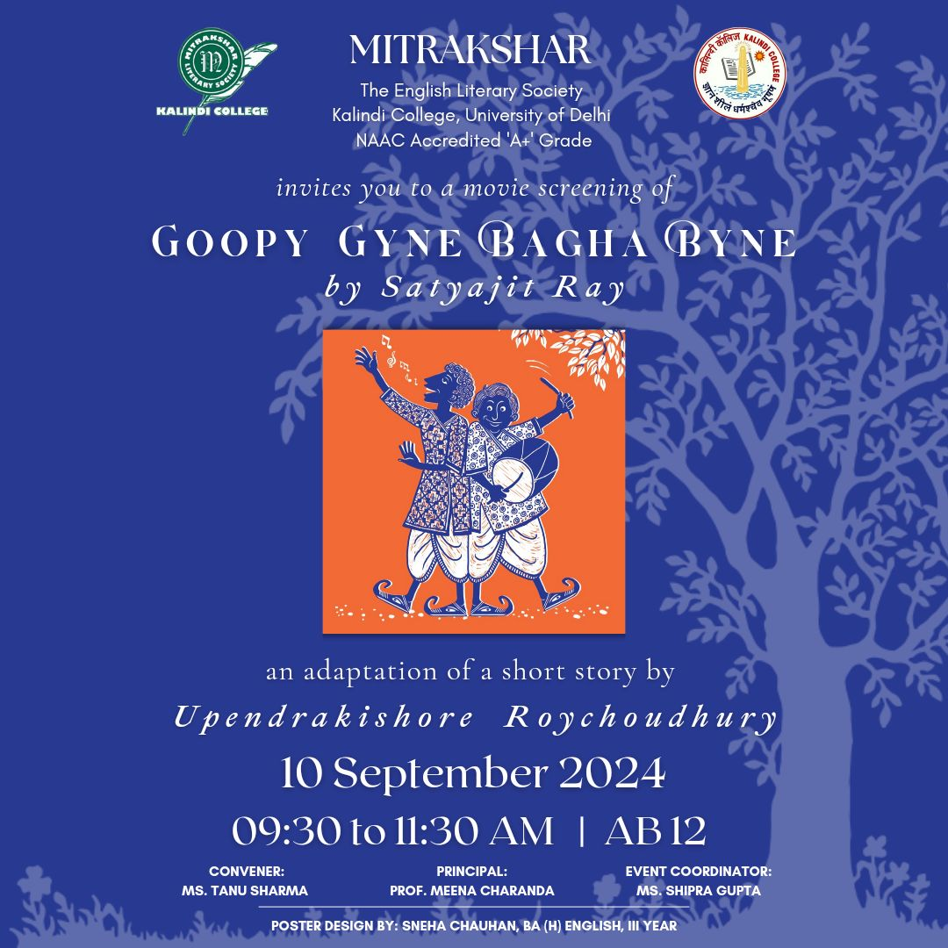
Attendance:
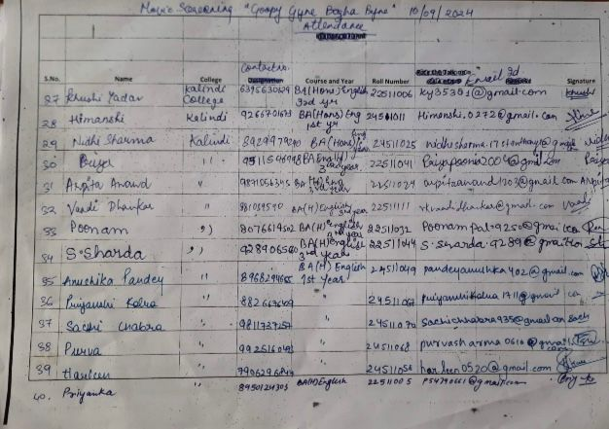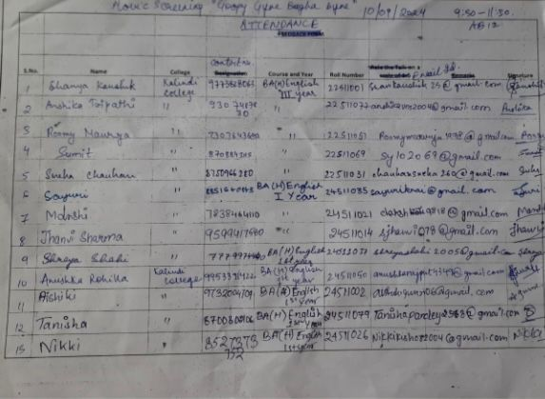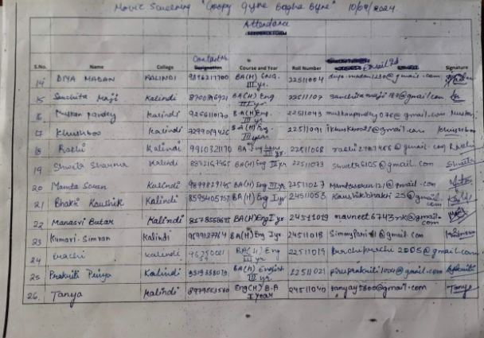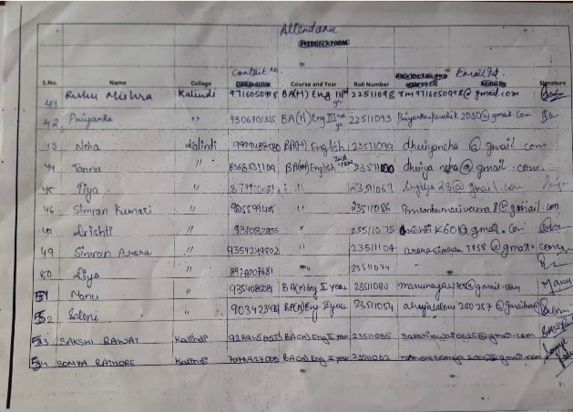
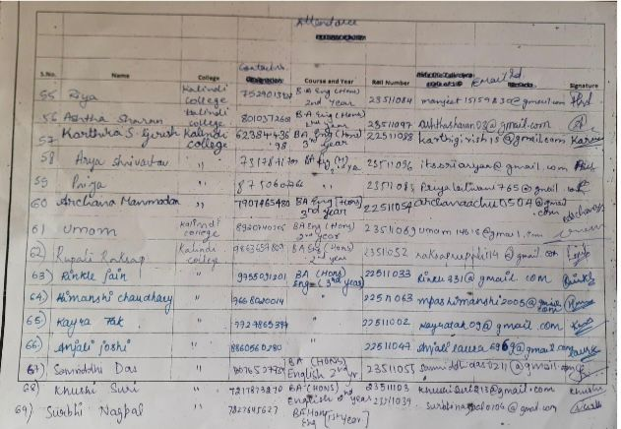
Detailed Report:
Kalindi College
10 September 2024
On 10 September 2024, Mitrakshar, the English Literary Society of Kalindi College organized the movie screening of Goopy Gyne Bagha Byne by Satyajit Ray, an adaptation of a short story by Upendrakishore Roychoudhury. The screening led to insightful discussions about the story as well as the cinematography among the students and teachers. Throughout the event the students indulged in the discussion about the critical aspect of the movie as well as the story with enthusiasm.

Geo-Tagged Pictures :

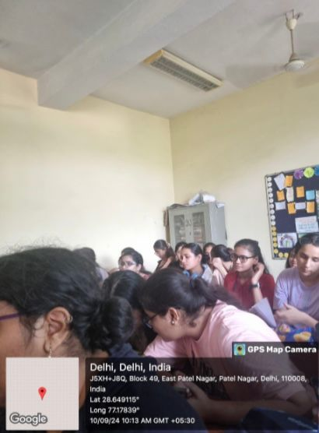 *Students discussing the movie.
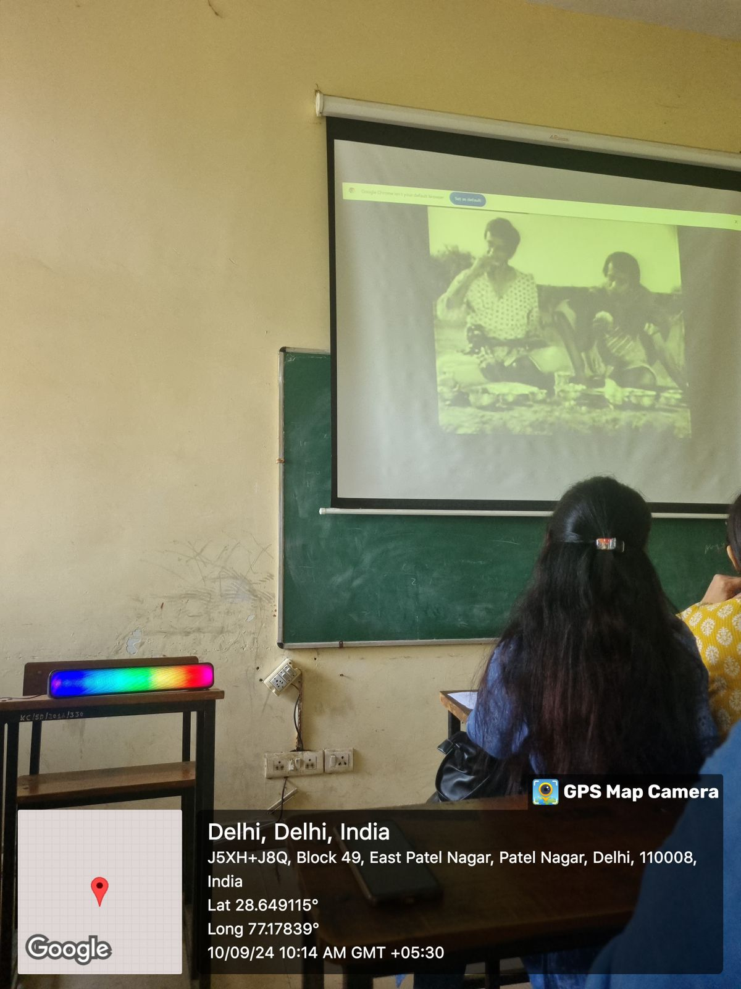 *Movie Screening of Goopy Gyne Bagha Byne
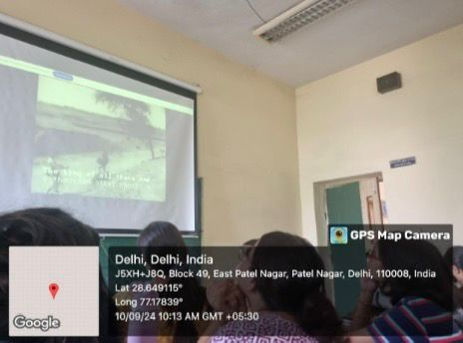 *Students watching the movie.

Performa for Submission of Activities From TIC/ Convener/ Co-Convener
/Organizer /Coordinator/Nodal Officer Etc.

- Department/Committee/Cell/Cultural Clubs, Others: Mitrakshar, the English Literary Society of Kalindi College, University of Delhi
- Name of the activity: “The Relevance of Literary Studies in Today’s World.”
- Funding Agency (Internal/External) and Amount:
- Name of the TIC/Convener/Coordinator/Nodal Officer/Other: Ms. Tanu Sharma (Convener), Ms. Vani M. Pyarilal (Co-convener)
- Date/s (-to-) and time (-to-) of activity: 4 October 2024 and 09:30 am to 11:00 am
- Collaborating agency if any:
- Number of students and teachers: 49 students, and 18 teachers.
- Number of participants outside Kalindi College:

- Proofs to be included

Poster/Banner/Flyer/Circular/Brochure etc.:
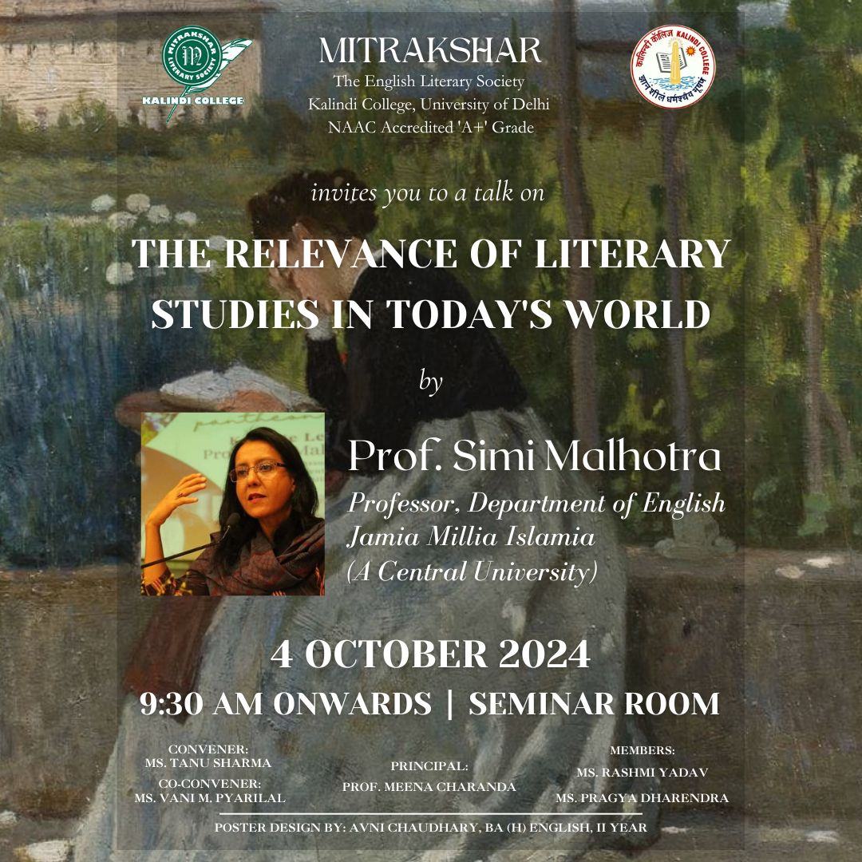

Google Attendance Sheet of all the participants if online;
and if offline, attendance sheet withsignature of all the participants:
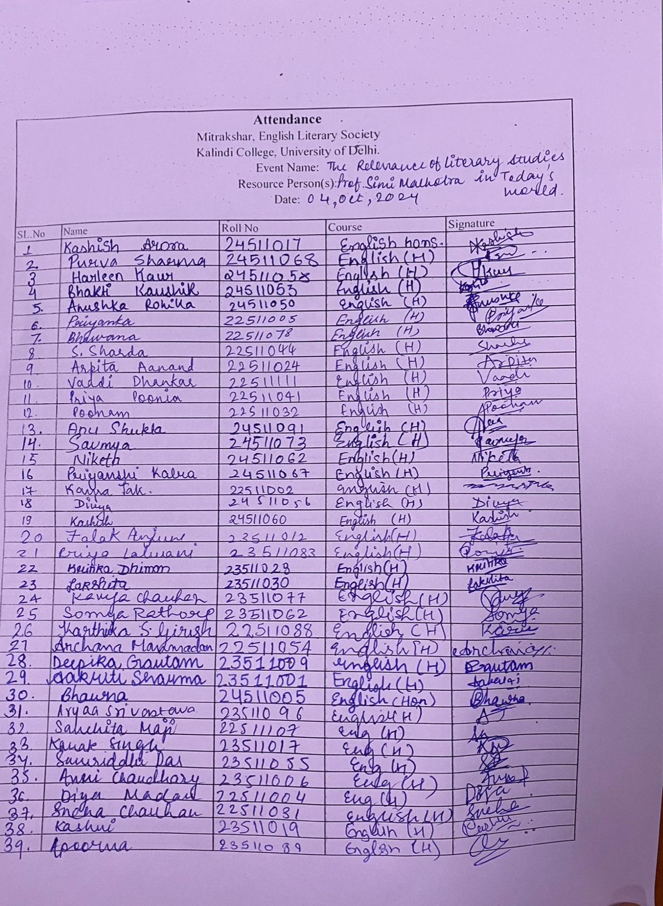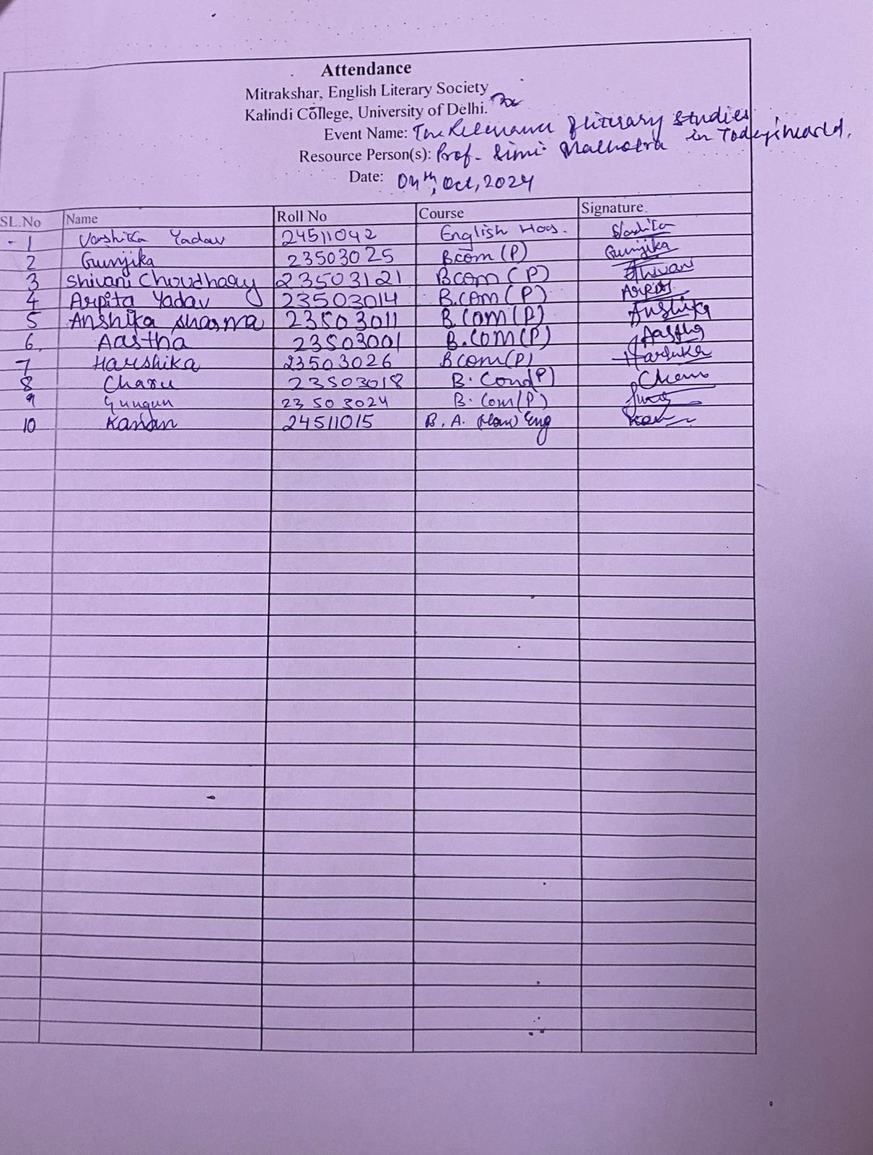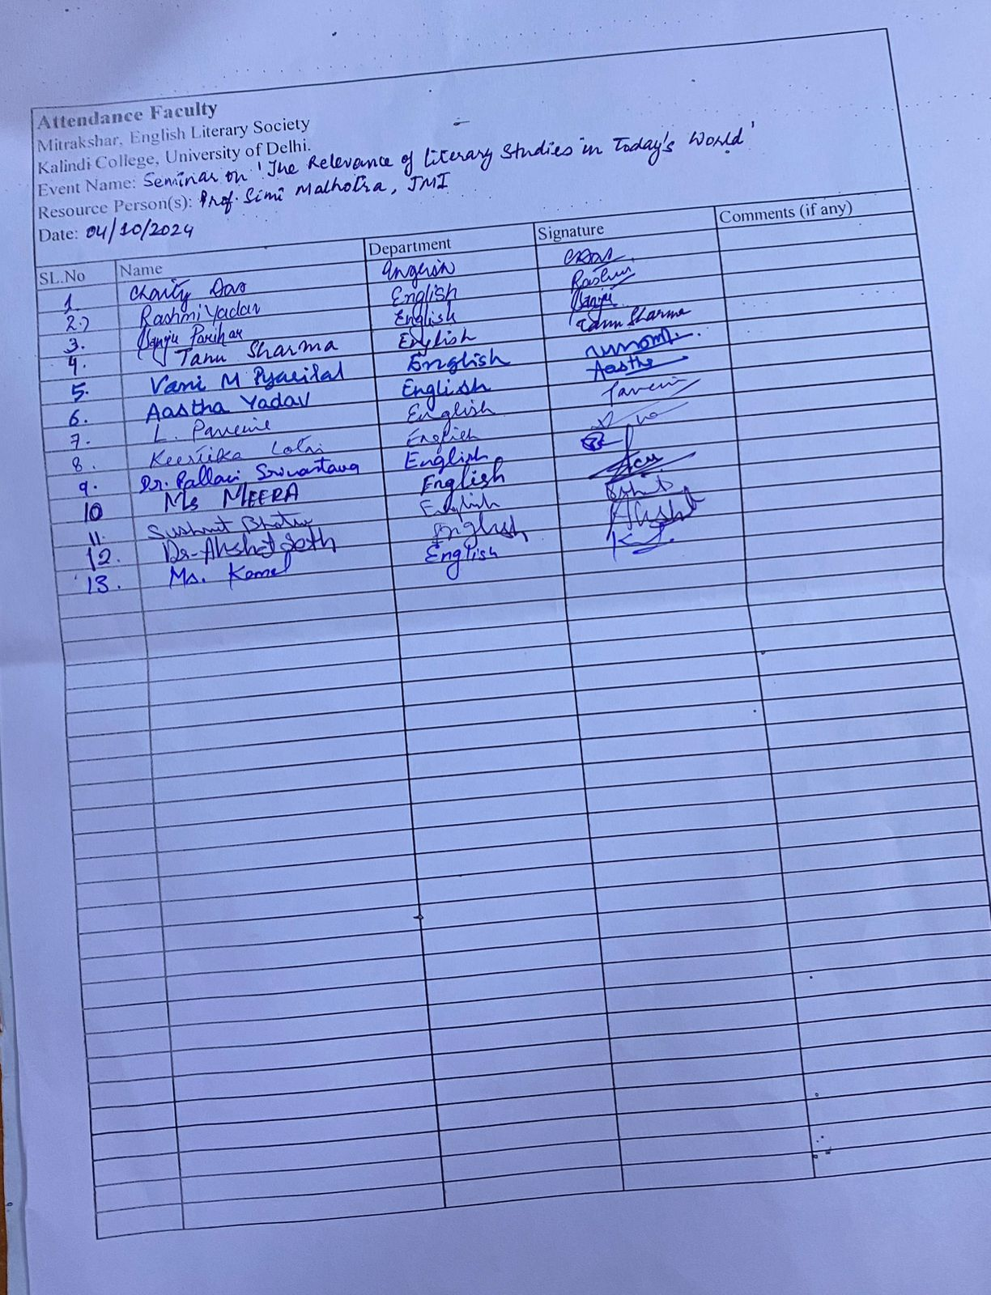

Names of the Resource Person/s: Professor Simi Malhotra

- Detailed Report:

The English Literary Society of Kalindi College, Mitrakshar, hosted a thought-provoking guest lecture on “The Relevance of Literary Studies in Today’s World” on 4th October 2024. The session was delivered by the distinguished academician Prof. Simi Malhotra, a noted professor from the Department of English at Jamia Millia Islamia.

The event began with a warm welcome extended to the speaker by the Teacher-in-Charge of the English Department, followed by brief introductory remarks that framed the significance of the discussion in a time marked by rapid technological, cultural, and ideological shifts.

Prof. Malhotra’s address was both intellectually rigorous and deeply engaging. She opened the lecture by tracing the historical evolution of literary studies, mapping its trajectory from canonical studies to contemporary intersections with cultural theory, gender studies, media, and politics. With lucidity and wit, she foregrounded the importance of literary inquiry as a means of understanding not just texts, but the systems of meaning-making that govern human life.

A key focus of the lecture was the transformative potential of literature in fostering critical thinking, empathy, and resistance. Prof. Malhotra argued that in an era of global crises—be it ecological, political, or psychological—literary studies offer a lens through which we can interrogate dominant narratives, question normative frameworks, and imagine alternative possibilities. She further explored how literature reflects, distorts, and shapes social realities, and how literary scholars today must grapple with the ethical, affective, and representational dimensions of reading.

She spoke with passion on the interdisciplinary future of literary studies, highlighting its growing relevance in fields such as environmental humanities, digital cultures, trauma studies, and postcolonial discourse. Drawing from both classical and contemporary texts, Prof. Malhotra illustrated how literature remains an indispensable tool for examining issues of identity, power, memory, and justice.

Throughout the session, Prof. Malhotra encouraged the students to think beyond conventional disciplinary boundaries. She posed challenging questions about the role of language, the authority of interpretation, and the politics of inclusion in literary canons. Her lecture was interspersed with vivid examples and referenced authors across genres, cultures, and centuries—demonstrating the truly global and dynamic nature of the field.

The session concluded with an interactive Q&A segment, where students engaged the speaker with insightful queries. Topics ranged from the employability of literature graduates to the social responsibility of writers and readers in the 21st century. Prof. Malhotra responded with nuance and clarity, leaving the audience with several thought-provoking takeaways.

Certificates of 10 participants: -

Geo tagged Photographs with captions:

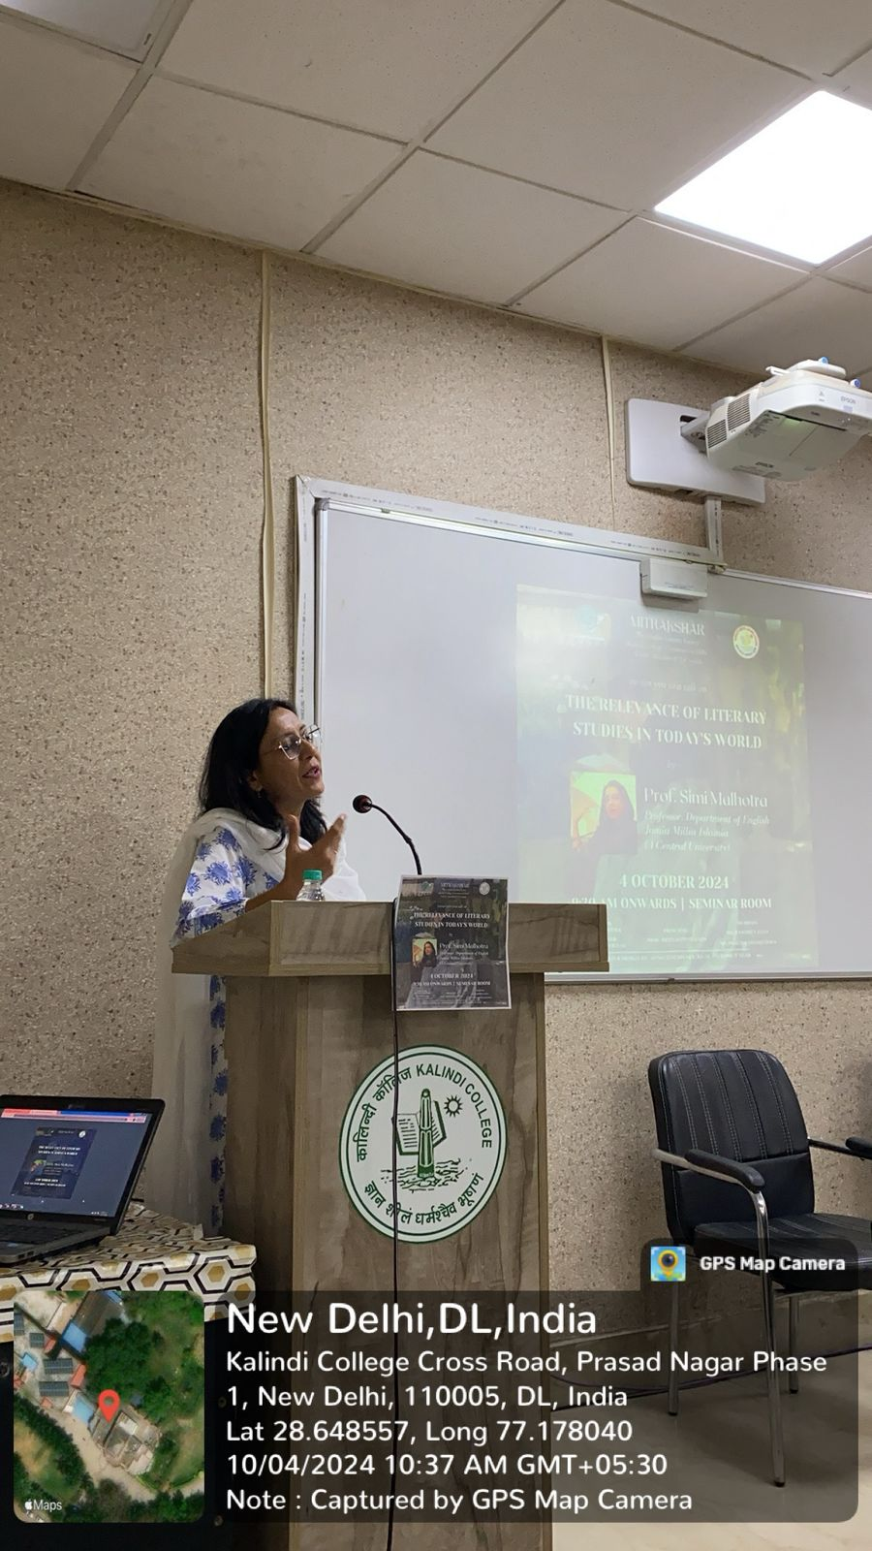*Professor Simi Malhotra delivering the talk

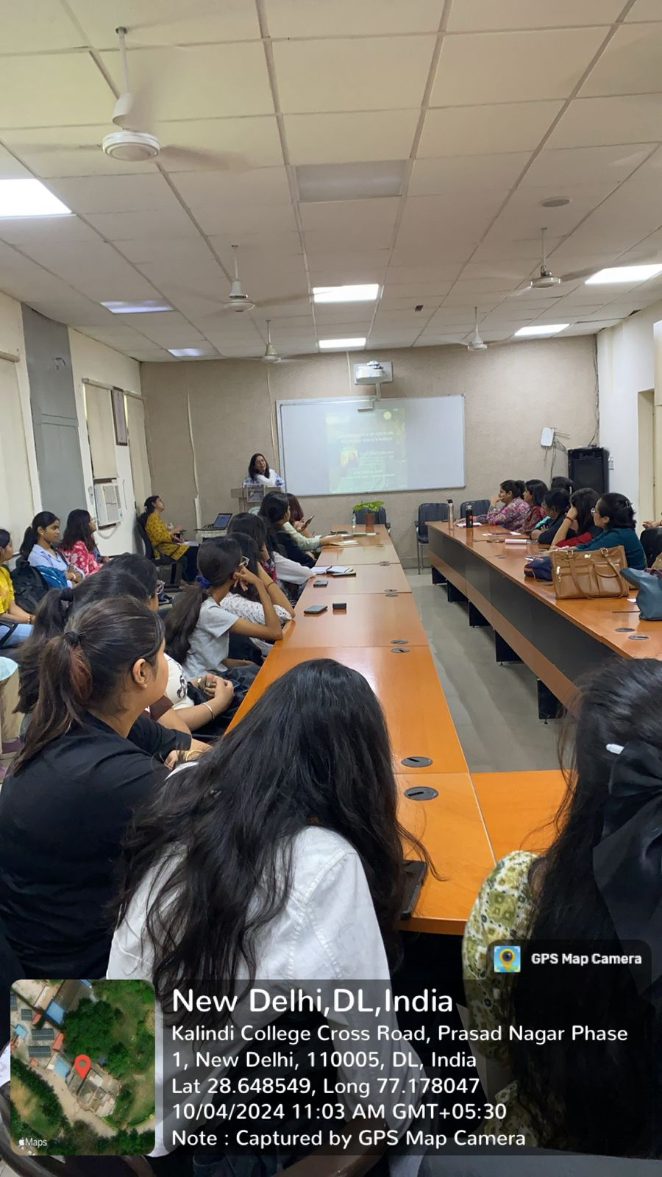*Students attending the seminar

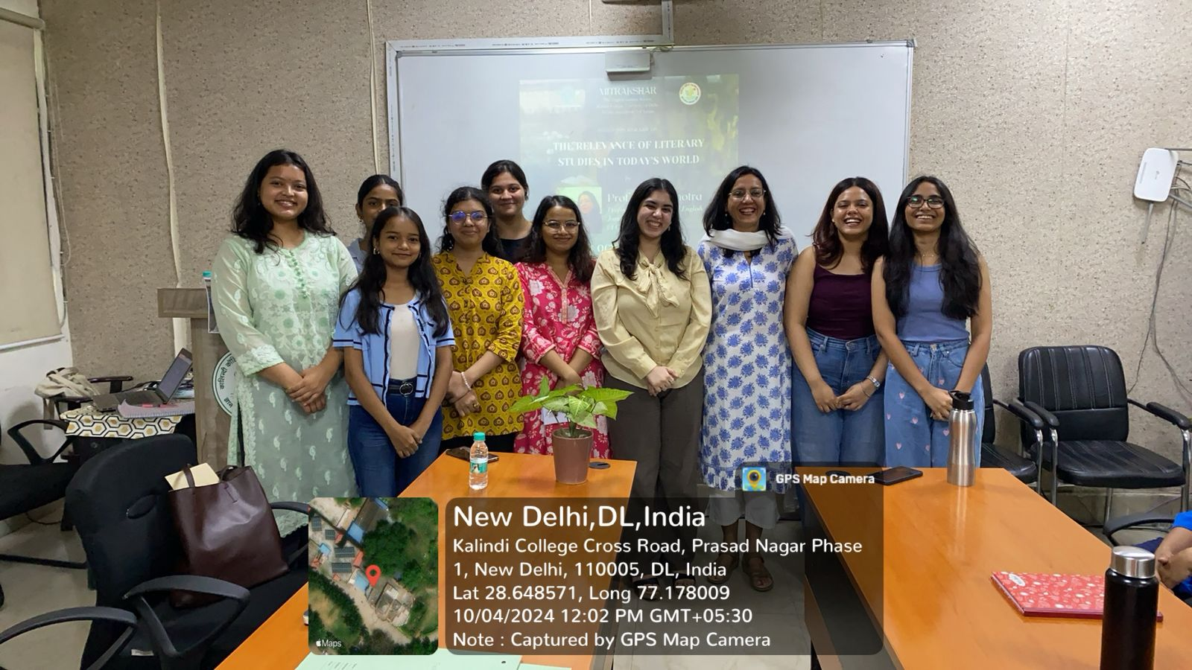*Professor Simi Malhotra with the office bearers

Newspaper clip or photograph if published: -

Performa for Submission of Activities From TIC/ Convener/ Co-Convener
/Organizer /Coordinator/Nodal Officer Etc.

- Department/Committee/Cell/Cultural Clubs, Others: Mitrakshar, English Literary Society of Kalindi College, University of Delhi
- Name of the activity: Veni Vidi Vici
- Funding Agency (Internal/External) and Amount: None
- Name of the TIC/Convener/Coordinator/Nodal Officer/Other: Ms. Tanu Sharma (Convener), Ms. Vani M. Pyarilal (Co-convener)
- Date/s (-to-) and time (-to-) of activity: 21 October 2024 and 9:00 am to 1:00 pm
- Collaborating agency if any: None
- Number of students and teachers: 28 students and 15 teachers
- Number of participants outside Kalindi College: None

Proofs to be included

Poster/Banner/Flyer/Circular/Brochure etc.:

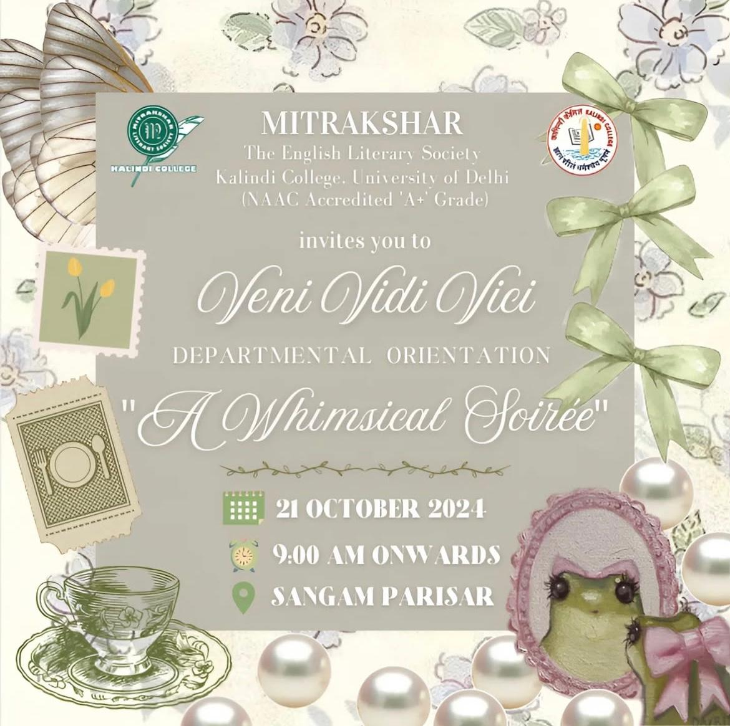

Google Attendance Sheet of all the participants if online;
and if offline, attendance sheet withsignature of all the participants:

Names of the Resource Person/s: -

Detailed Report:
Mitrakshar, the English Literary Society of Kalindi College, hosted its annual Freshers’ Welcome for the incoming batch of 2024 under the title “Veni Vidi Vici”. The event marked the beginning of a new academic year and was held with warmth, enthusiasm, and a shared sense of anticipation for the journey ahead. Themed “A Whimsical Soirée”, the celebration invited students to explore the elegance of the Coquettecore aesthetic—encouraging delicate, vintage-inspired outfits with a modern flair. The response to the theme was remarkable, as the venue came alive with vibrant expression and creativity, setting the tone for an event both graceful and memorable. The second and third-year students took the lead in curating performances for the day. Through music, dance, and engaging segments, they extended a heartfelt welcome to the freshers, creating an atmosphere that was both celebratory and inclusive. The dedication and efforts of the seniors were evident throughout the programme and played a crucial role in the event’s success.
The faculty members of the English Department were also present and shared a few words with the students, offering warm encouragement and support as the new session began. The event was a resounding success, leaving everyone with smiles, selfies, and shared memories. “Veni Vidi Vici” wasn’t just a welcome—it was a statement of togetherness and the beginning of a new chapter, beautifully penned by Mitrakshar.

Certificates of 10 participants: -

Geo tagged Photographs with captions:
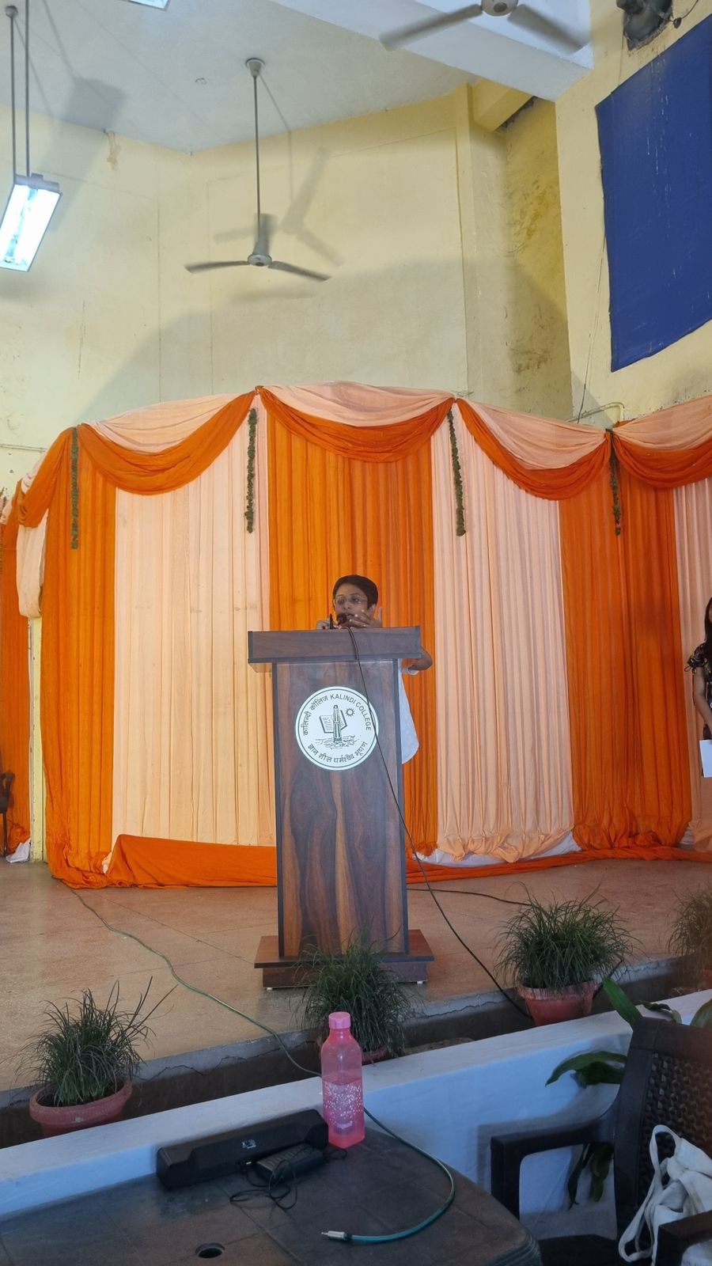 *The TIC addresses the first years.
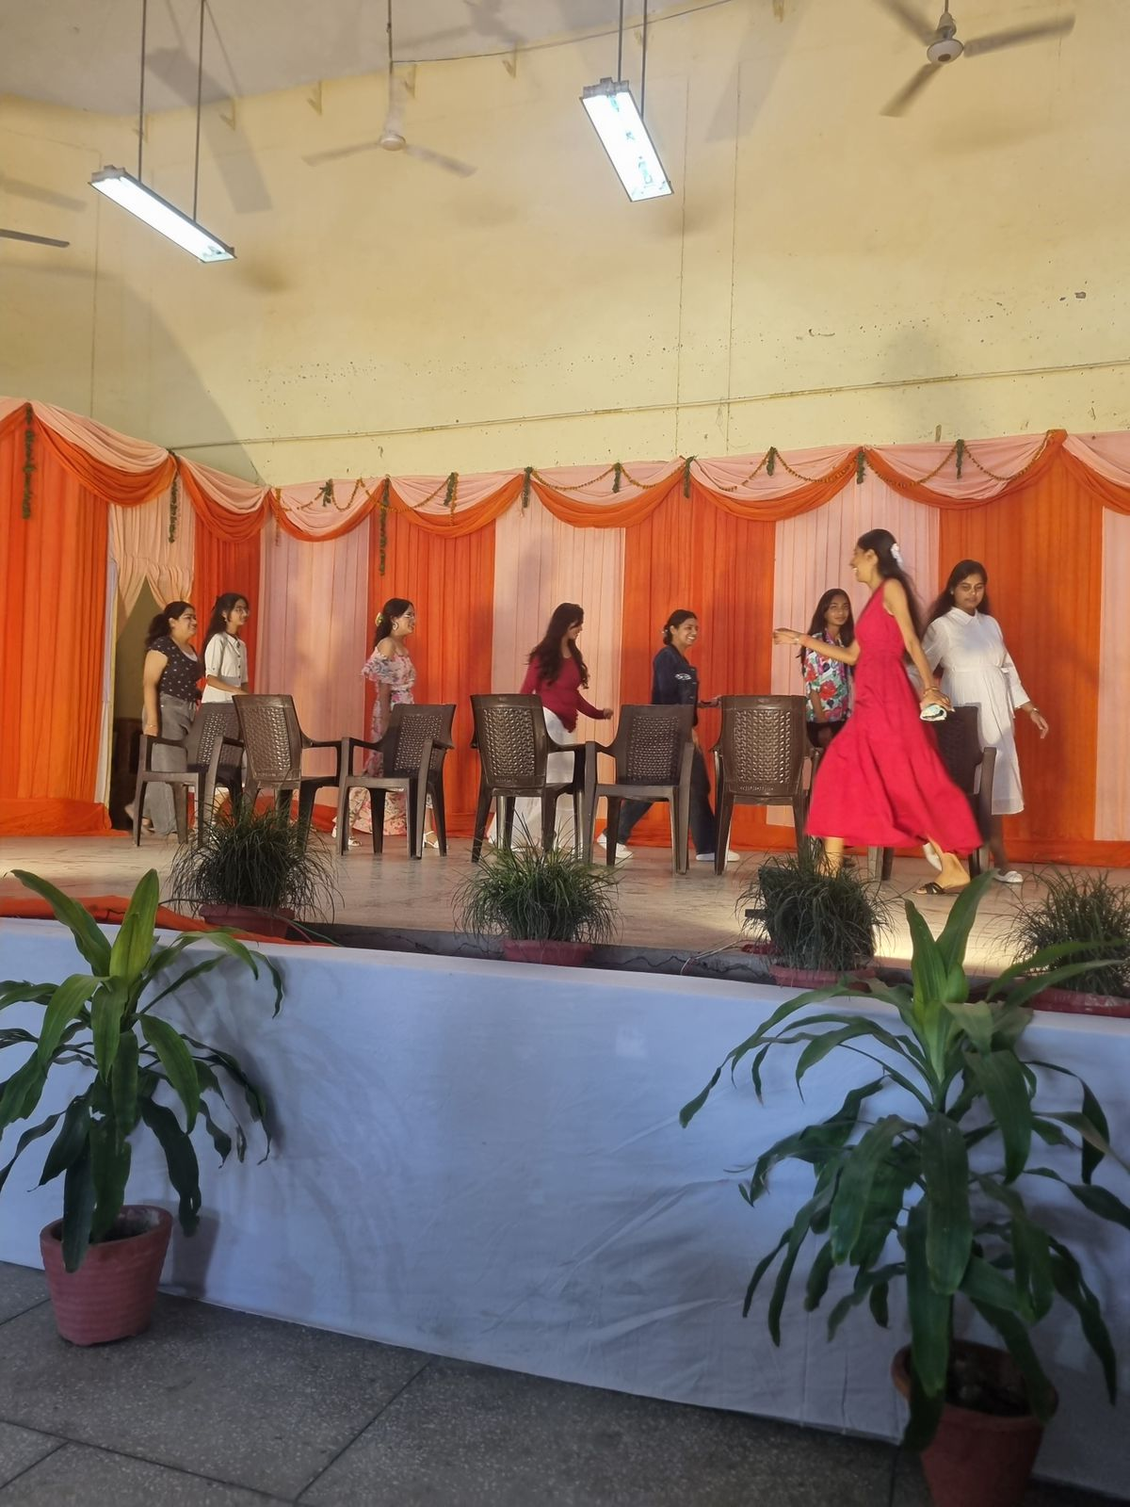 *Students engaging in a game.
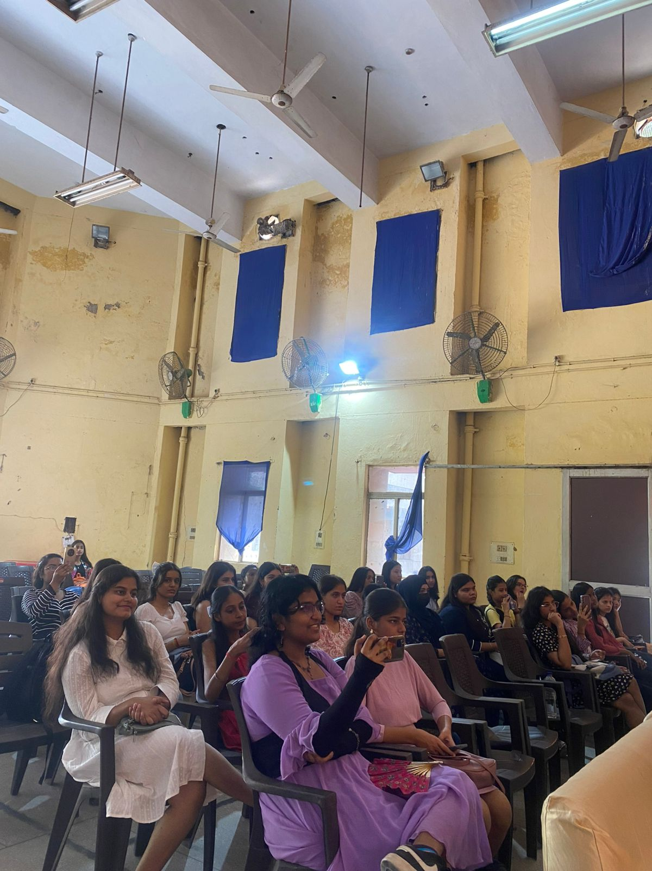 *Audience supporting the first years.
Newspaper clip or photograph if published: -

Performa for Submission of Activities From TIC/ Convener/ Co-Convener
/Organizer /Coordinator/Nodal Officer Etc.

Department/Committee/Cell/Cultural Clubs, Others: Mitrakshar, English Literary Society of Kalindi College, University of Delhi
Name of the activity: Afterthoughts (A literary discussion)
Funding Agency (Internal/External) and Amount: None
Name of the TIC/Convener/Coordinator/Nodal Officer/Other: Ms. Tanu Sharma (Convener), Ms. Vani M. Pyarilal (Co-convener)
Date/s (-to-) and time (-to-) of activity: 6 November 2024 and 1:00 pm to 3:00 pm
Collaborating agency if any: None
Number of students and teachers: 35 students and 6 teachers
Number of participants outside Kalindi College: None

- Proofs to be included

- Poster/Banner/Flyer/Circular/Brochure etc.:

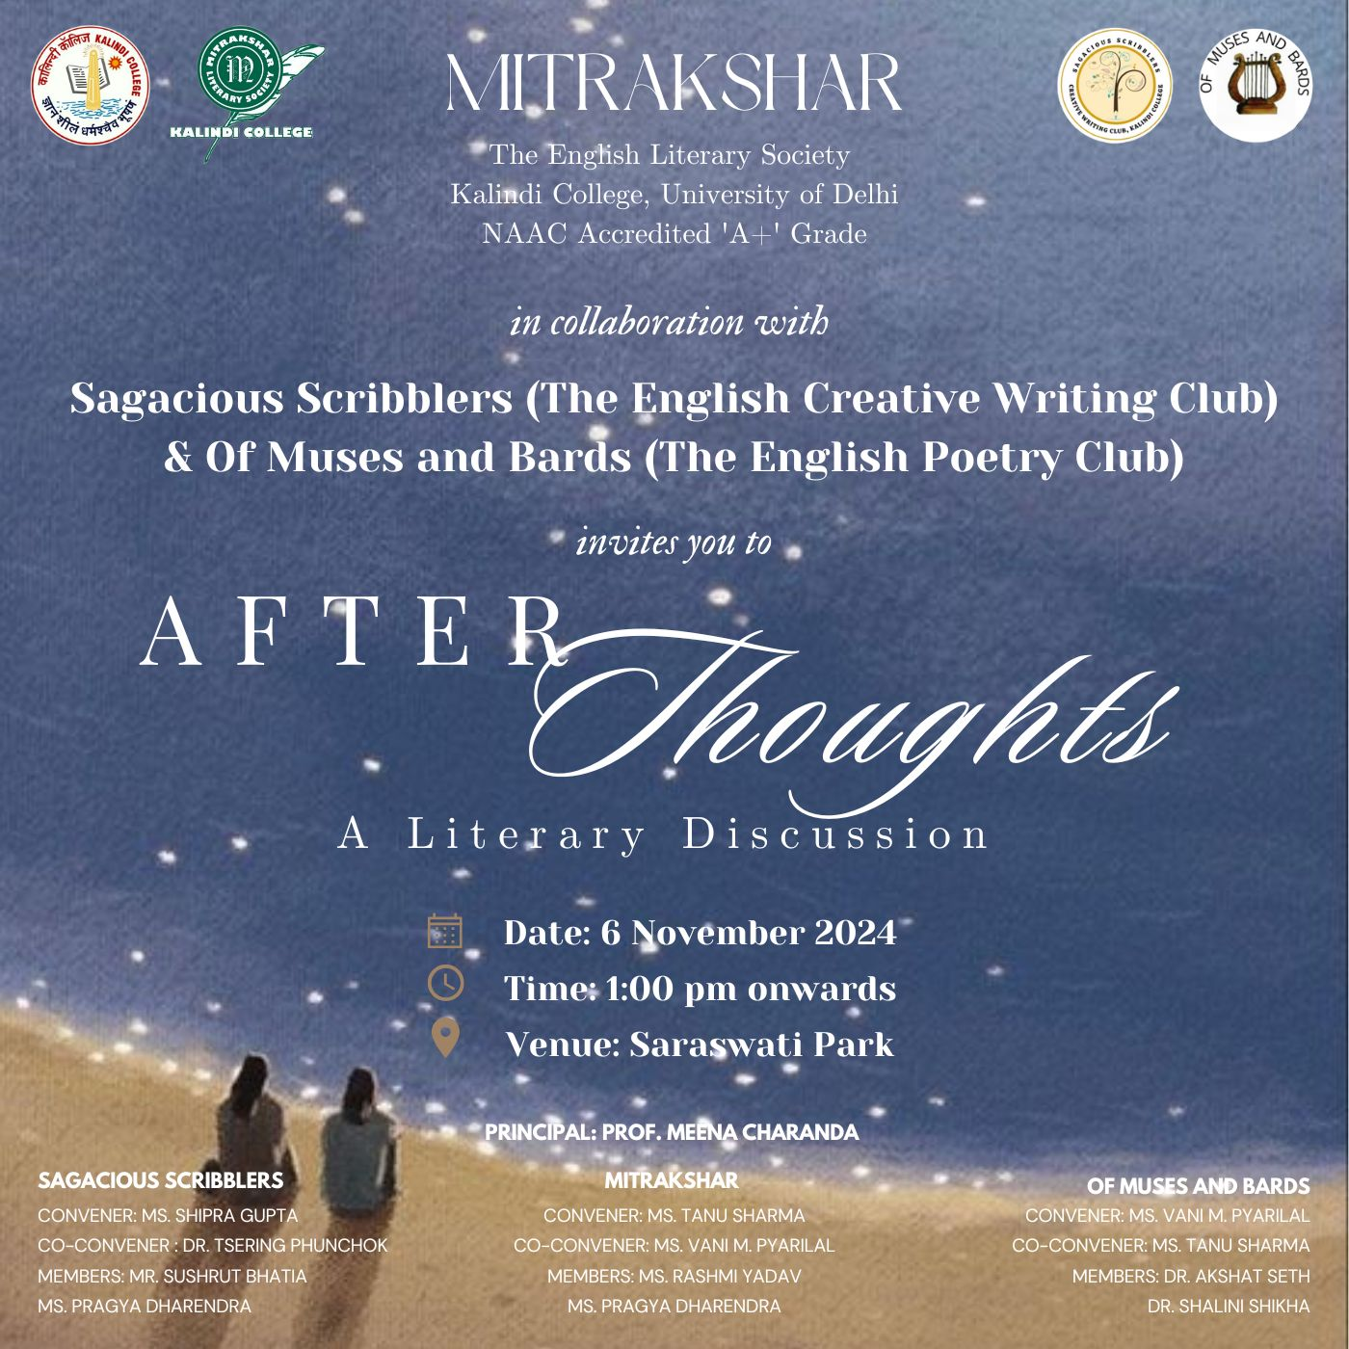

- Google Attendance Sheet of all the participants if online;
- and if offline, attendance sheet withsignature of all the participants:

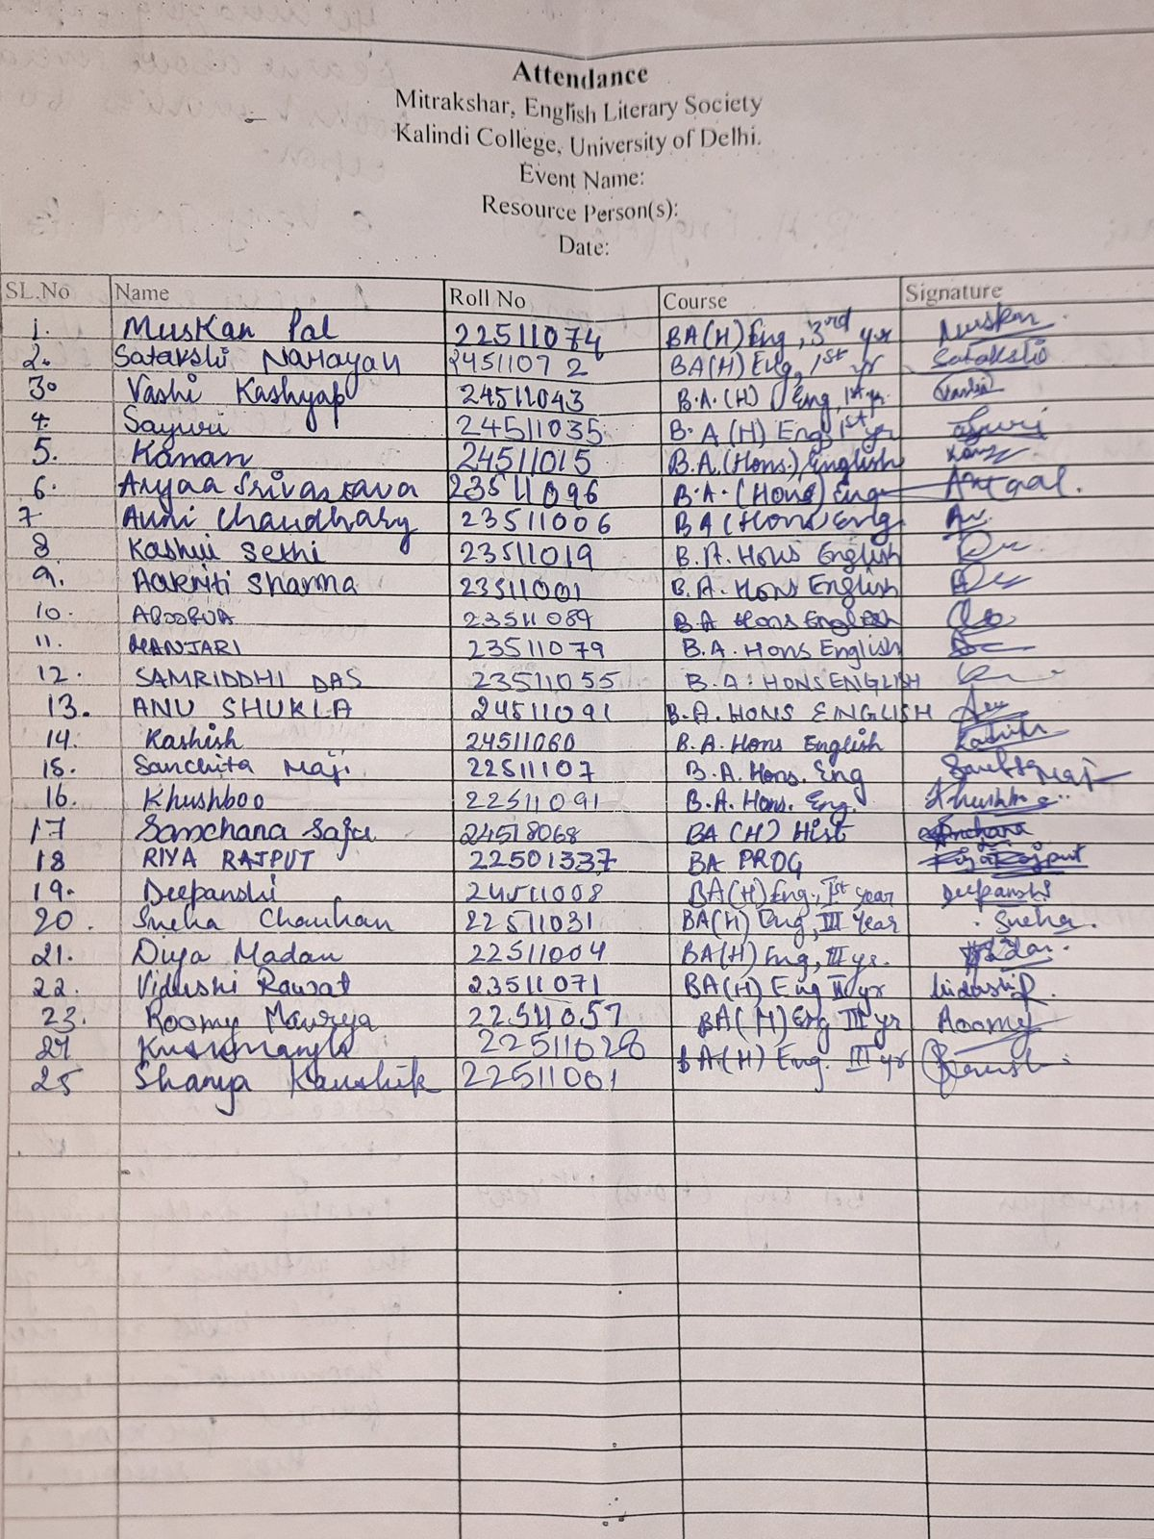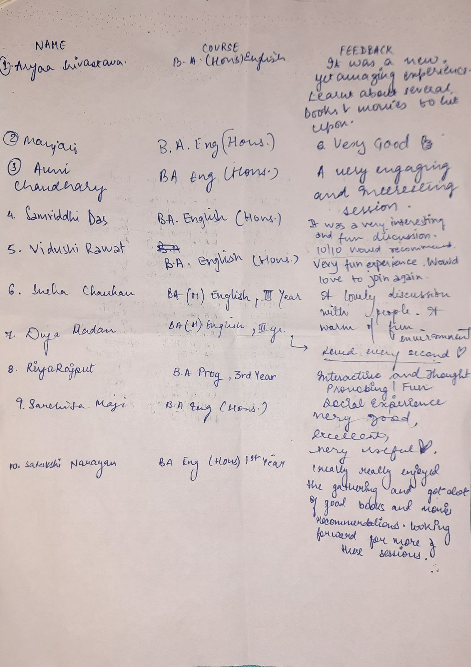

.

- Names of the Resource Person/s: -

- Detailed Report:

On November 6, Mitrakshar, the English Literary Society in collaboration with Sagacious Scribblers, the English Creative Writing Club, and Of Muses and Bards, the English Poetry Club, organized Afterthoughts, a literary discussion and meet-and-greet that turned into an evening of shared stories, lively debates, and a celebration of literature in all its forms.
The gathering brimmed with conversations about favourite books, beloved authors, and the ever-contentious topic of movie adaptations. While some attendees ardently defended the classics closest to their hearts, others introduced underrated gems that had left a quiet but lasting impression. The discussion on film adaptations was particularly spirited—some celebrated the magic of seeing literary worlds come alive on screen, while others mourned the subtleties lost in translation from text to cinema.
But Afterthoughts was more than a discussion. It was a space where people could simply revel in the joy of reading—among those who understood what it meant to be moved by a sentence, a character, a story. The evening unfolded with ease, flowing from sharp literary observations to playful anecdotes and shared laughter. There were debates about plot twists, impromptu quotes, and those silent nods of recognition when someone mentioned a book that felt like home.
As the evening drew to a close, Afterthoughts left behind more than just reflections—it left a sense of belonging. An unspoken understanding lingered in the room: that such conversations, such moments, should happen more often. It was never just about books or films—it was about the joy of talking about them, and about finding those rare people who feel the same way.

- Certificates of 10 participants: -

- Geo tagged Photographs with captions:

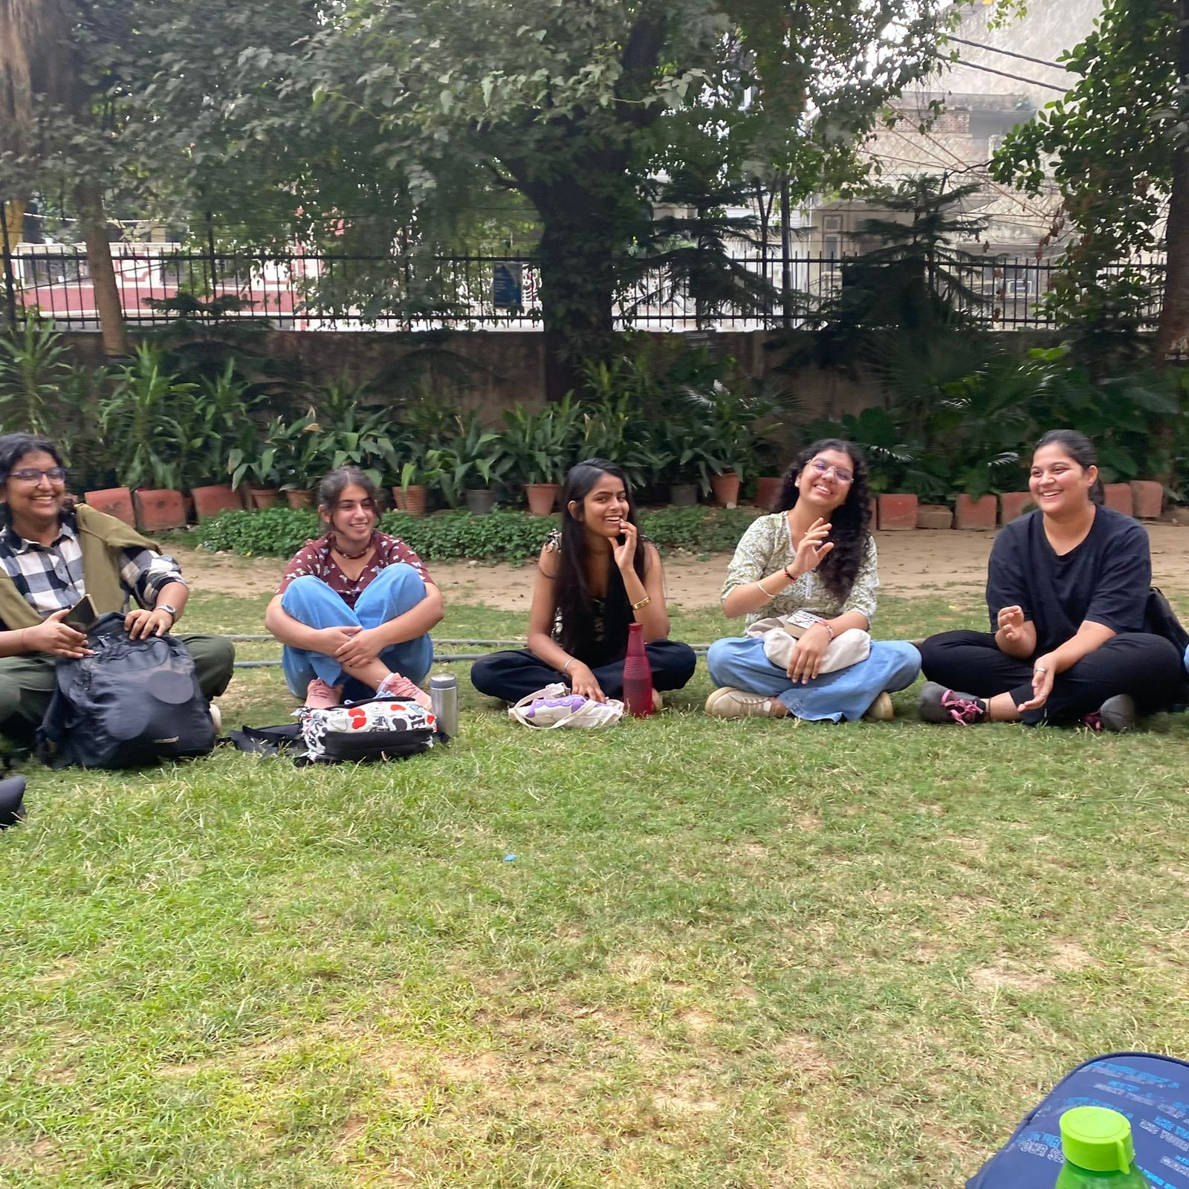 *Students discussing cinema.

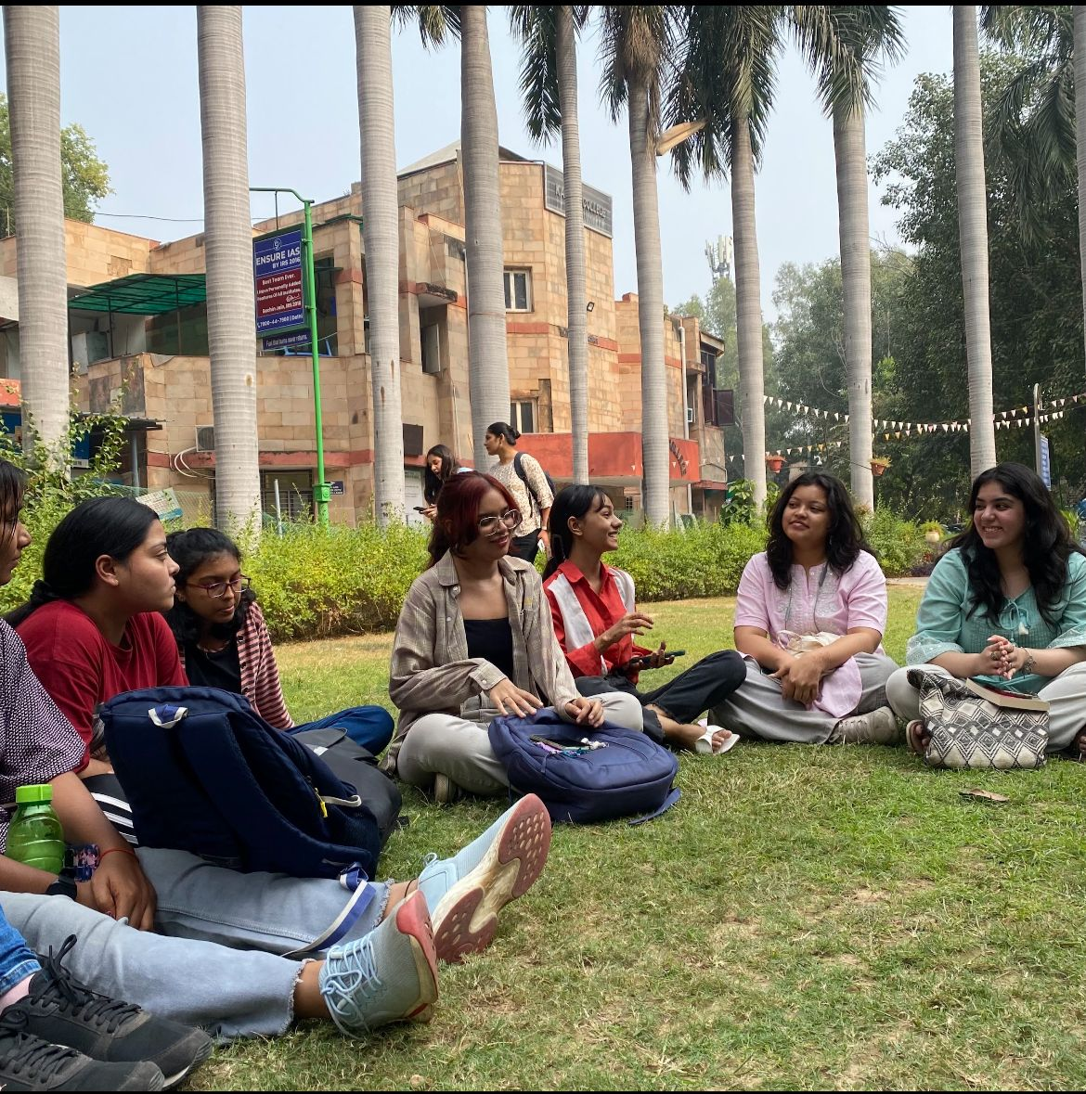 *Students sharing their insights on media consumption.

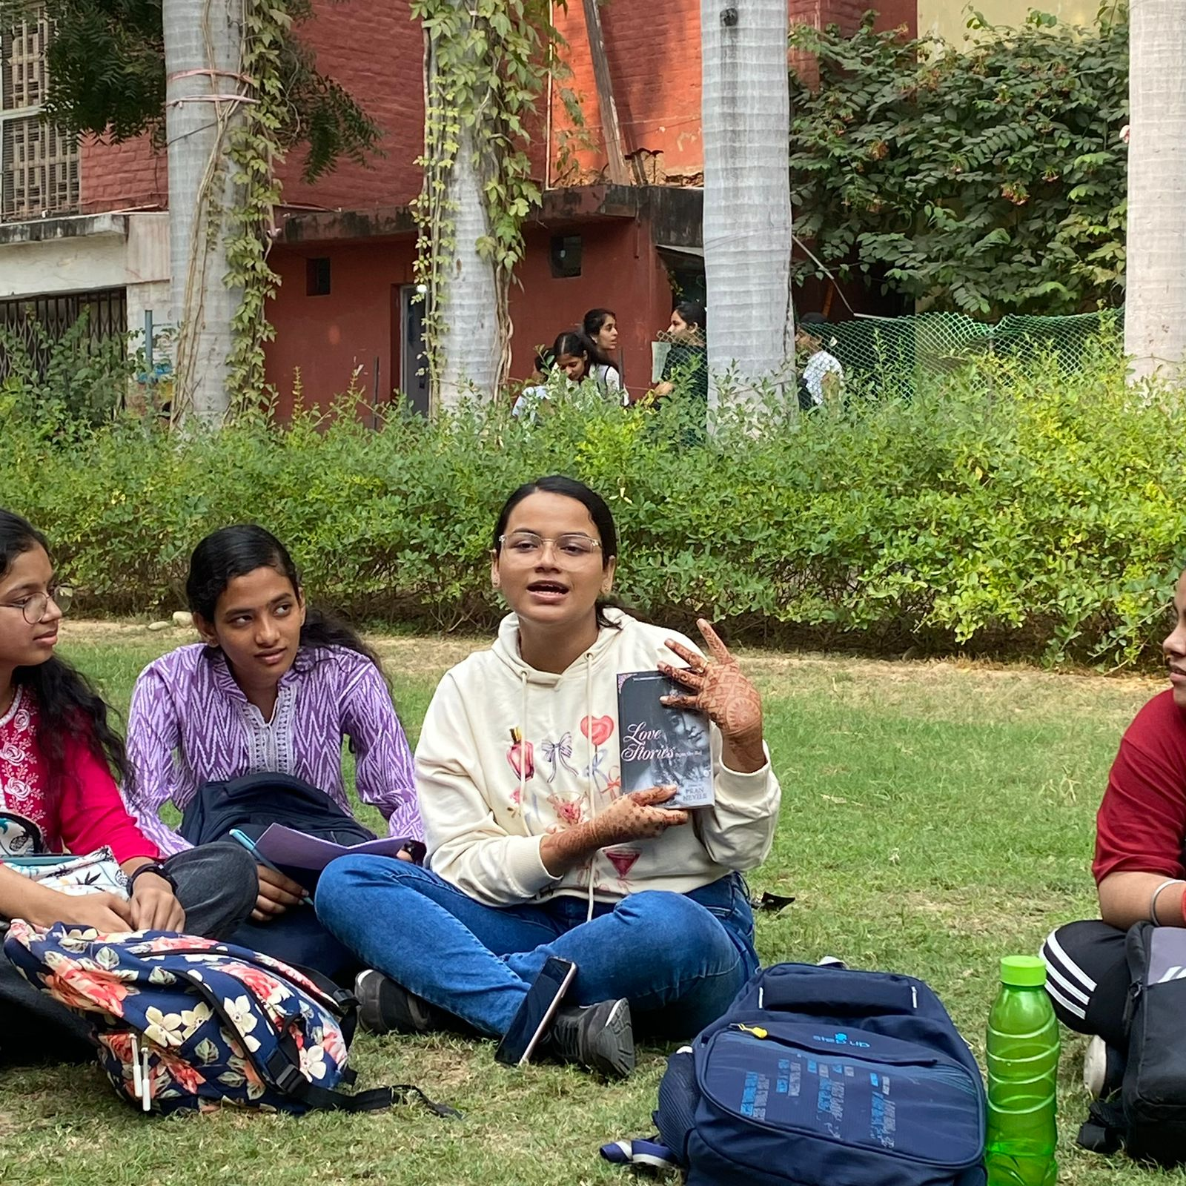 *Students discussing their favourtite books.

Newspaper clip or photograph if published: -

Performa for Submission of Activities From TIC/ Convener/ Co-Convener
/Organizer /Coordinator/Nodal Officer Etc.

Department/Committee/Cell/Cultural Clubs, Others: Mitrakshar, English Literary Society of Kalindi College, University of Delhi
Name of the activity: “The How and Why: Becoming Menstrual Health Advocates” ( a Community Outreach Workshop)
Funding Agency (Internal/External) and Amount: None
Name of the TIC/Convener/Coordinator/Nodal Officer/Other: Ms. Tanu Sharma (Convener), Ms. Vani M. Pyarilal (Co-convener)
Date/s (-to-) and time (-to-) of activity: 8 November 2024 and 10:30 am to 12pm
Collaborating agency if any: Project Baala
Number of students and teachers: 84 students and 13 teachers
Number of participants outside Kalindi College: None

- Proofs to be included

- Poster/Banner/Flyer/Circular/Brochure etc.:
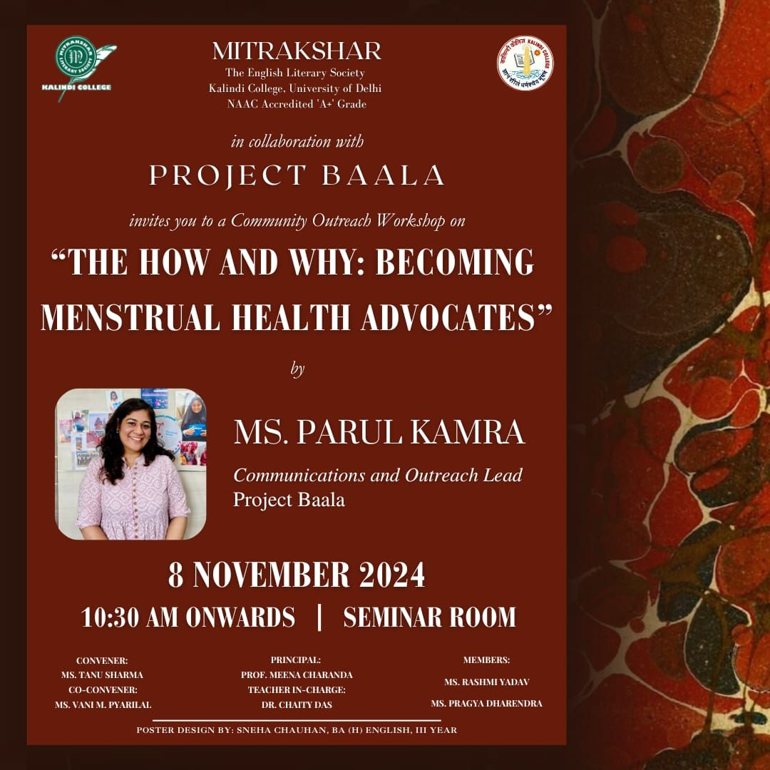

Google Attendance Sheet of all the participants if online;
and if offline, attendance sheet withsignature of all the participants:
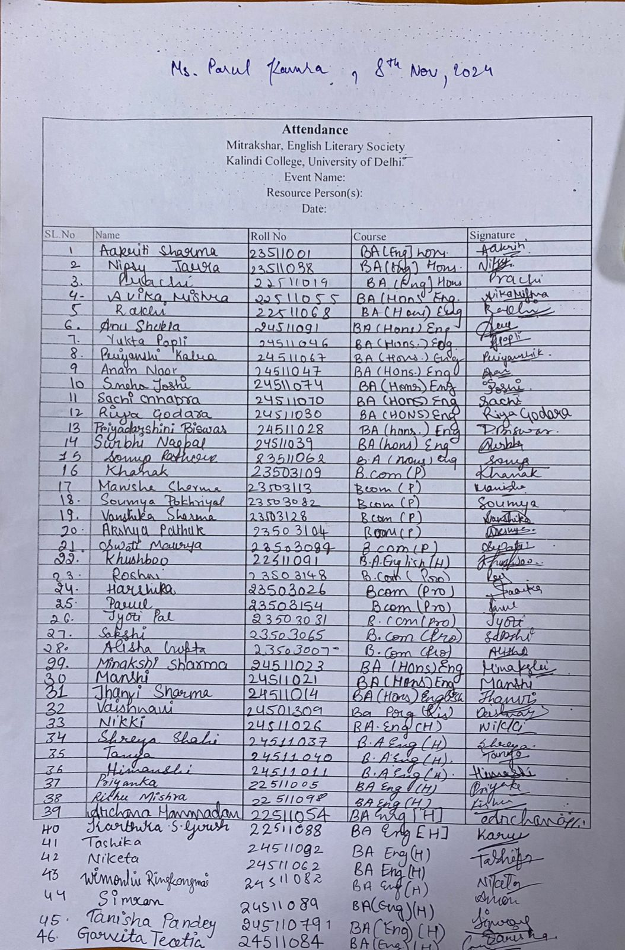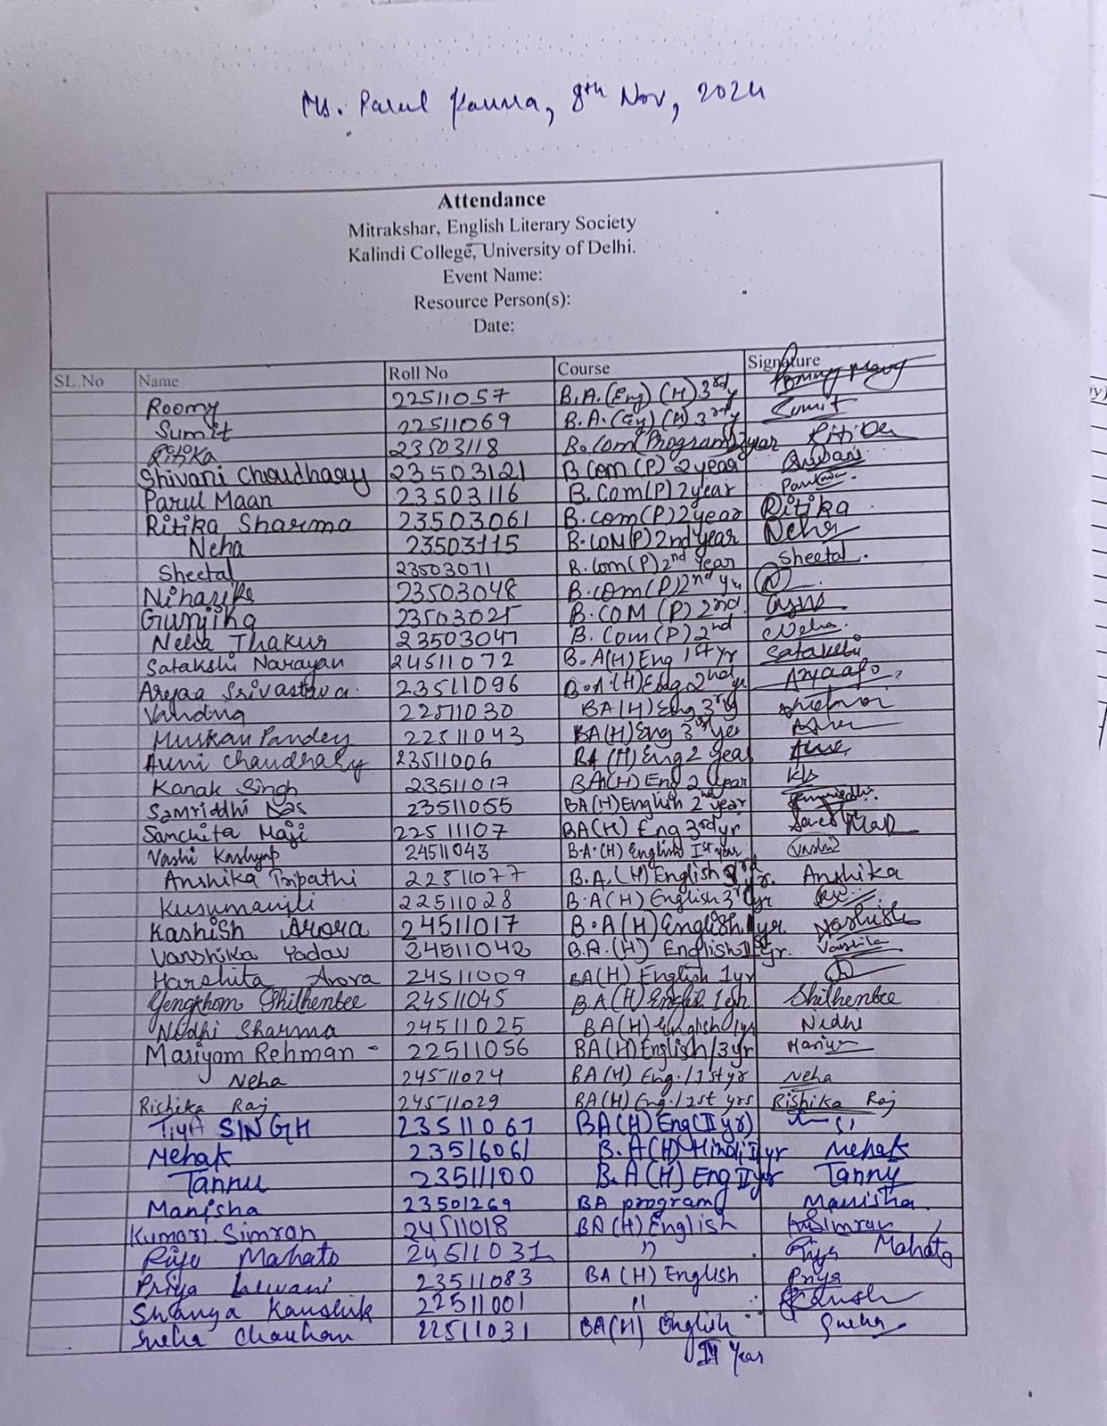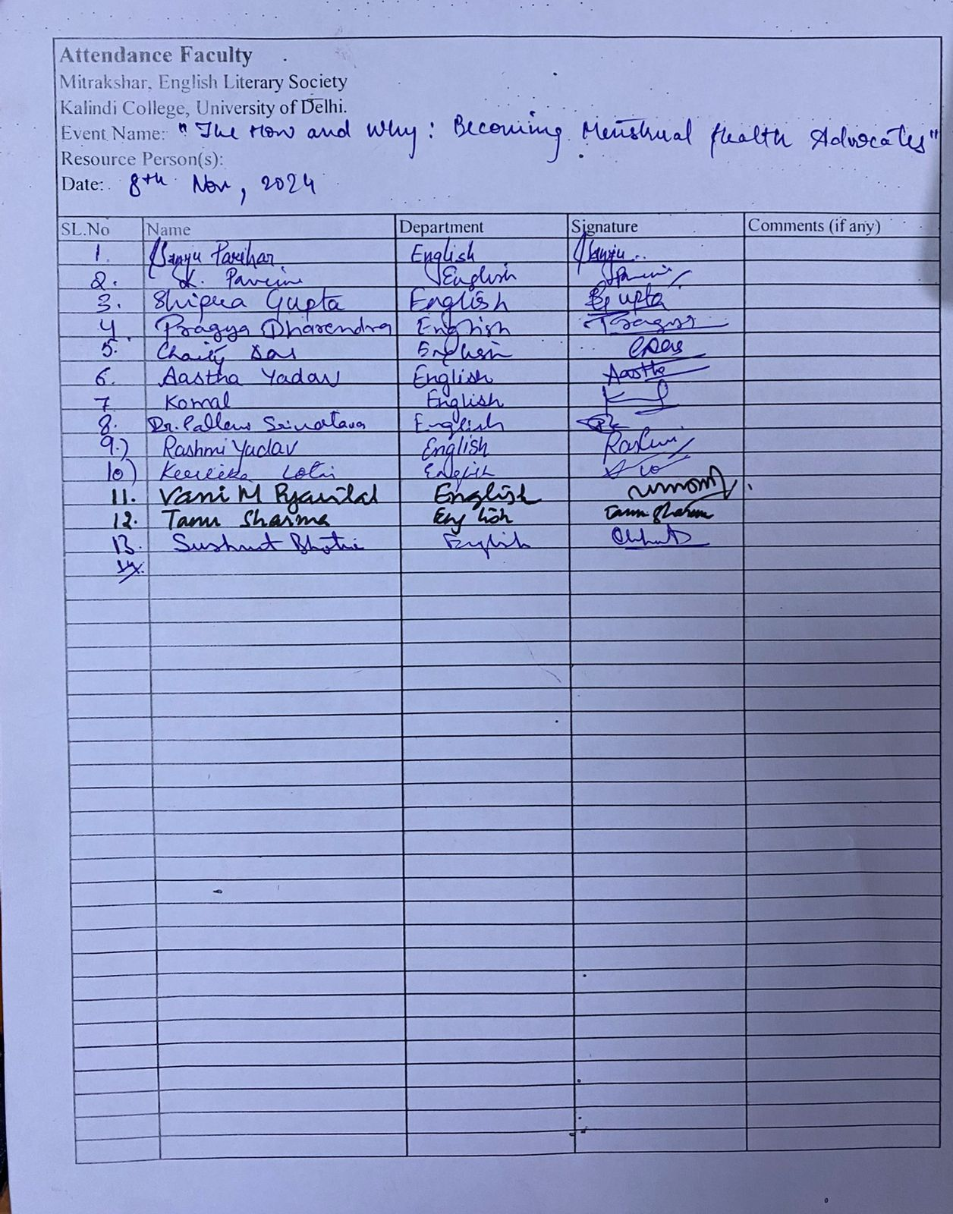

- Names of the Resource Person/s: Ms. Parul Kamra

- Detailed Report:

On 8th November 2024, Mitrakshar, the English Literary Society of Kalindi College, in collaboration with Project Baala, organised a community outreach workshop titled “The How and Why: Becoming Menstrual Health Advocates.” The session aimed to foster awareness, sensitivity, and responsibility around menstrual health—a subject that remains under-discussed and often stigmatised.
The workshop was led by Ms. Parul Kamra, the Communications and Outreach Lead at Project Baala, whose address was both enlightening and deeply engaging. Drawing from her extensive field experience, Ms. Kamra spoke candidly about her work with children and adolescents in rural areas. She shed light on the multifaceted challenges that menstruators in these communities face—ranging from lack of access to sanitary products and clean facilities, to deeply entrenched social taboos and discriminatory practices.
Her talk emphasised that menstrual health is not just a personal or medical issue, but one rooted in education, access, and social equity. Through real-life anecdotes and reflections, she encouraged students to rethink silence and shame around menstruation, and to instead become informed advocates capable of supporting inclusive health narratives within their communities.
The event was well-attended by students and faculty members of the English Department. The interactive nature of the session allowed for meaningful engagement, with students asking questions and sharing thoughts that contributed to a dynamic, respectful dialogue. The presence and support of the faculty further underscored the importance of such conversations in academic spaces.
By the end of the session, it was evident that conversations around menstrual health need to be normalised, sensitised, and continued—not just in healthcare settings, but also within educational institutions. The workshop marked a significant step in that direction.

- Certificates of 10 participants: -

- Geo tagged Photographs with captions
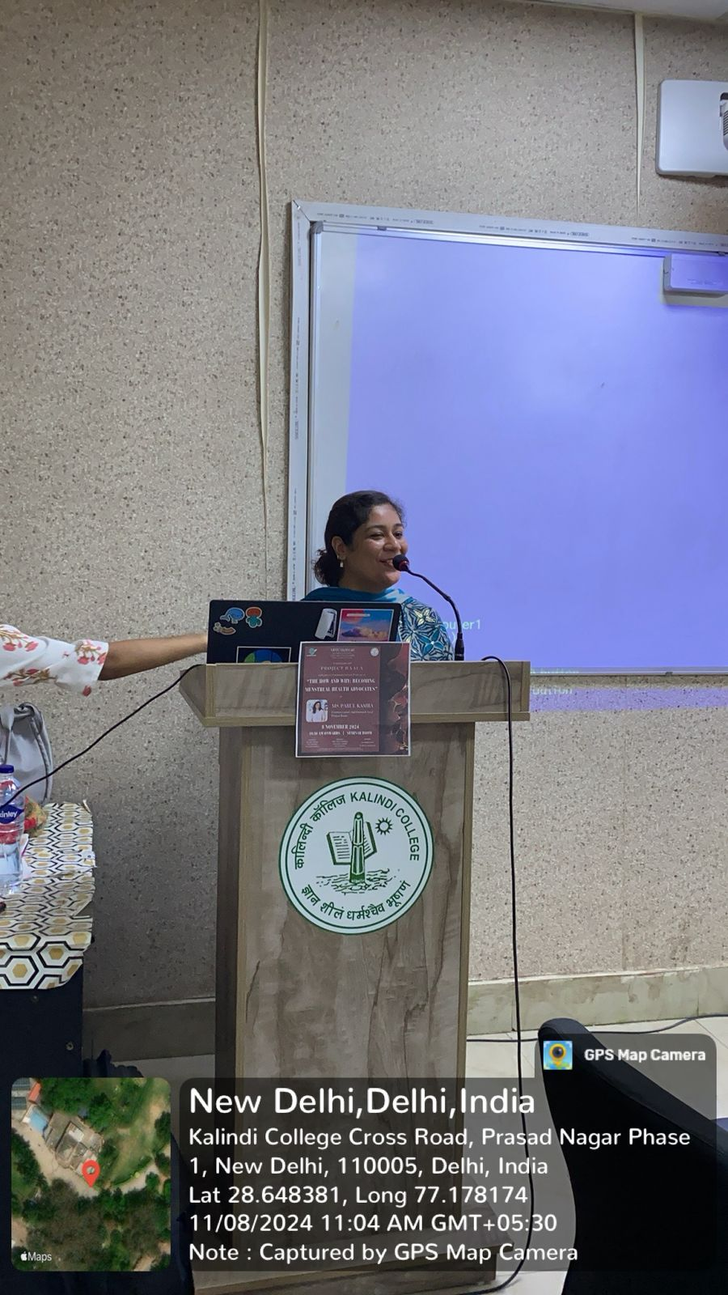 *Miss Parul Kamra addressing the students
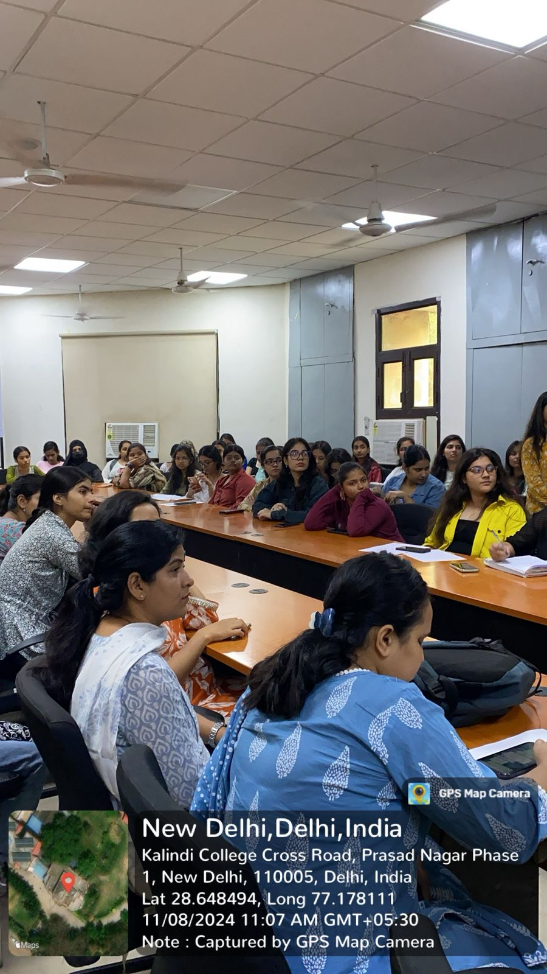 *Students attending the seminar
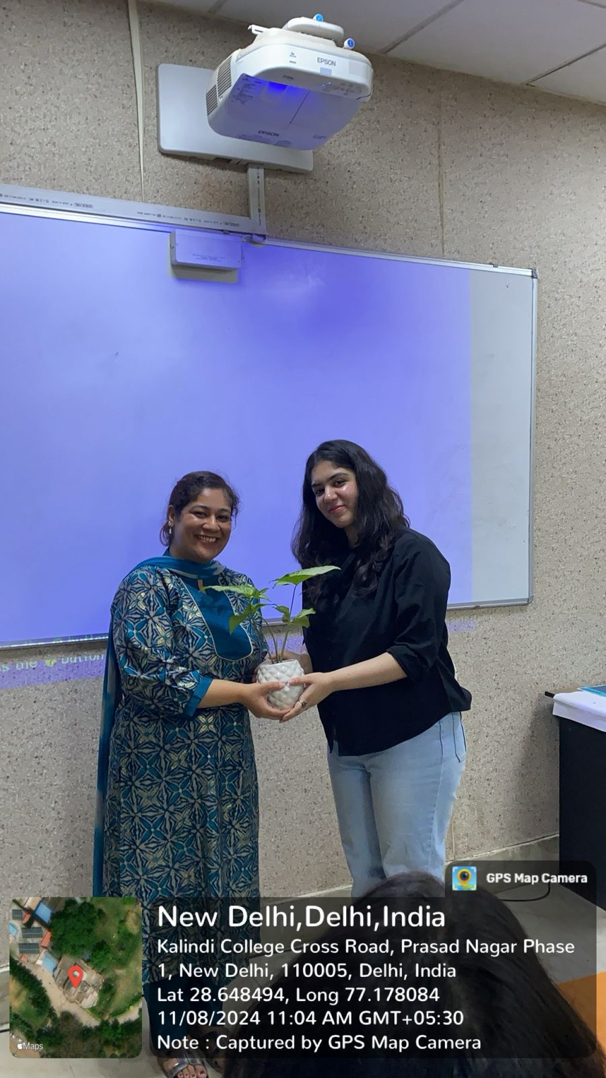 *The President of Mitrakshar honoured the Keynote Speaker via a planter.

Newspaper clip or photograph if published: -

Performa for Submission of Activities From TIC/ Convener/ Co-Convener
/Organizer /Coordinator/Nodal Officer Etc.

Department/Committee/Cell/Cultural Clubs, Others: Mitrakshar, English Literary Society of Kalindi College, University of Delhi
Name of the activity: A Field Trip to The National Gallery of Modern Art
Funding Agency (Internal/External) and Amount: None
Name of the TIC/Convener/Coordinator/Nodal Officer/Other: Ms. Tanu Sharma (Convener), Ms. Vani M. Pyarilal (Co-convener)
Date/s (-to-) and time (-to-) of activity: 7 February 2025 and 10:30 to 12:30 pm
Collaborating agency if any: None
Number of students and teachers: 74
Number of participants outside Kalindi College: None

- Proofs to be included

- Poster/Banner/Flyer/Circular/Brochure etc.:

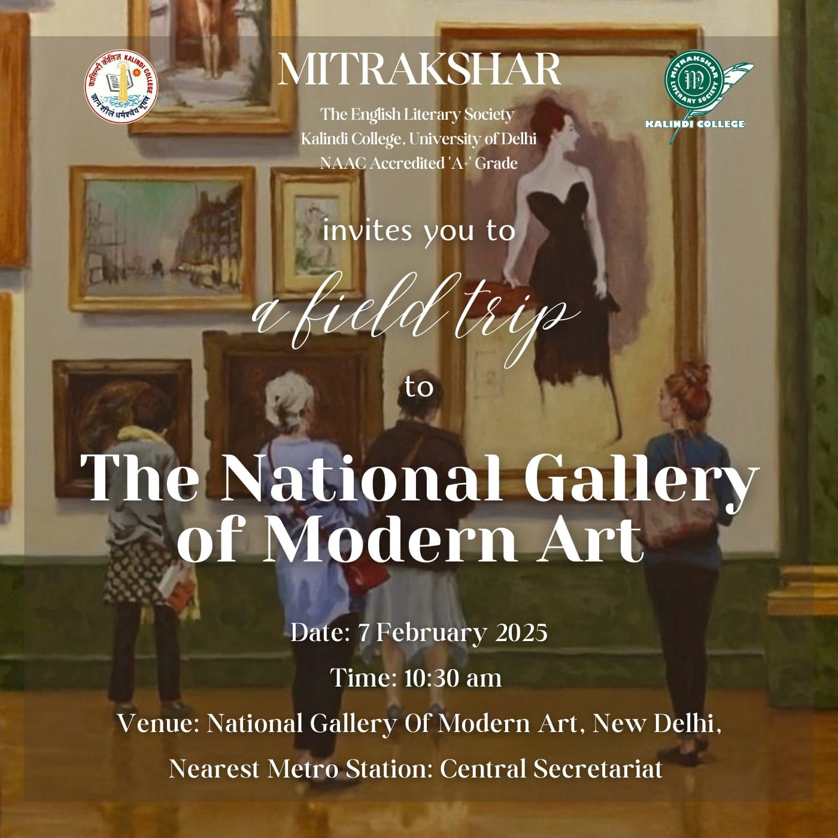

- Google Attendance Sheet of all the participants if online; and if offline, attendance sheet with signature of all the participants:
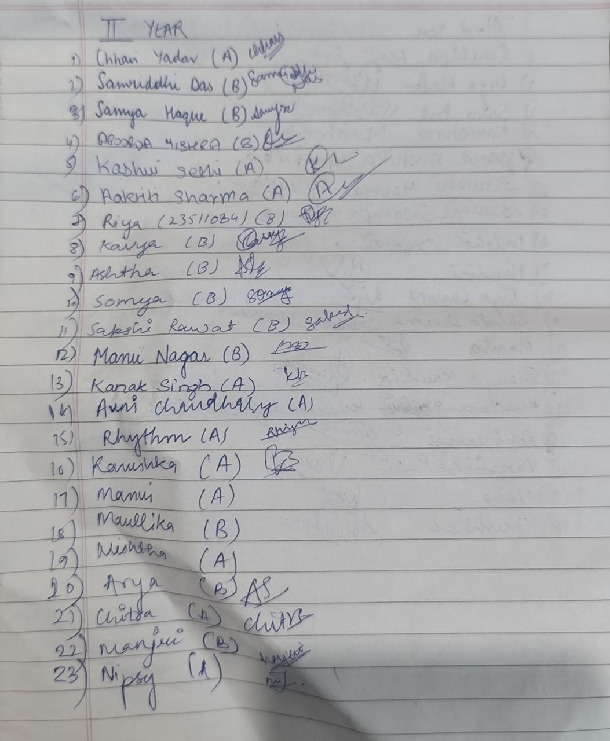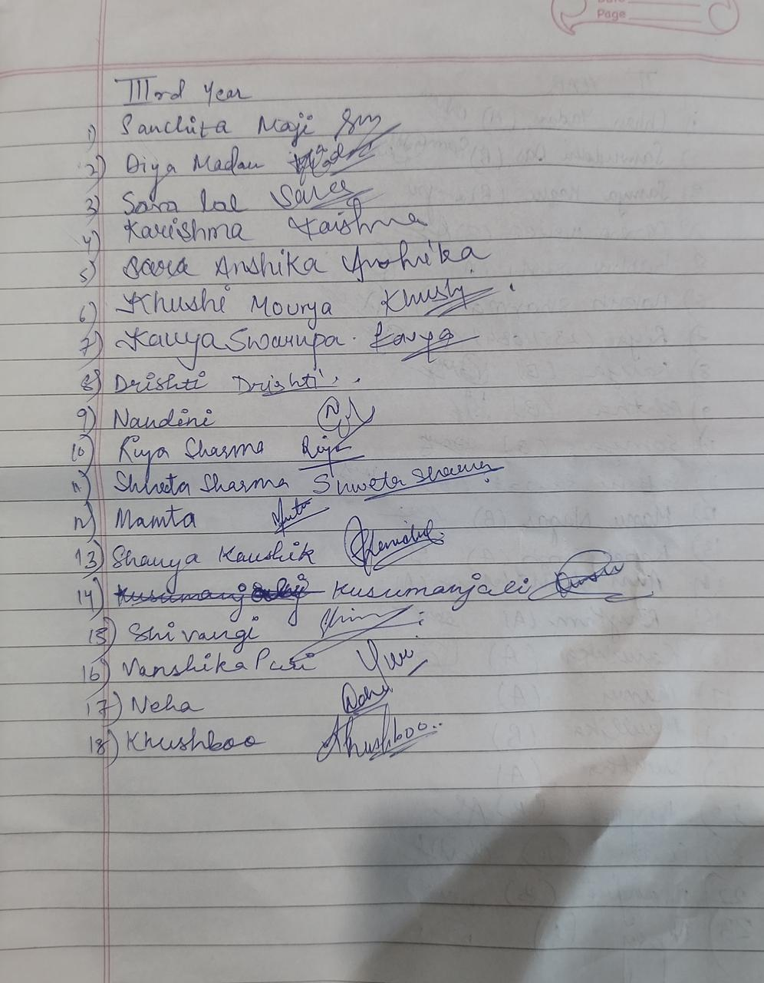

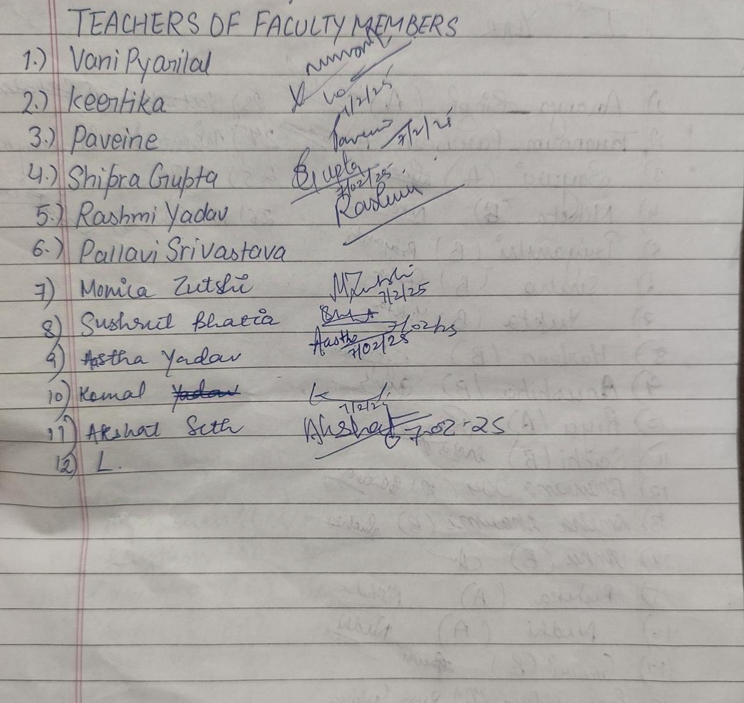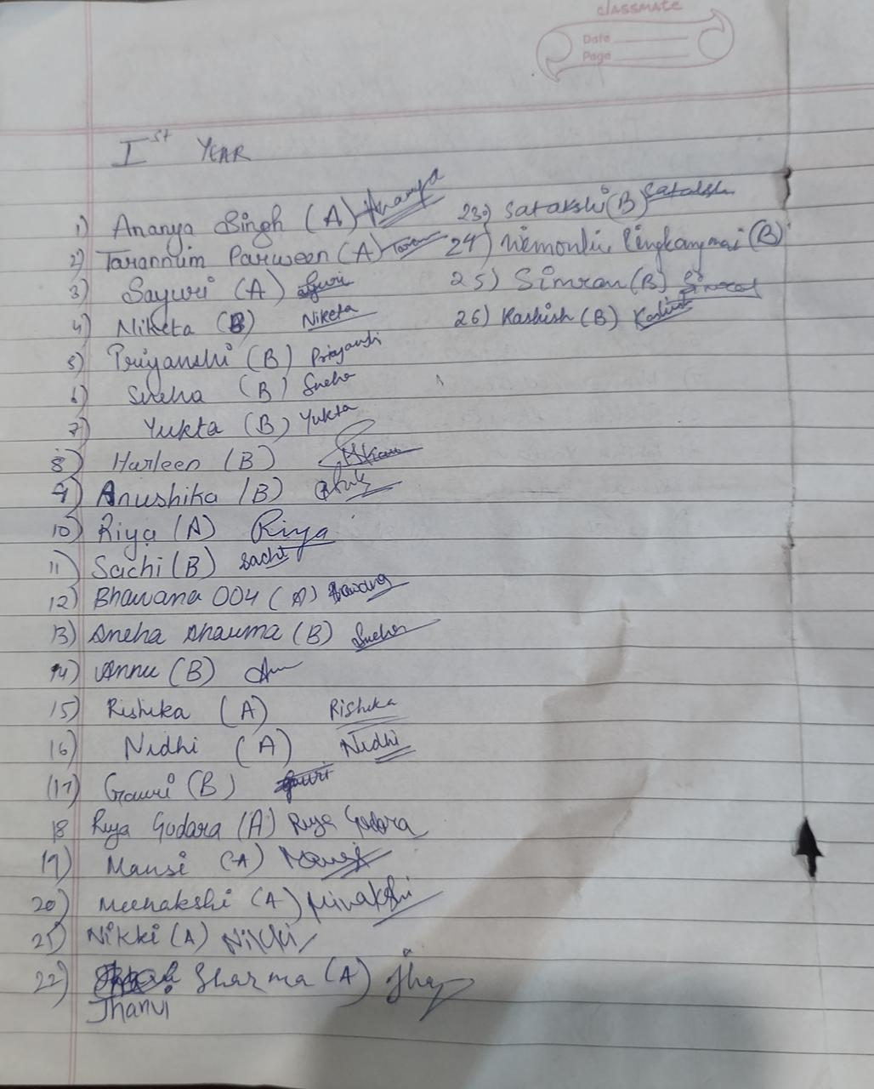

- Names of the Resource Person/s: -

- Detailed Report:

On 7 February 2025, Mitrakshar, the English Literary Society of Kalindi College, organized an educational field trip to the National Gallery and Museum of Arts. The objective of the visit was to enhance students’ understanding of the relationship between art, literature, and culture while providing an immersive experience beyond the classroom. The trip was met with enthusiastic participation, reflecting the students’ keen interest in exploring artistic expressions and their cultural significance.
Upon arrival at the National Gallery, students were welcomed by the museum staff, who provided an overview of the institution’s history and its role in preserving and promoting artistic heritage. The museum’s impressive architecture and serene atmosphere set the tone for an engaging and insightful experience.

The visit encompassed classical, modern, and contemporary artworks. Students were introduced to diverse artistic movements, including Mughal and Rajput miniature paintings, colonial-era portraits, and experimental contemporary works. The intricate detailing and symbolic representations in classical Indian paintings were of particular interest, as they reflected mythological and literary influences.

A key highlight of the tour was the modern and contemporary art section, where students engaged with artworks that challenged conventional artistic norms. This segment of the visit prompted discussions on the evolving nature of artistic expression and its intersection with literature and cultural identity.Students actively participated in discussions, drawing connections between visual and literary narratives.

The trip concluded with a reflective discussion among the participants. Many expressed their appreciation for the opportunity to engage with art in a direct and meaningful way. The experience reinforced the importance of interdisciplinary learning and deepened students’ appreciation for artistic and literary traditions.

Certificates of 10 participants: -
Geo tagged Photographs with captions:
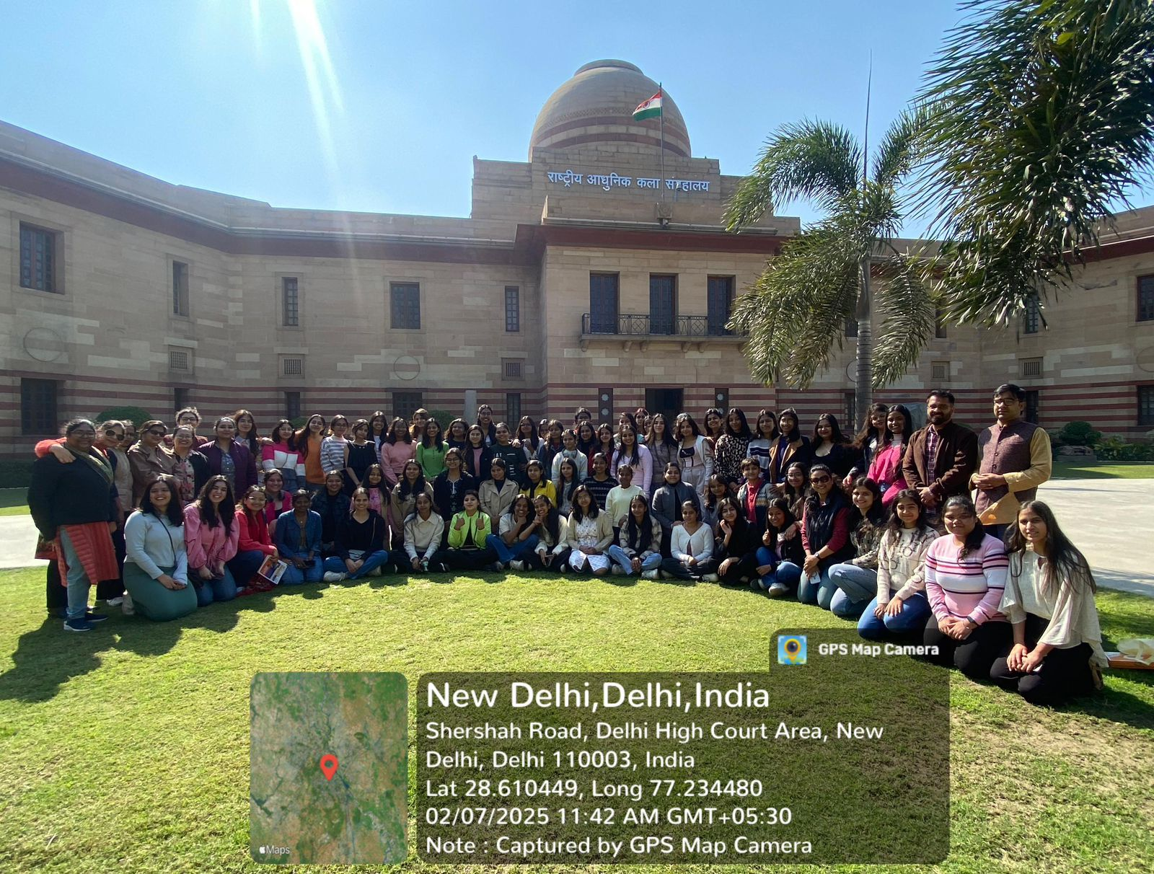*The English Department at NGMA
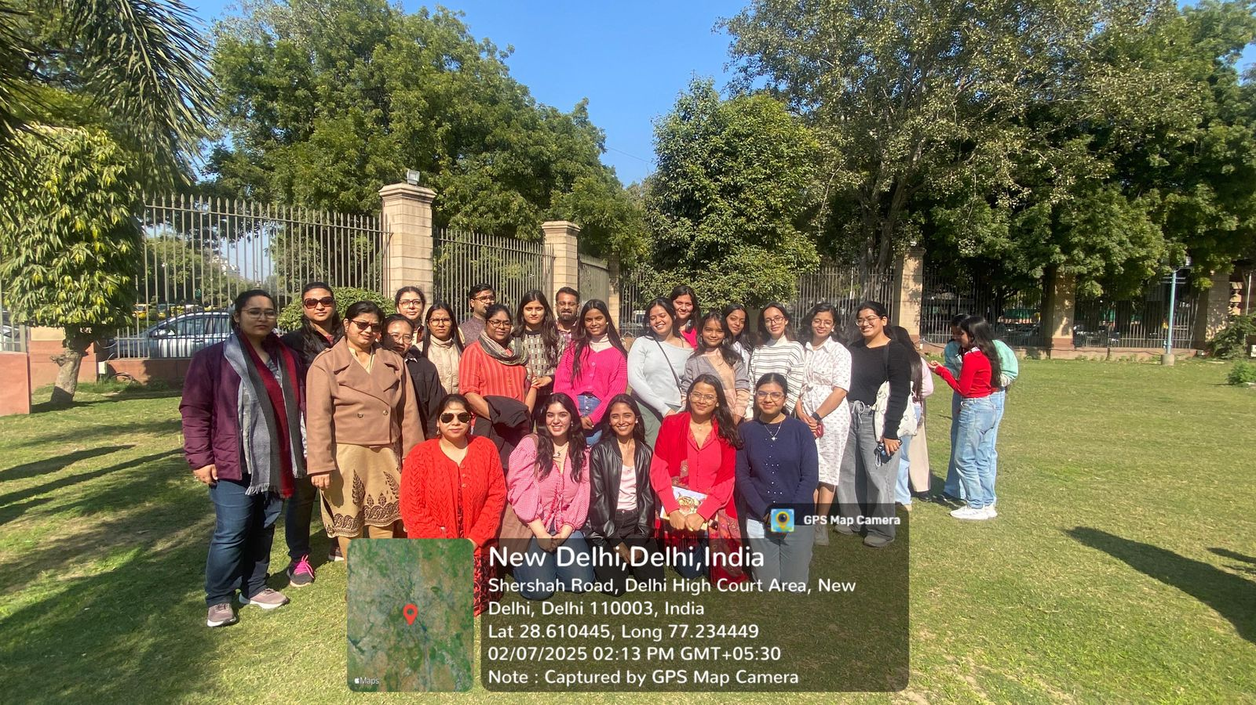* Team Mitrakshar at NGMA.
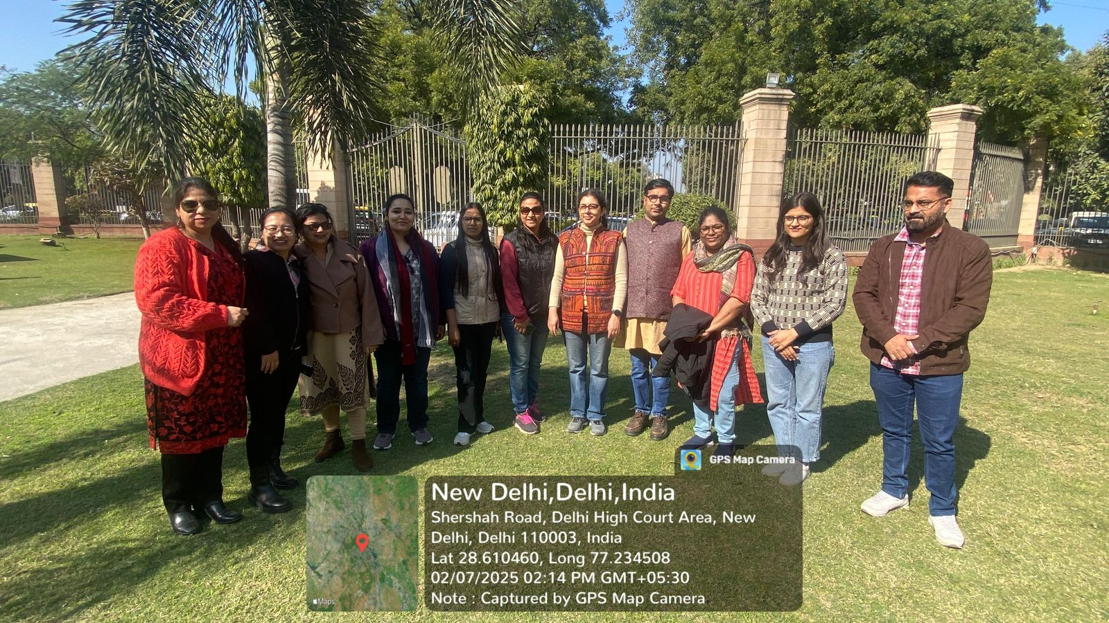* Faculty at NGMA.

Newspaper clip or photograph if published: -

Performa for Submission of Activities From TIC/ Convener/ Co-Convener
/Organizer /Coordinator/Nodal Officer Etc.

Department/Committee/Cell/Cultural Clubs, Others: Mitrakshar, the English Literary Society, University of Delhi
Name of the activity: ‘Rabindranath Tagore: Evolving Translations and Textual Transformations’
Funding Agency (Internal/External) and Amount: None
Name of the TIC/Convener/Coordinator/Nodal Officer/Other: Ms. Tanu Sharma (Convener) and Ms. Vani M Pyarilal (Co-convener)
Date/s (-to-) and time (-to-) of activity: 12 February 2025 and 10:30 to 12:30 pm
Collaborating agency if any: None
Number of students and teachers: 65
Number of participants outside Kalindi College: None

Proofs to be included

- Poster/Banner/Flyer/Circular/Brochure etc:
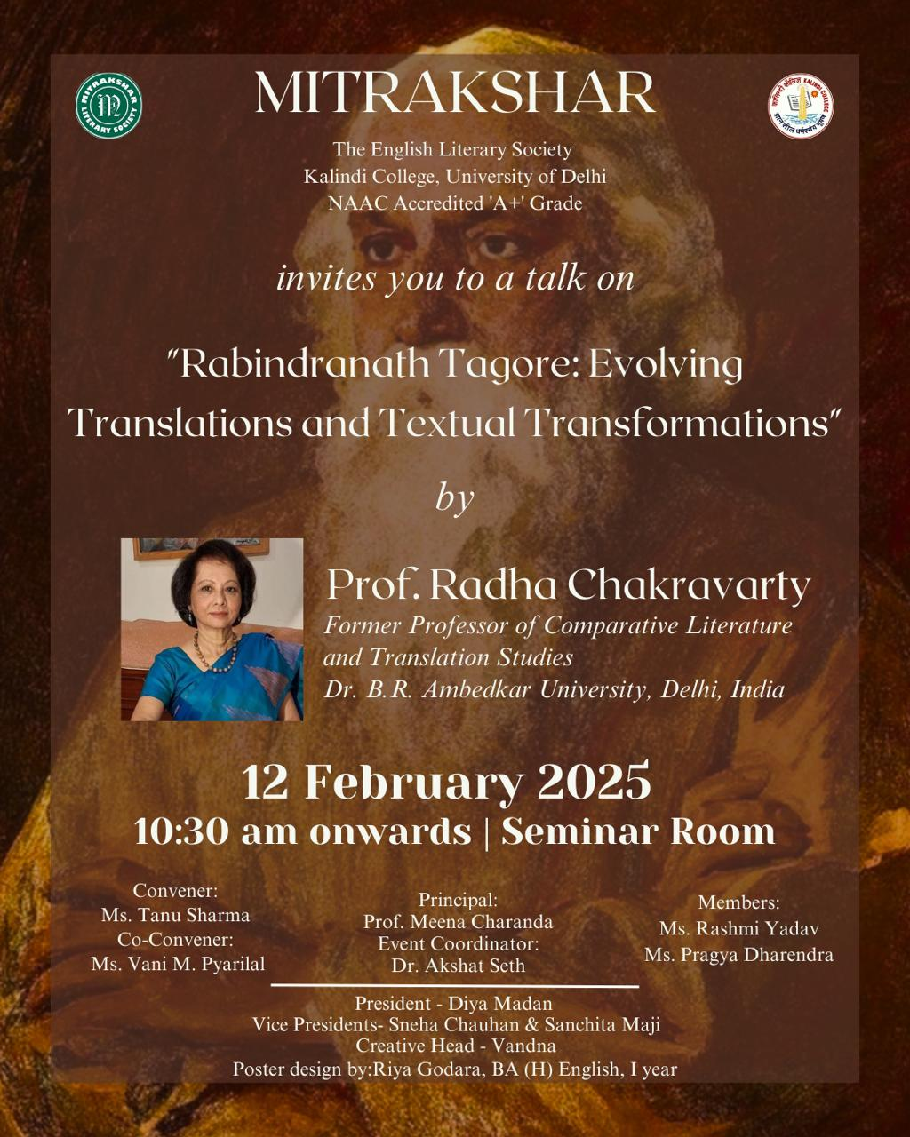

- Google Attendance Sheet of all the participants if online; and if offline, attendance sheet withsignature of all the participants:

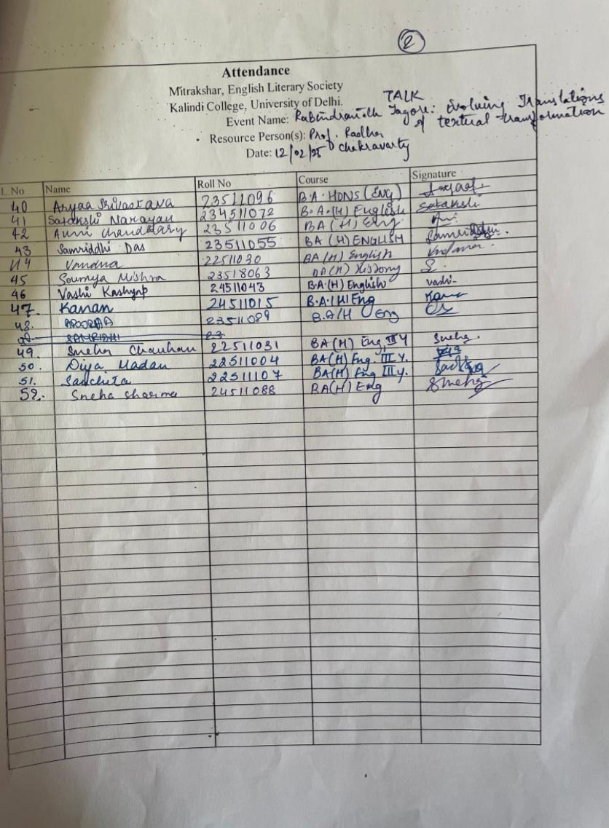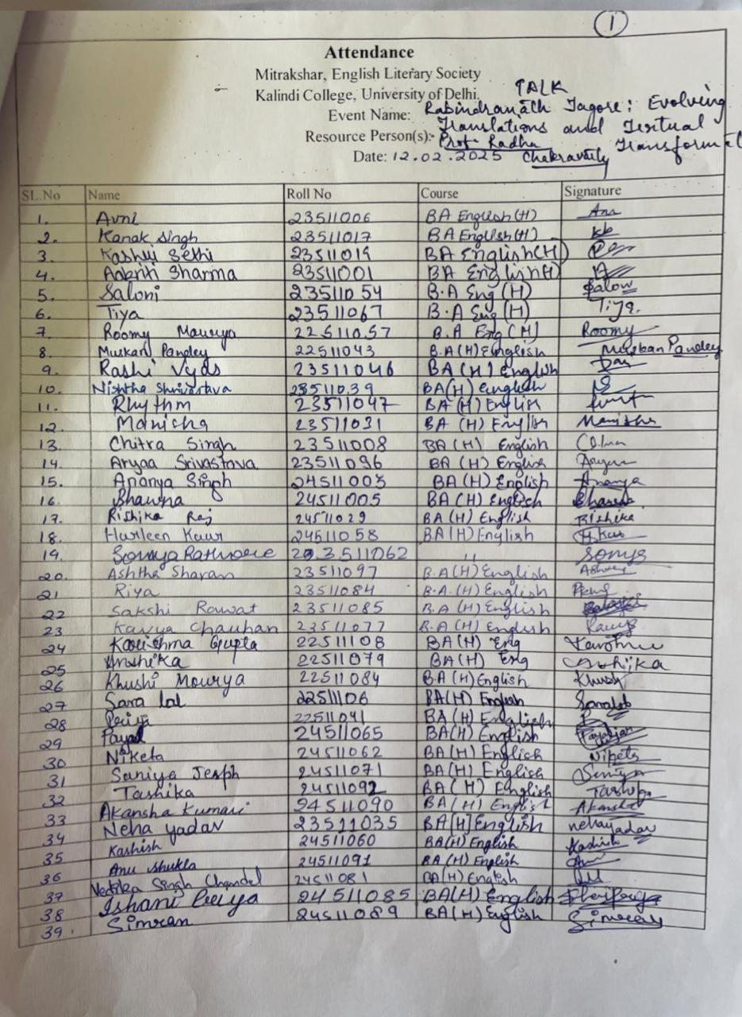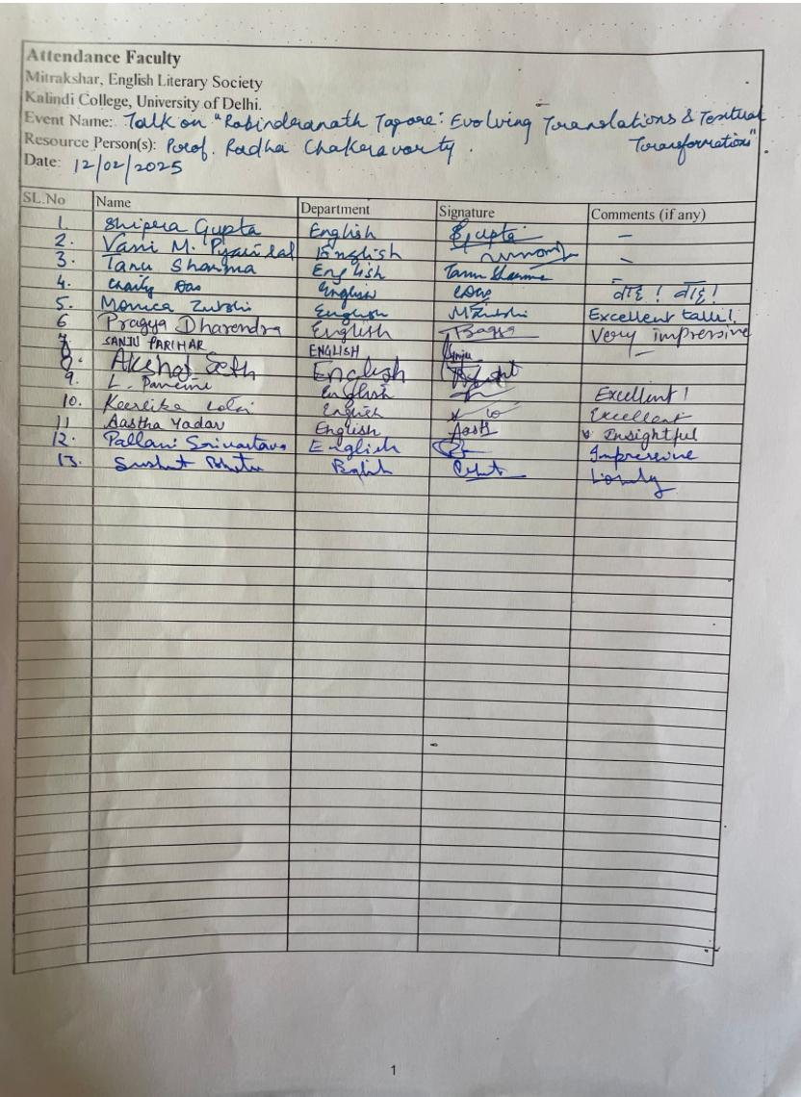

- Names of the Resource Person/s: Prof. Radha Chakravarty

- Detailed Report:
The English Literary Society of Kalindi College, Mitrakshar, hosted an engaging seminar on January 12, 2025, featuring Professor Radha Chakravarty, an eminent scholar and translator. The seminar, titled “Rabindranath Tagore Evolving: Translations and Textual Transformations,” explored the complexities of translating Tagore’s works, the transformations they underwent across languages and cultures, and the larger implications of these changes.

The event commenced with an introduction to Tagore’s engagement with translation, particularly his own role in translating Gitanjali into English, a work that led to him becoming the first non-European Nobel Laureate in Literature. Professor Chakravarty highlighted how Tagore did not merely translate his writings from Bengali to English but also engaged in translating works by figures like Guru Nanak. However, even as he translated, he remained deeply concerned about the inevitable gaps and losses that occur in the process. His anxiety regarding the accuracy of translations and the nuances that might be lost underscored his keen awareness of the delicate nature of linguistic and cultural transference.

One of the key points raised during the seminar was the idea that texts are not static but evolve with every translation. Each version, Professor Chakravarty noted, is a distinct entity rather than a mere reproduction of the original. This led to a discussion on how, for a long time, Vishva-Bharati held the authority to translate Tagore’s works, raising questions about control, authenticity, and ownership. She cited Mr. S. Mukherjee, who observed that the copyright on Tagore’s writings was not just a legal matter but a reflection of the fact that only certain interpretations were deemed admissible.

Professor Chakravarty then touched upon the critical reception of Tagore’s translations, particularly how some English writers, such as Edward Thompson, felt that his attempts to translate himself had dulled the distinctiveness of his Bengali voice in an effort to cater to a Western audience. Furthermore, when others took on the task of translating his works, their choices—sometimes poorly judged selections or diluted interpretations—further distanced his writing from its original depth and cultural specificity.

The discussion became particularly personal when Professor Chakravarty spoke about her own experiences translating Tagore. She recounted her first major translation, Chokher Bali (2003), and acknowledged the encouragement she received from her mentor and friend, Rani Ray. She spoke about the challenge of making Tagore accessible to contemporary readers and her subsequent work on The Essential Tagore (2011), co-edited with Fakrul Alam. She noted that one of their primary objectives was to push back against the idea that Tagore belonged solely to Bengal or Vishva-Bharati, arguing instead that he was, and should be, regarded as a South Asian writer whose influence extended beyond regional boundaries.

As the session progressed, Professor Chakravarty raised significant questions about the nature of translation itself. Who does a translation belong to—the author, the translator, or the reader? Should a translation domesticate the text for its new audience, or should it preserve the foreignness of the original? What liberties can a translator take, and how do market forces shape what gets translated and how? These questions, she suggested, do not have fixed answers but must be considered in the broader context of cultural exchange and literary reception.

Translation, she emphasized, is not simply a technical process but an act of interpretation. A translated text is not an echo of the original; it has its own existence, shaped by the translator’s perspective, the linguistic possibilities of the target language, and the expectations of its readership. Tagore himself understood this mutability, recognizing that a text must have a life beyond its source.

Towards the end of the seminar, Professor Chakravarty spoke about the role of the translator as a cultural mediator, a bridge between languages, histories, and identities. She cited Satya Mohanty, who questioned how we negotiate between personal and collective histories, and how translation allows us to find common ground rather than merely highlighting differences. She also pointed out the political dimensions of translation, particularly in postcolonial contexts, where using English—once a colonial language—can now serve as a means of reclaiming and reshaping narratives.

The seminar concluded with an engaging discussion, leaving the audience with much to reflect on. Professor Chakravarty’s insights reaffirmed that translation is not just about linguistic conversion but about carrying across meaning, context, and emotion. More than anything, it is an act of creative and intellectual engagement—one that allows literature to travel across time, space, and cultural boundaries.

- Certificates of 10 participants: -

- Geo tagged Photographs with captions:
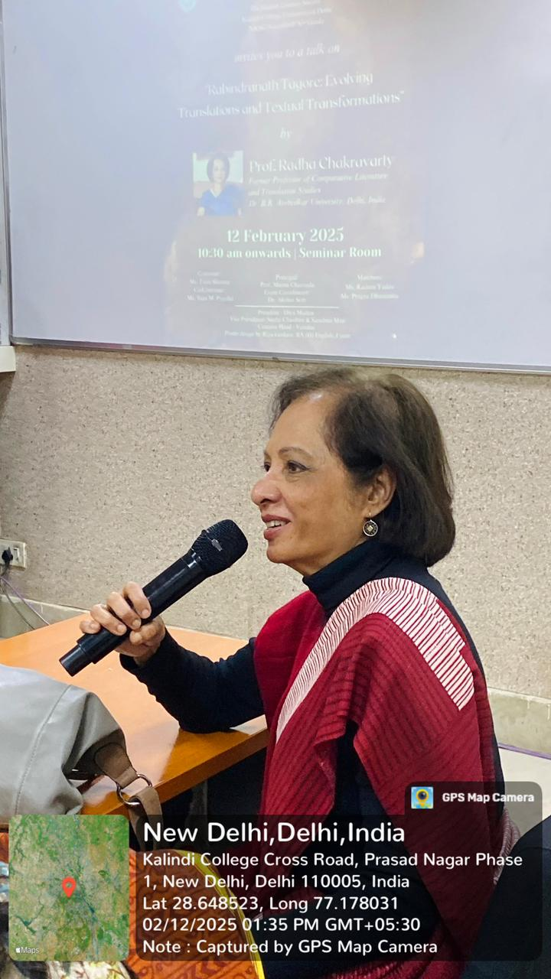 *Professor Radha Chakravarty engaging with the students.
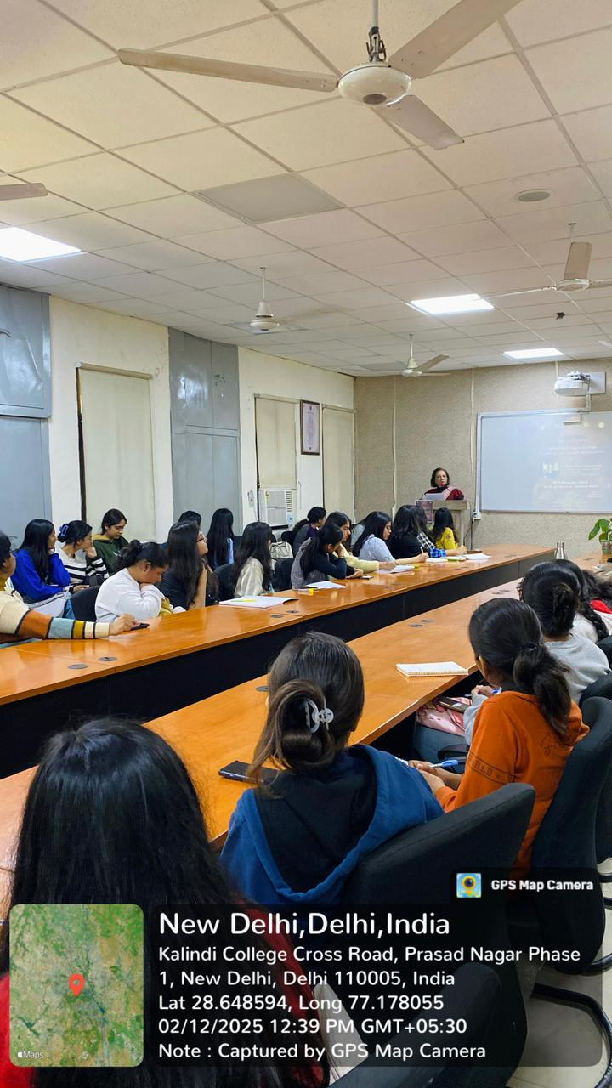 *Students attending the seminar.
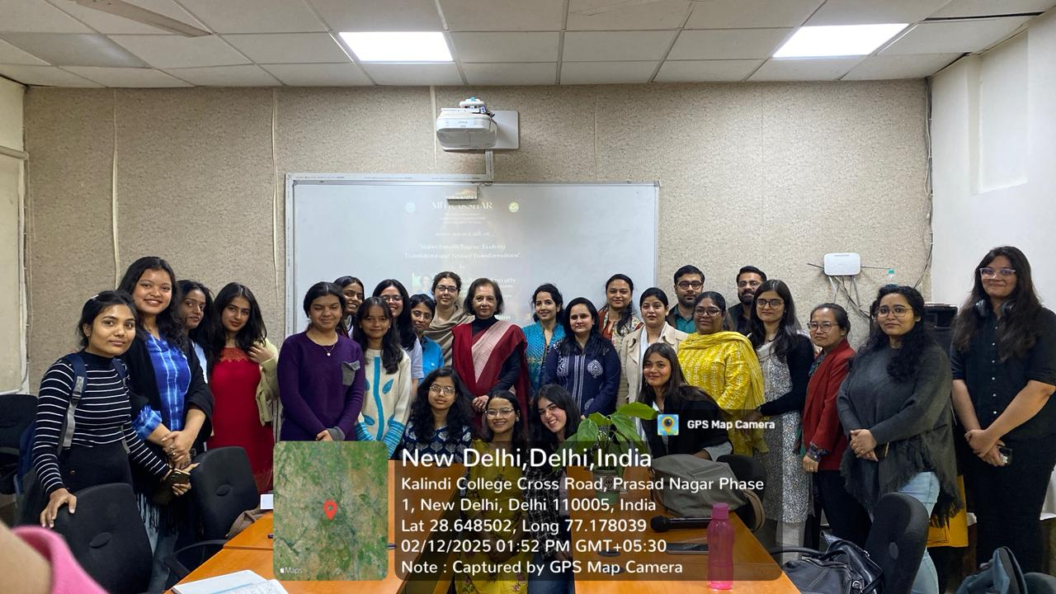 *Team Mitrakshar with the Keynote Speaker

Newspaper clip or photograph if published:

Performa for Submission of Activities From TIC/ Convener/ Co-Convener
/Organizer /Coordinator/Nodal Officer Etc.

Department/Committee/Cell/Cultural Clubs, Others: Mitrakshar, English Literary Society of Kalindi College, University of Delhi
Name of the activity: “Frames and Pages: Bridging Literature and Cinema through Realism” (Student Seminar
Funding Agency (Internal/External) and Amount: None
Name of the TIC/Convener/Coordinator/Nodal Officer/Other: Ms. Tanu Sharma (Convener), Ms. Vani M. Pyarilal (Co-convener)
Date/s (-to-) and time (-to-) of activity: 21 February 2025 and 9:00 am to 2:00 pm
Collaborating agency if any: None
Number of students and teachers: 20 students and 9 teachers
Number of participants outside Kalindi College: 8

- Proofs to be included

- Poster/Banner/Flyer/Circular/Brochure etc.:

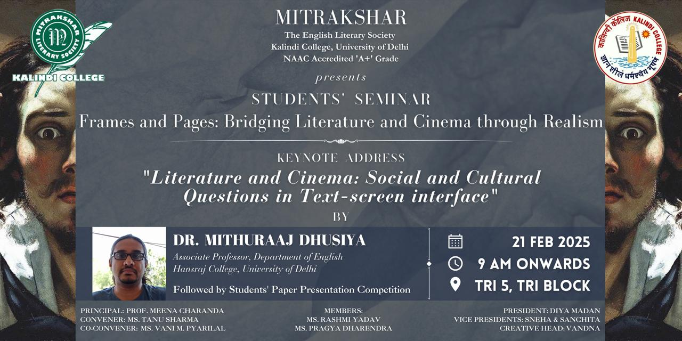

- Google Attendance Sheet of all the participants if online; and if offline, attendance sheet with signature of all the participants:

- Names of the Resource Person/s: Dr. Mithunraj Dhusiya

- Detailed Report:

Mitrakshar, the English Literary Society of Kalindi College, successfully organised its student seminar titled “Frames and Pages: Bridging Literature and Cinema through Realism” on 21st February 2025. Designed as a platform for undergraduate students across disciplines to present their research and reflections, the seminar sought to explore the intersections of literary realism and cinematic representation.
The event was graced by the esteemed presence of Dr. Mithuraaj Dhusiya, Assistant Professor, Department of English, Hansraj College, University of Delhi, who delivered the keynote address. Dr. Dhusiya’s insightful remarks set the tone for the day, offering a compelling framework to understand realism as both a literary and cinematic mode. His lecture, rich in examples and critical analysis, was a valuable contribution to the theme and was greatly appreciated by the audience.
Following the keynote, a series of student paper presentations took place, each engaging deeply with the seminar’s core theme. Participants explored a wide range of topics, from adaptations of realist texts in cinema, to the politics of representation in visual storytelling. The papers demonstrated a strong grasp of theoretical concepts and a creative application of literary and cinematic analysis.
The following participants were adjudged winners for their outstanding presentations:
🏅 First Prize – Sanchita Maji
🥈 Second Prize – Vama Suvani
🥉 Third Prize (shared) – Diya Madan and Sneha Chauhan
The seminar provided a space for dialogue, reflection, and critical inquiry—strengthening the culture of academic exchange within the Department of English. It also reaffirmed Mitrakshar’s commitment to fostering undergraduate research and interdisciplinary engagement.

- Certificates of 10 participants: -
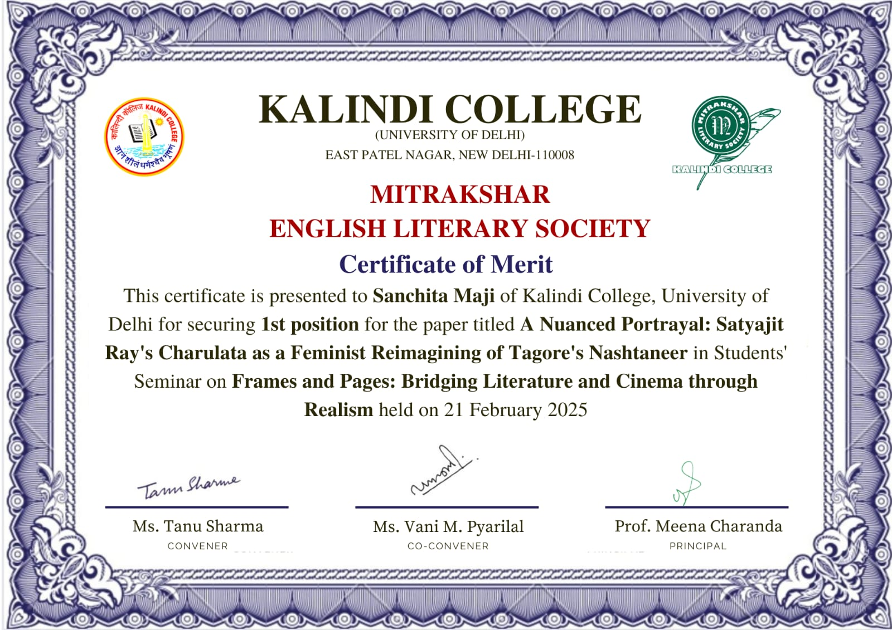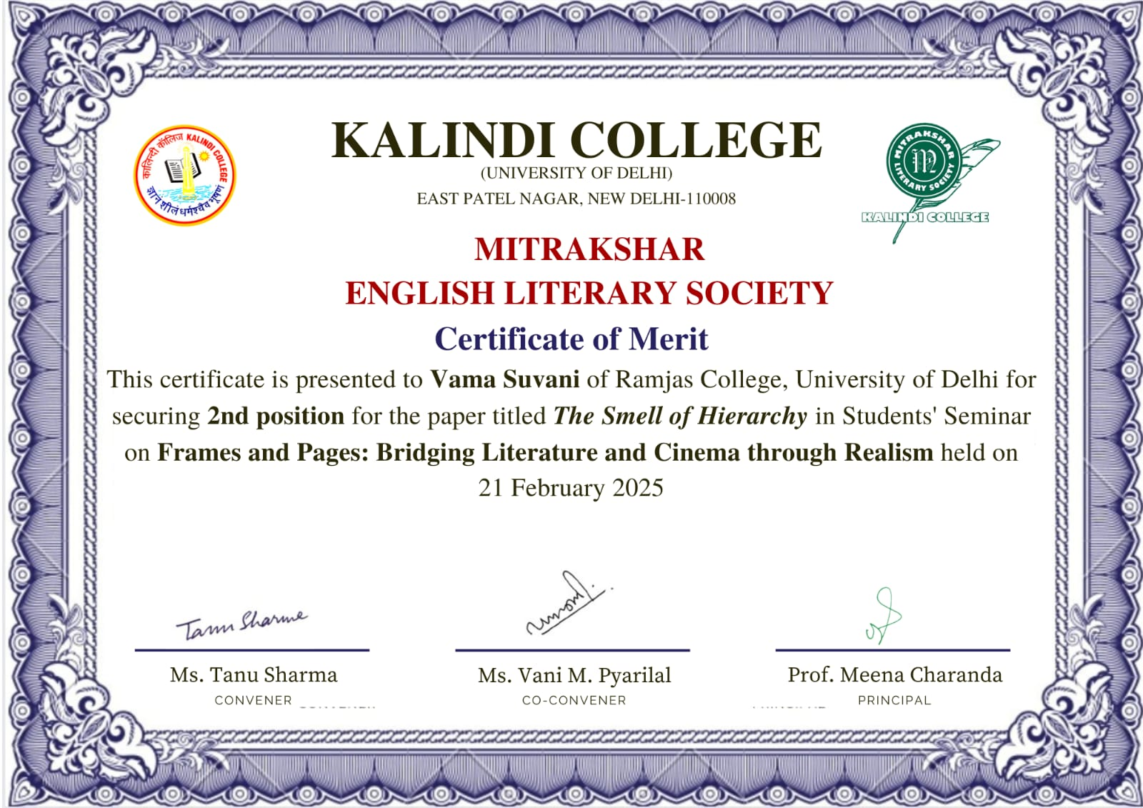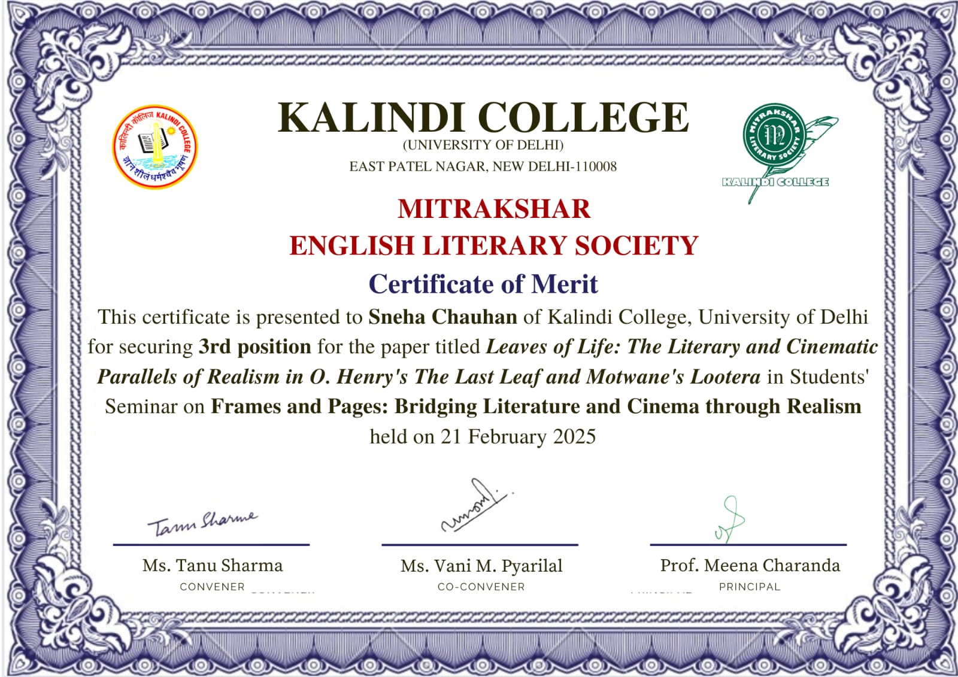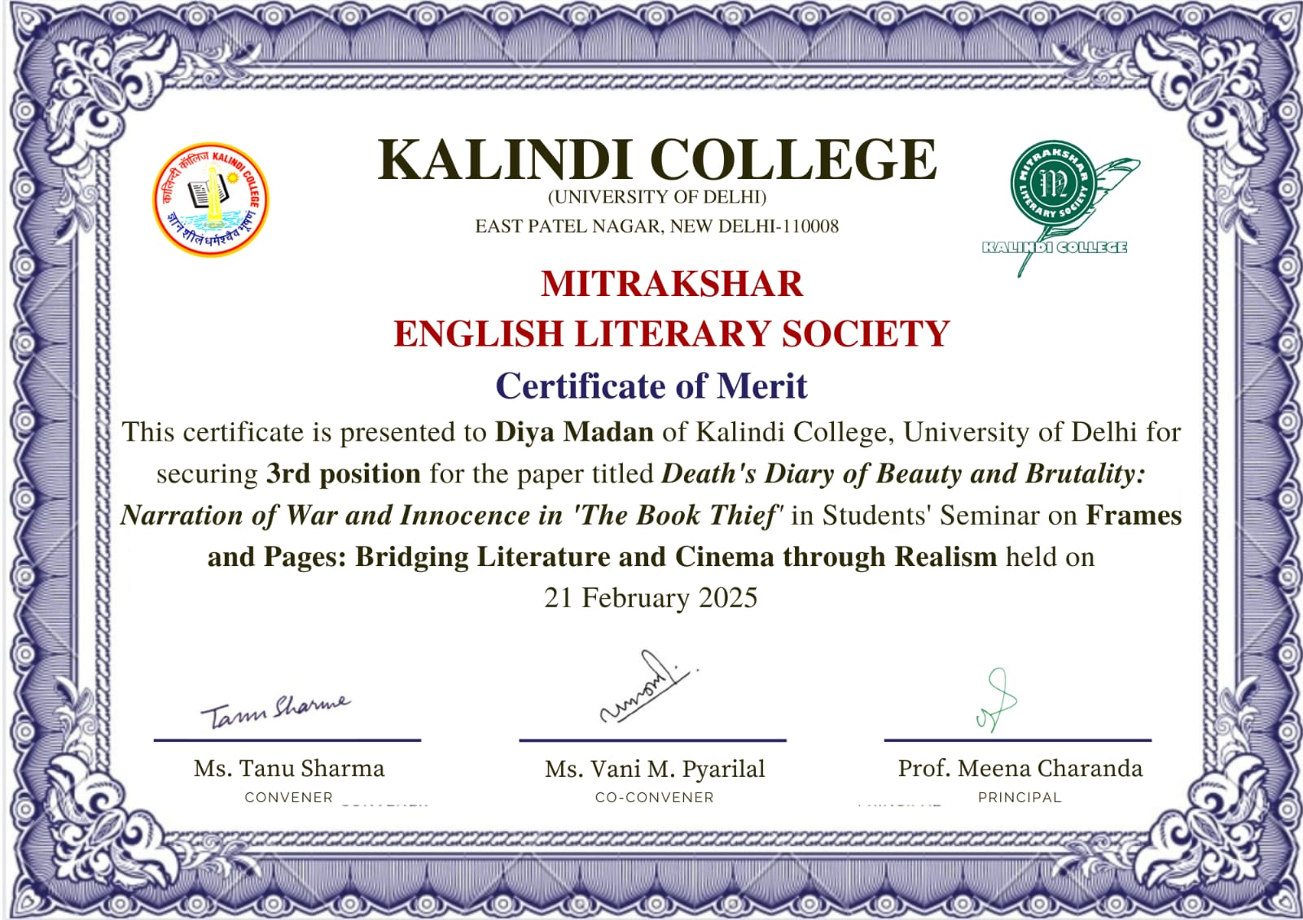
- Geo tagged Photographs with captions:

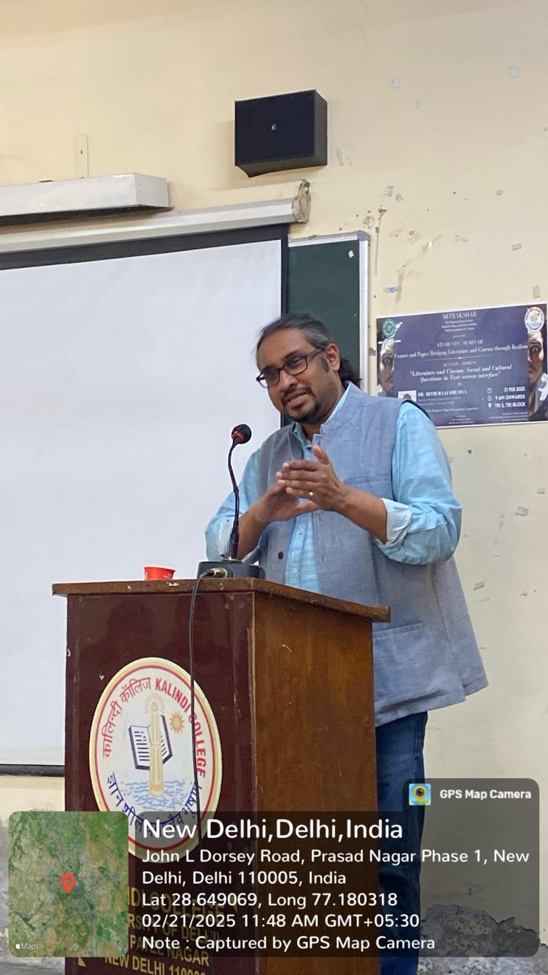 *Dr. Mithuraaj addressing the participants and attendees.
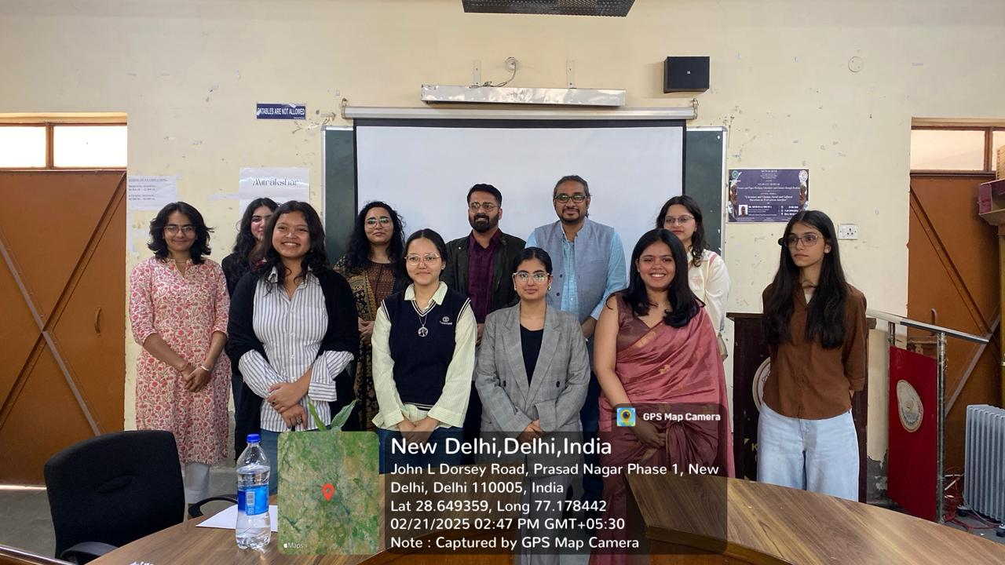 *Winners with Dr. Mithuraaj.
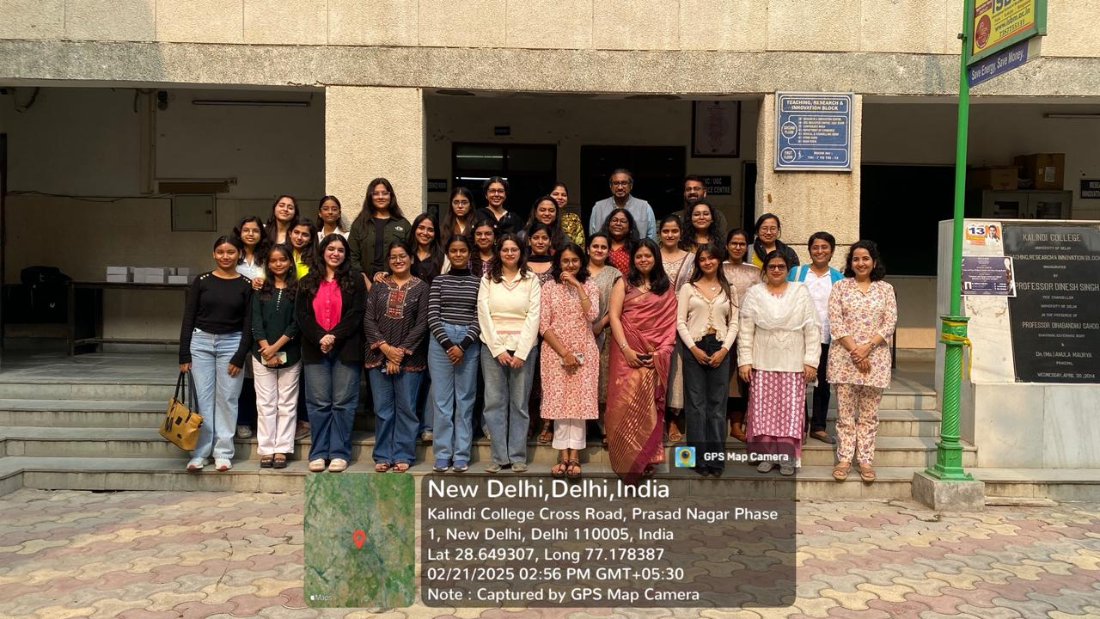 *Attendees, participants, and judges with Dr. Muthuraaj.

Newspaper clip or photograph if published: -

Performa for Submission of Activities From TIC/ Convener/ Co-Convener
/Organizer /Coordinator/Nodal Officer Etc.

Department/Committee/Cell/Cultural Clubs, Others: Mitrakshar, English Literary Society of Kalindi College, University of Delhi
Name of the activity: “From Inclusion to Transformation: Rethinking Disability in Education”
Funding Agency (Internal/External) and Amount: None
Name of the TIC/Convener/Coordinator/Nodal Officer/Other: Ms. Tanu Sharma (Convener), Ms. Vani M. Pyarilal (Co-convener)
Date/s (-to-) and time (-to-) of activity: 28 February 2025 and 10:30 am to 12:00 pm
Collaborating agency if any: None
Number of students and teachers: 29 students and 11 teachers
Number of participants outside Kalindi College: None

- Proofs to be included

- Poster/Banner/Flyer/Circular/Brochure etc.:
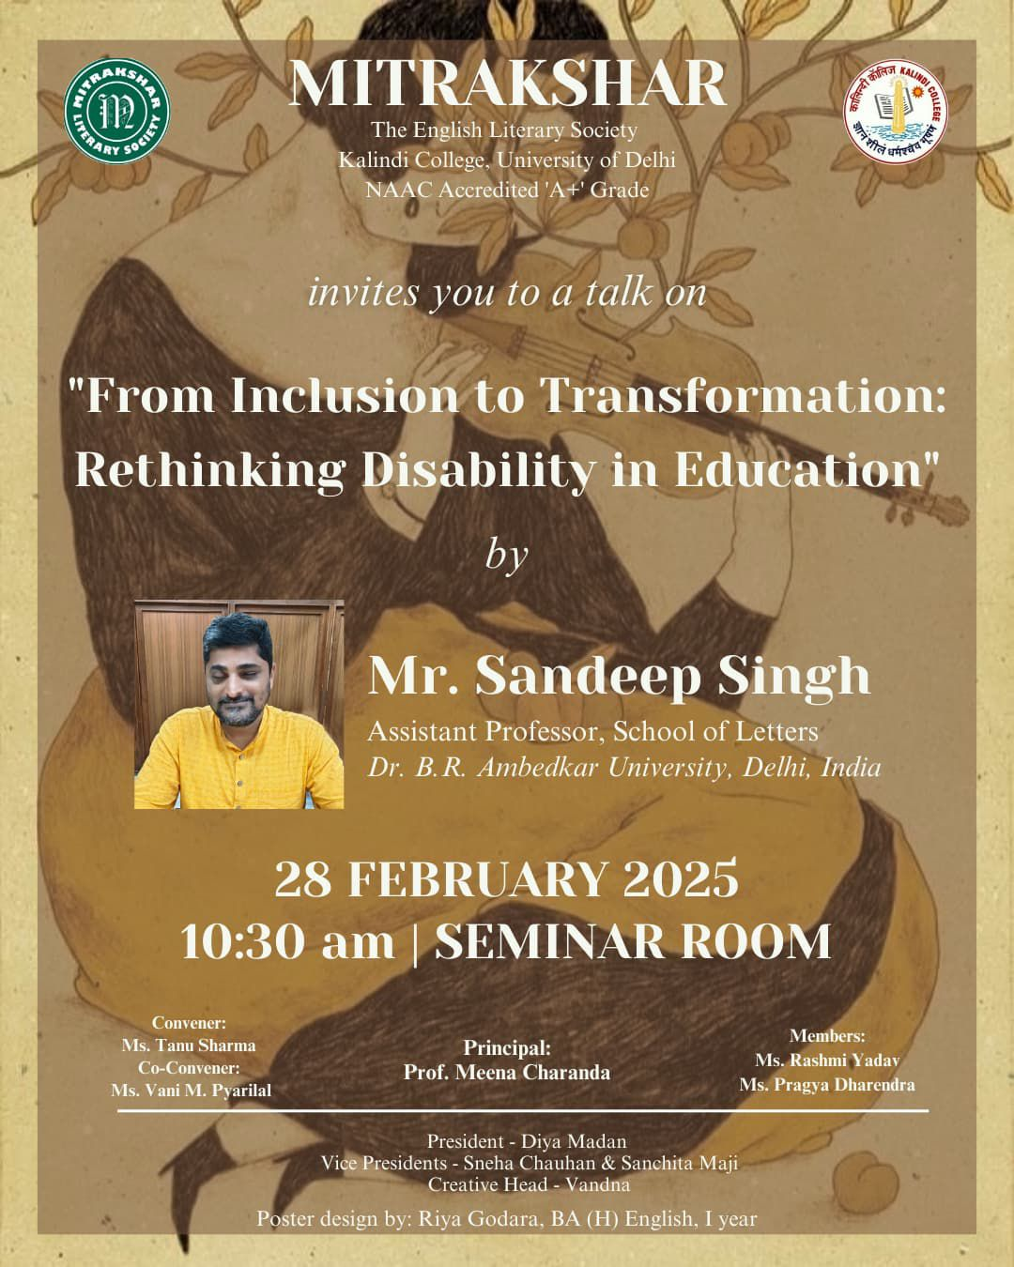

- Google Attendance Sheet of all the participants if online;
and if offline, attendance sheet withsignature of all the participants:

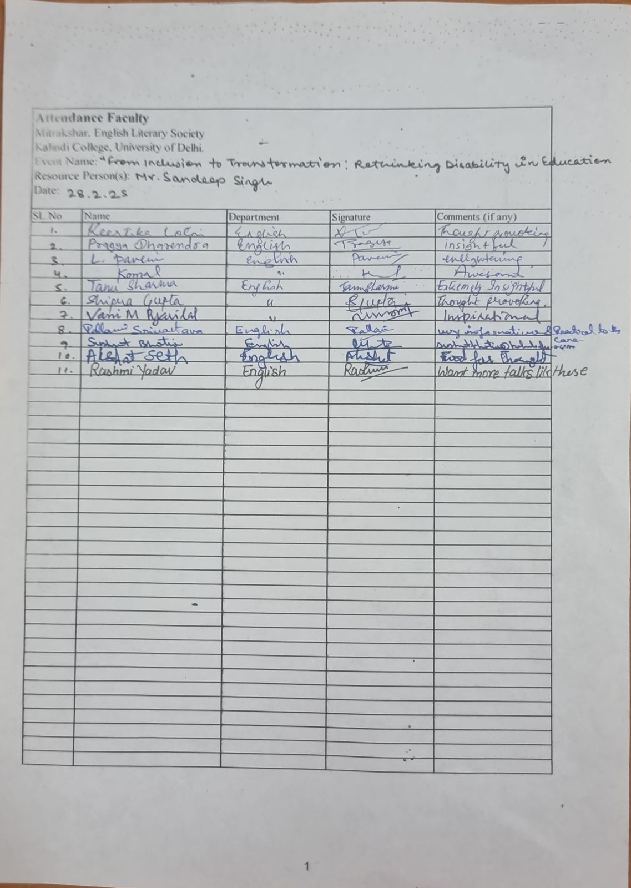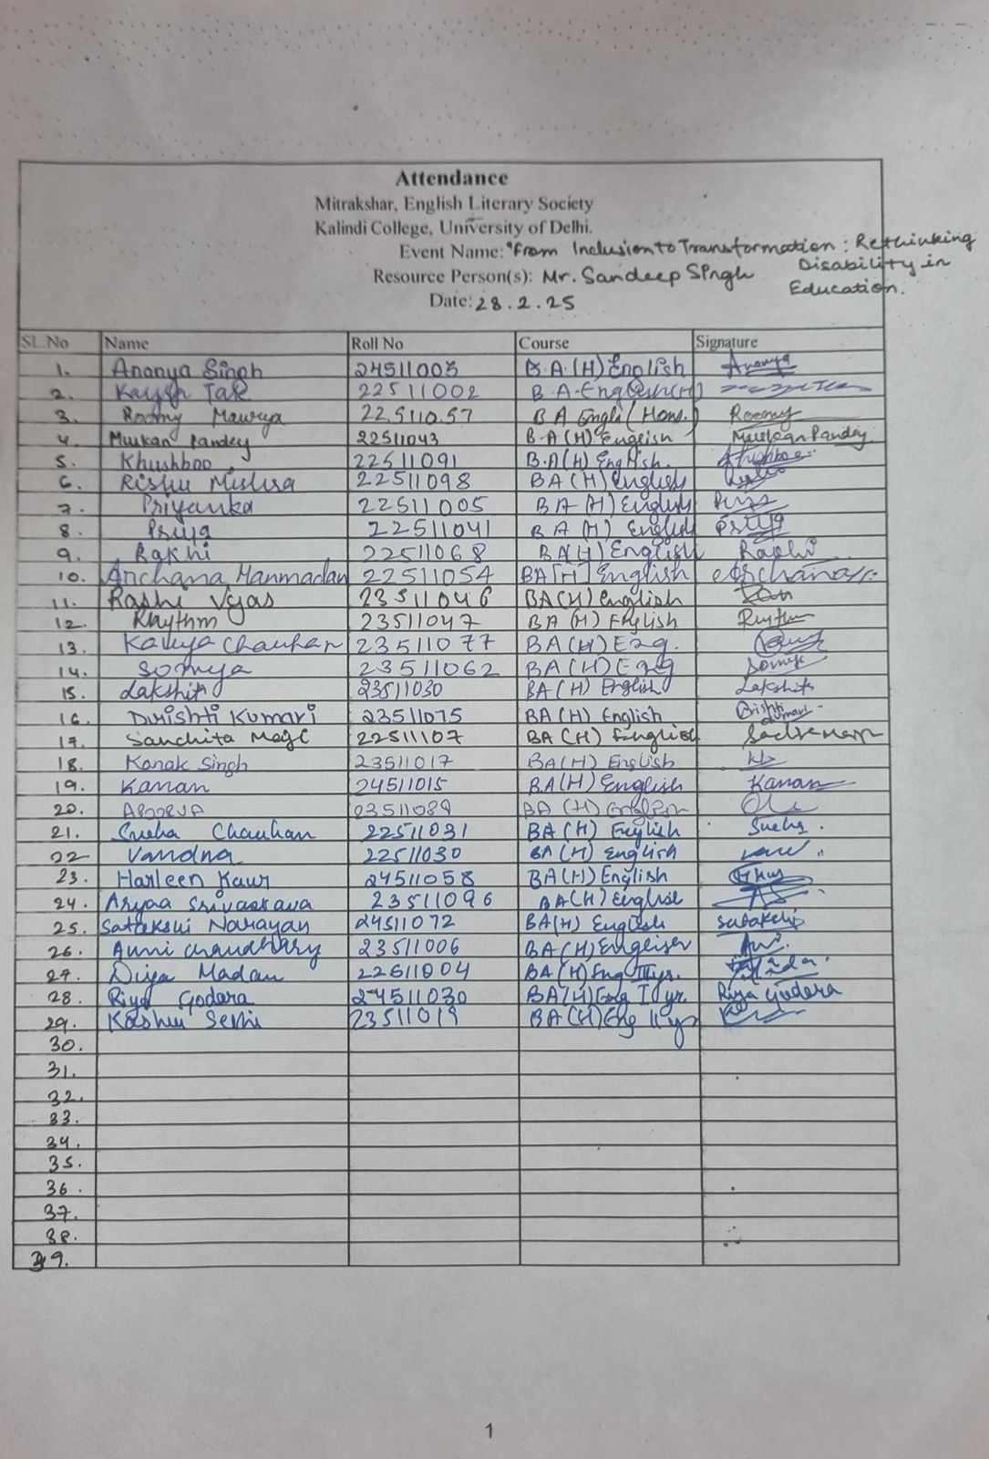

- Names of the Resource Person/s: Mr. Sandeep Singh

- Detailed Report:

Mitrakshar, the English Literary Society of Kalindi College, organised a thought-provoking guest talk on 28th February 2025, titled “From Inclusion to Transformation: Rethinking Disability in Education”. The session was conducted by Mr. Sandeep Singh, Assistant Professor at the School of Letters, Dr. B.R. Ambedkar University Delhi, and aimed to engage students and faculty alike in a critical discussion on the evolving discourse surrounding disability in educational spaces.
Mr. Singh’s lecture addressed the urgent need to move beyond the framework of mere inclusion, advocating instead for a transformative approach that redefines accessibility and empowerment in classrooms and institutional structures. Drawing upon his academic expertise and lived experiences, he offered fresh perspectives on rethinking pedagogical methods, curriculum design, and institutional attitudes that often overlook the complexities of disability.
The talk was particularly insightful in highlighting how inclusion, while necessary, can sometimes remain superficial unless accompanied by deeper structural change. Mr. Singh invited the audience to reflect on the roles of empathy, equity, and reform in creating learning environments that are not only accessible but meaningfully participatory.
The event was attended by students and faculty members of the Department of English, who actively engaged with the ideas presented and participated in a brief interactive session following the lecture. The conversation sparked a meaningful dialogue on the ethics of education and the importance of advocating for systemic change.
“From Inclusion to Transformation” marked a vital contribution to the society’s ongoing commitment to socially relevant dialogue and critical academic engagement.

- Certificates of 10 participants: -

- Geo tagged Photographs with captions:

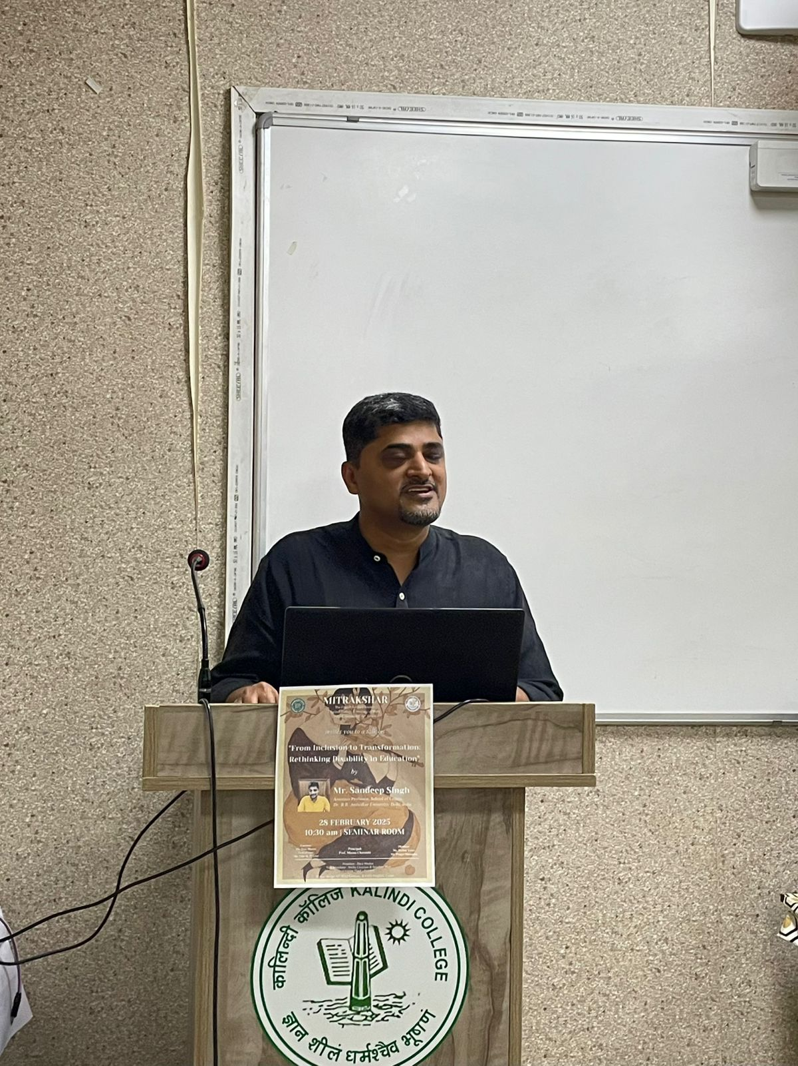 *Mr. Sandeep Singh addressing the seminar.

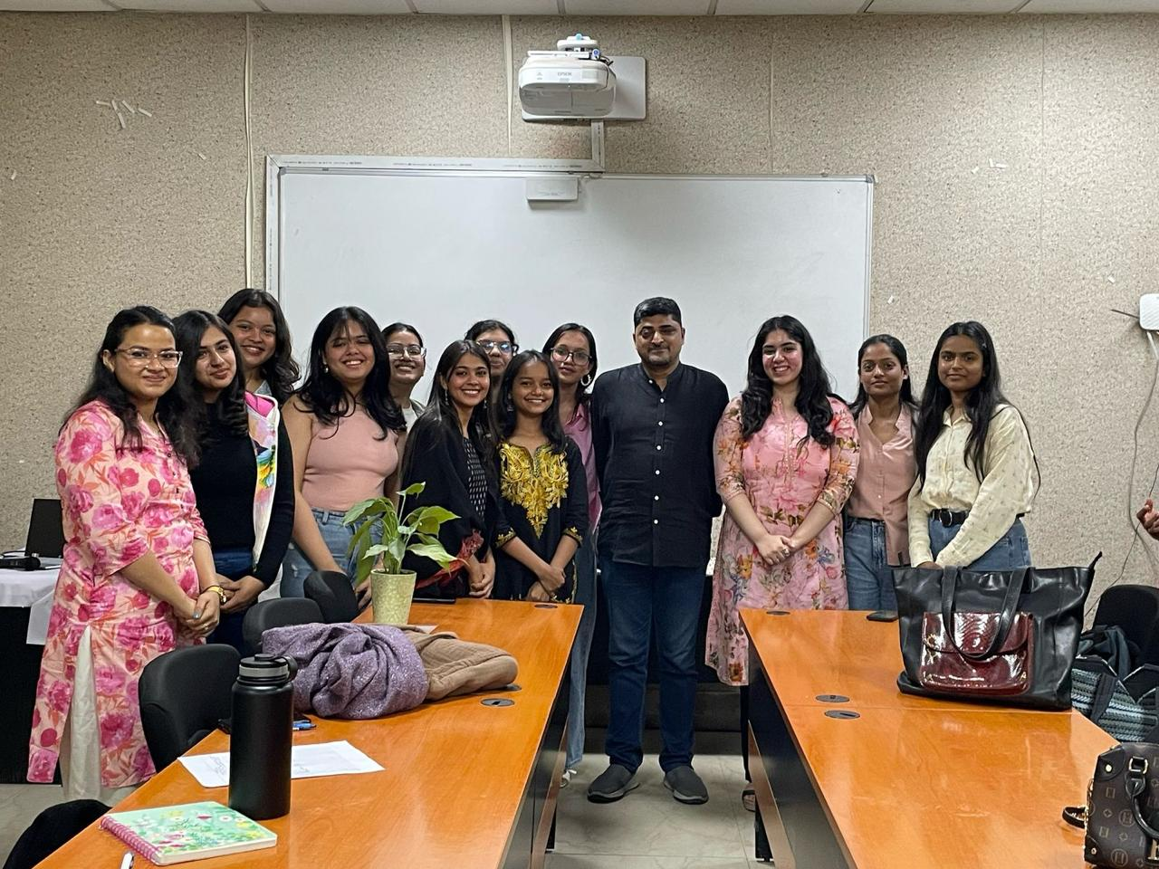 *Mr. Sandeep Singh and the Office Bearers.
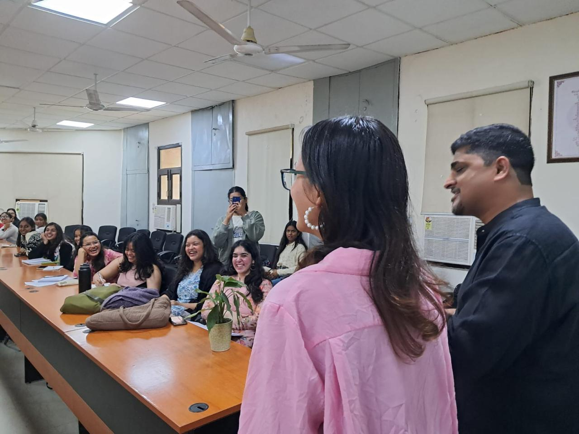 *Ongoing seminar.

Newspaper clip or photograph if published: -

Performa for Submission of Activities From TIC/ Convener/ Co-Convener
/Organizer /Coordinator/Nodal Officer Etc.

Department/Committee/Cell/Cultural Clubs, Others: Mitrakshar, English Literary Society of Kalindi College, University of Delhi
Name of the activity: A Field Trip to Shankar’s International Doll Museum
Funding Agency (Internal/External) and Amount: None
Name of the TIC/Convener/Coordinator/Nodal Officer/Other: Ms. Tanu Sharma (Convener), Ms. Vani M. Pyarilal (Co-convener)
Date/s (-to-) and time (-to-) of activity: 25 March 2025 and 10:30 am to 01:00 pm
Collaborating agency if any: None
Number of students and teachers: 24 students
Number of participants outside Kalindi College: None

- Proofs to be included

- Poster/Banner/Flyer/Circular/Brochure etc.:

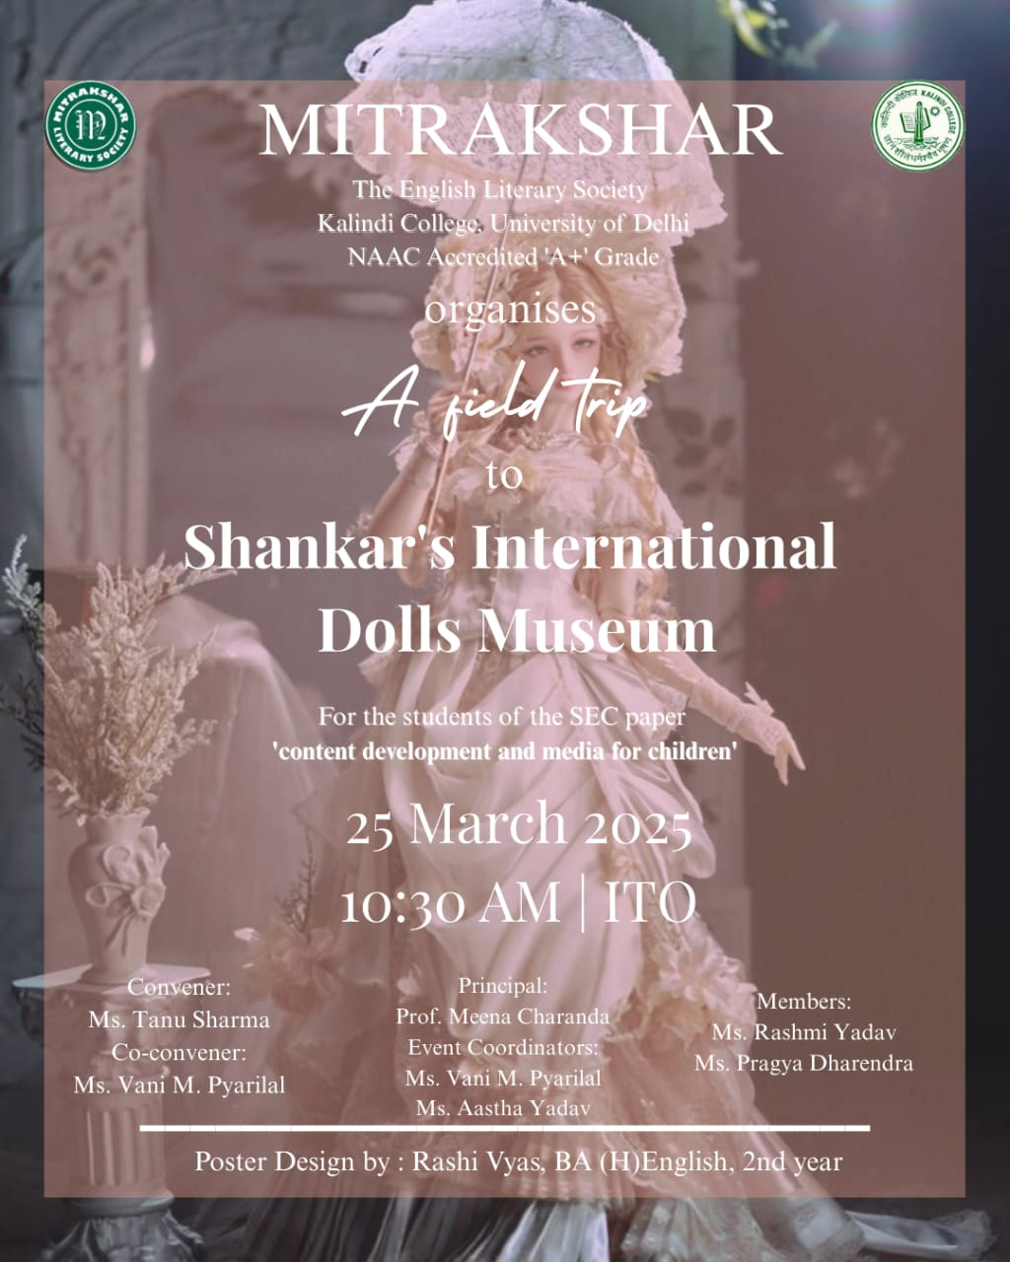

- Google Attendance Sheet of all the participants if online;
and if offline, attendance sheet withsignature of all the participants:

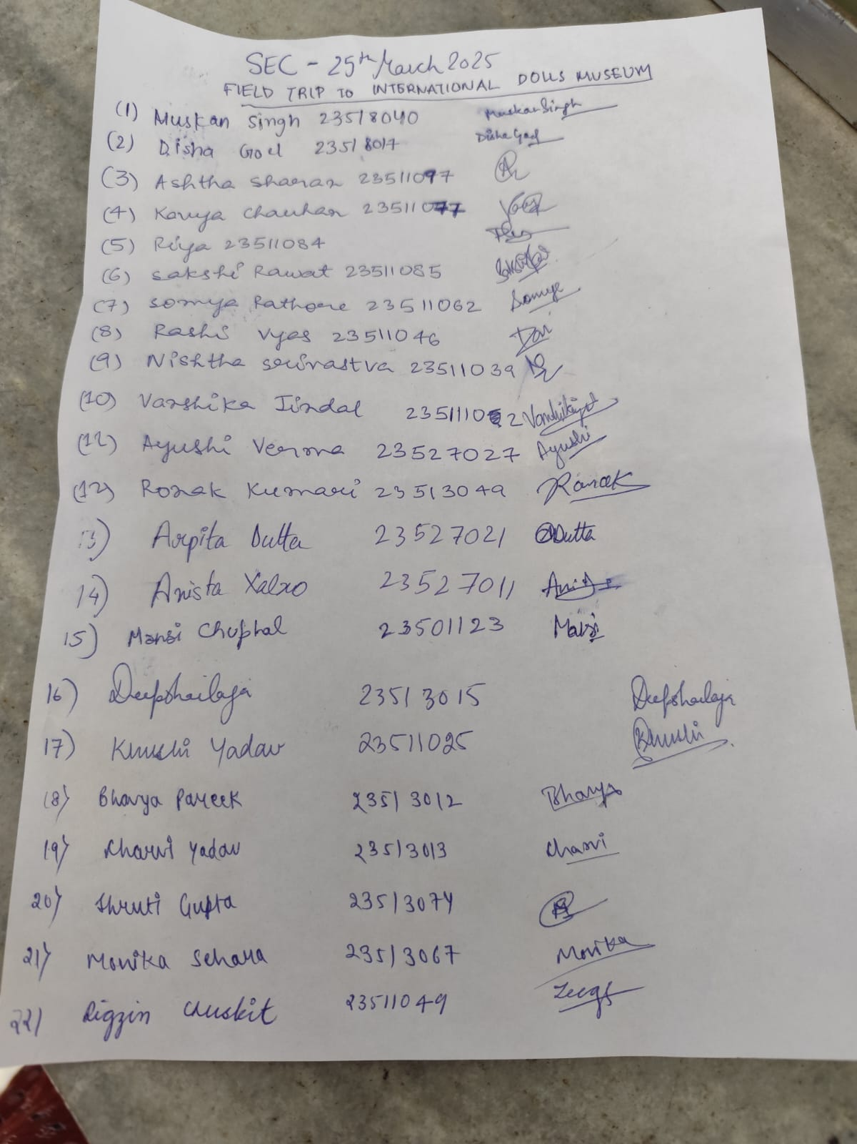

- Names of the Resource Person/s:

- Detailed Report:
On the 25th of March, 2025, Mitrakshar, the English Literary Society of Kalindi College, organised a field trip to Shankar’s International Doll Museum for the 4th semester students. The visit allowed the students to further their awareness of the global richness of a multitude of cultures; The purpose of the trip was to provide the students with an experience that would help them develop a better understanding of the intricate details that set the attire of the dolls, and their respective cultures apart from each other. Not only was it a valuable learning experience, but it was also an outing that helped the students bond and explore with each other the beauty of the exhibits from around 85 countries.

At present, the museum, founded in 1965 by Shankar Pillai, the political cartoonist, is home to around 7000 dolls, each created with utmost perfection by its craftsmen. The museum, divided into two sections: One, which has exhibits from places like Europe, New Zealand, Australia, the U.S., and the Commonwealth of Independent States; the Second, which has exhibits from Asian countries, including an Indian section which serves as a testimony to the unique and diverse cultures of various states.

Concluding the visit with a few group photographs, followed by a brief discussion where the students shared their individual experiences, the outing became a memorable one for the teachers and students alike.

- Certificates of 10 participants: -

- Geo tagged Photographs with captions: 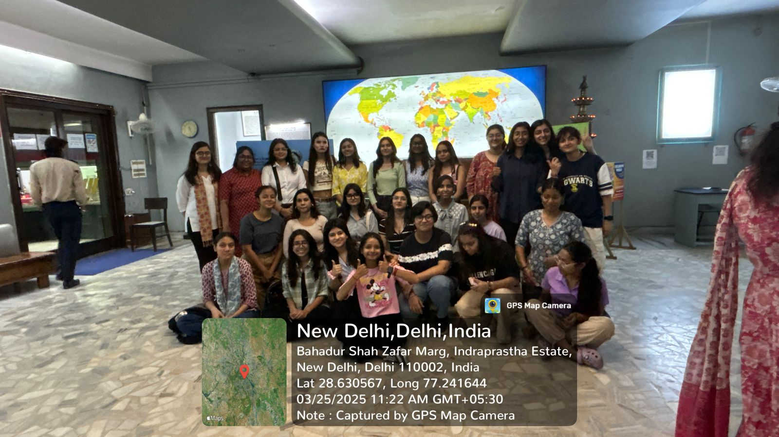 *Students at the museum.

Newspaper clip or photograph if published: -

Performa for Submission of Activities From TIC/ Convener/ Co-Convener
/Organizer /Coordinator/Nodal Officer Etc.

Department/Committee/Cell/Cultural Clubs, Others: Mitrakshar, English Literary Society of Kalindi College, University of Delhi
Name of the activity: Chrysalis’ 25
Funding Agency (Internal/External) and Amount:
Name of the TIC/Convener/Coordinator/Nodal Officer/Other: Ms. Tanu Sharma (Convener), Ms. Vani M. Pyarilal (Co-convener)
Date/s (-to-) and time (-to-) of activity: 8 April 2025 and 11:00 am to 4:00 pm
Collaborating agency if any: Zubaan Books
Number of students and teachers:
Number of participants outside Kalindi College:

- Proofs to be included

- Poster/Banner/Flyer/Circular/Brochure etc.:

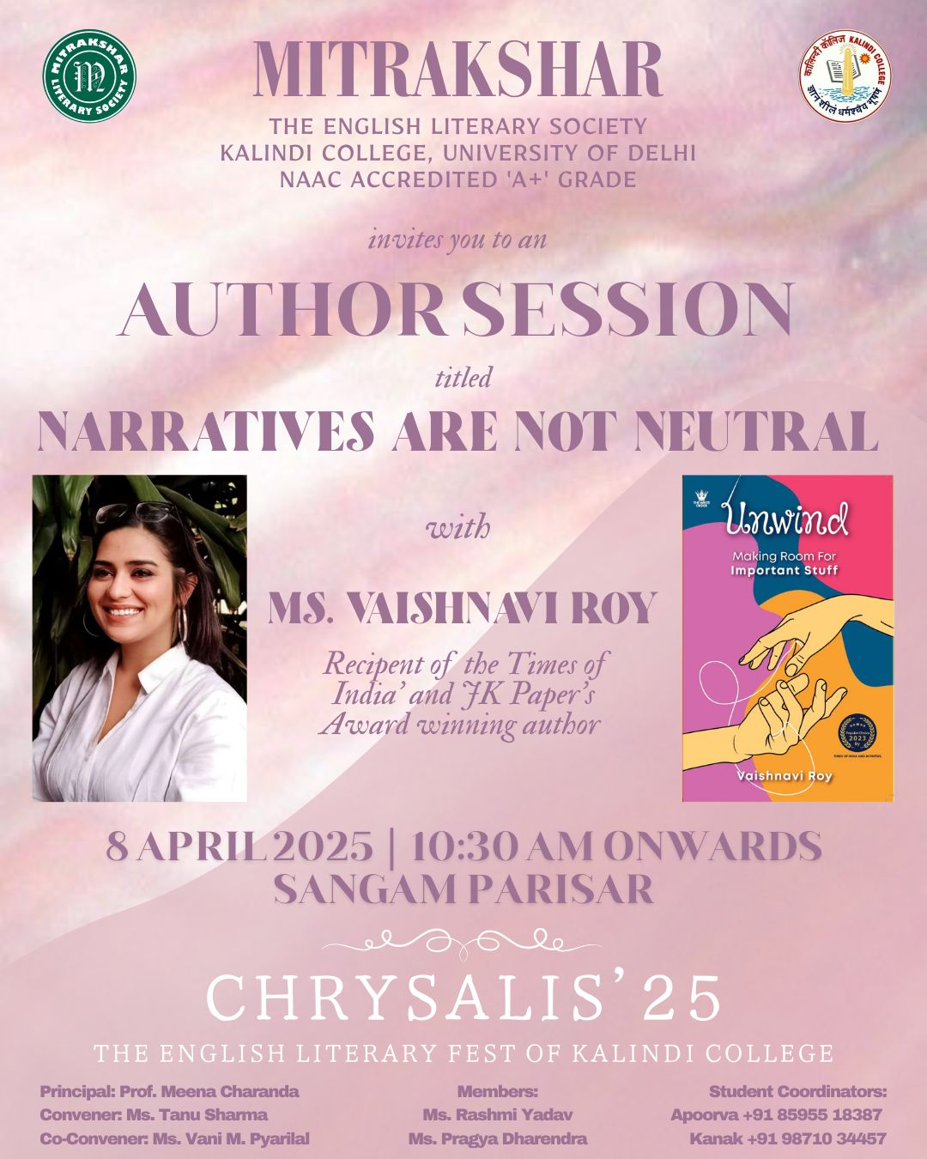
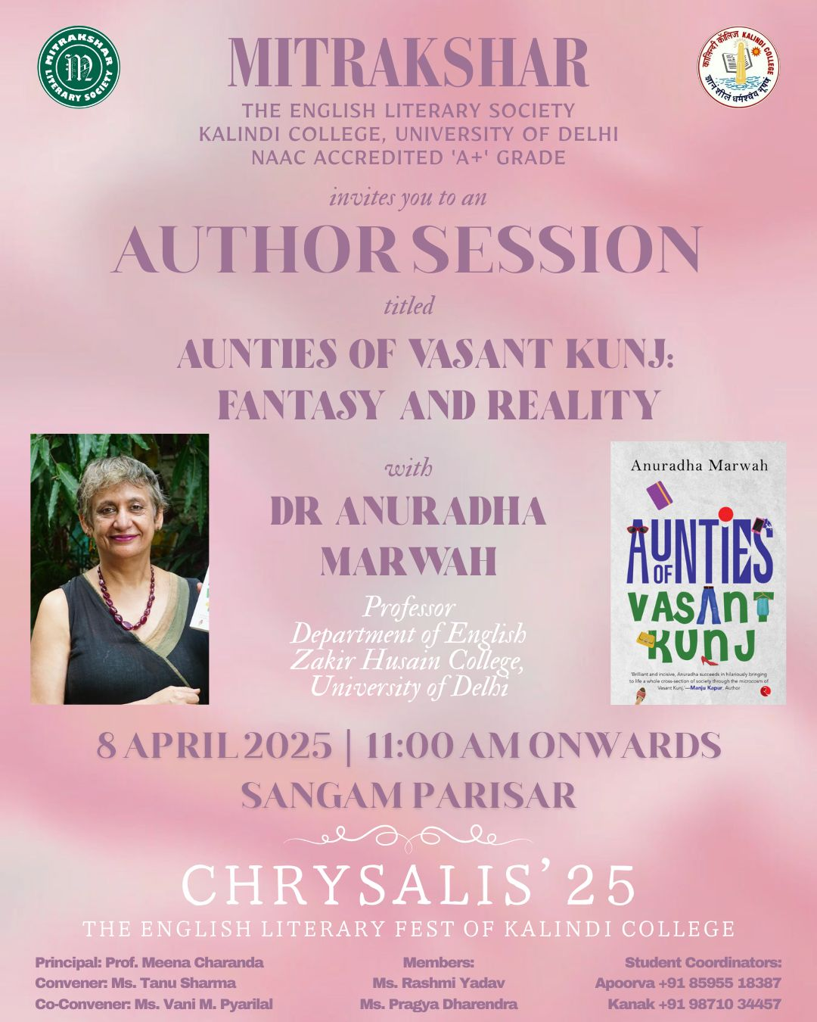
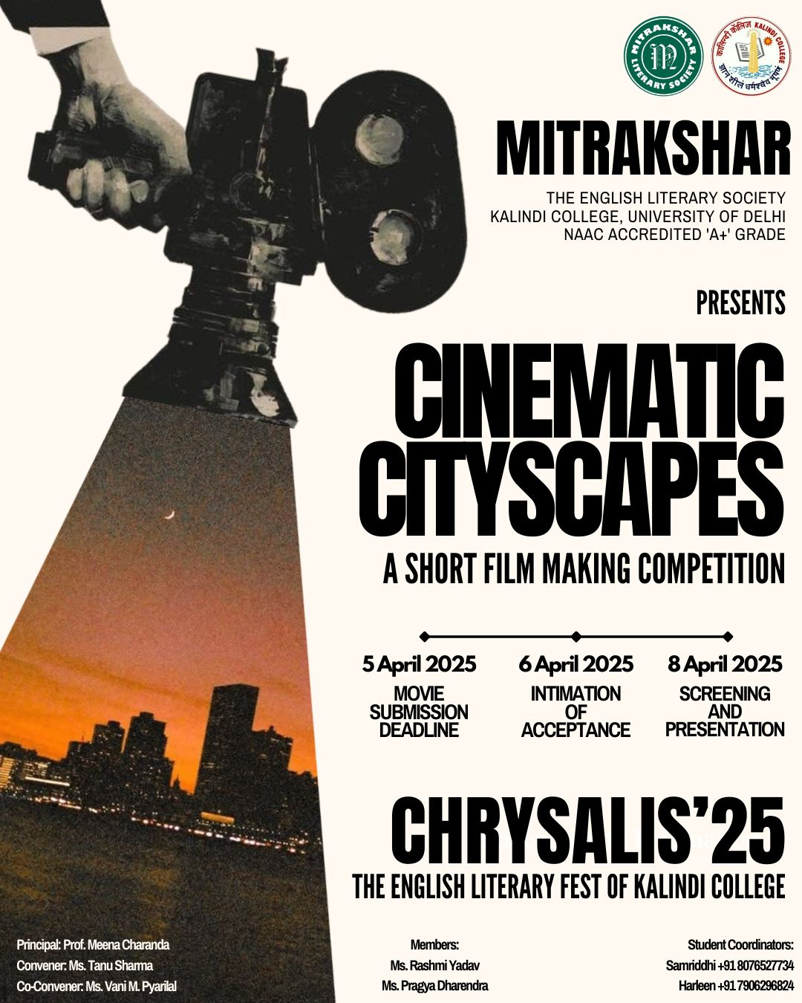
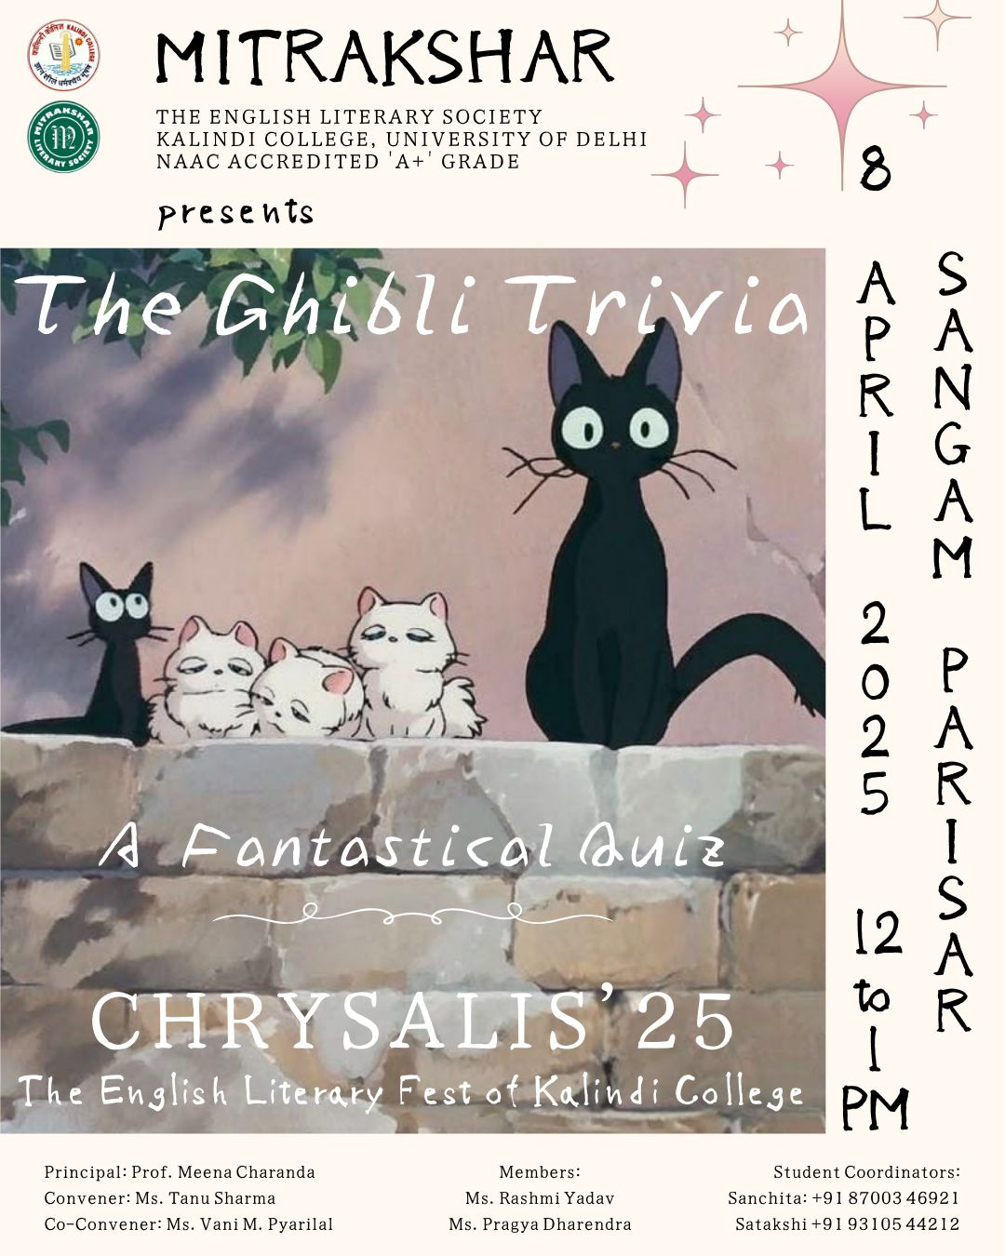
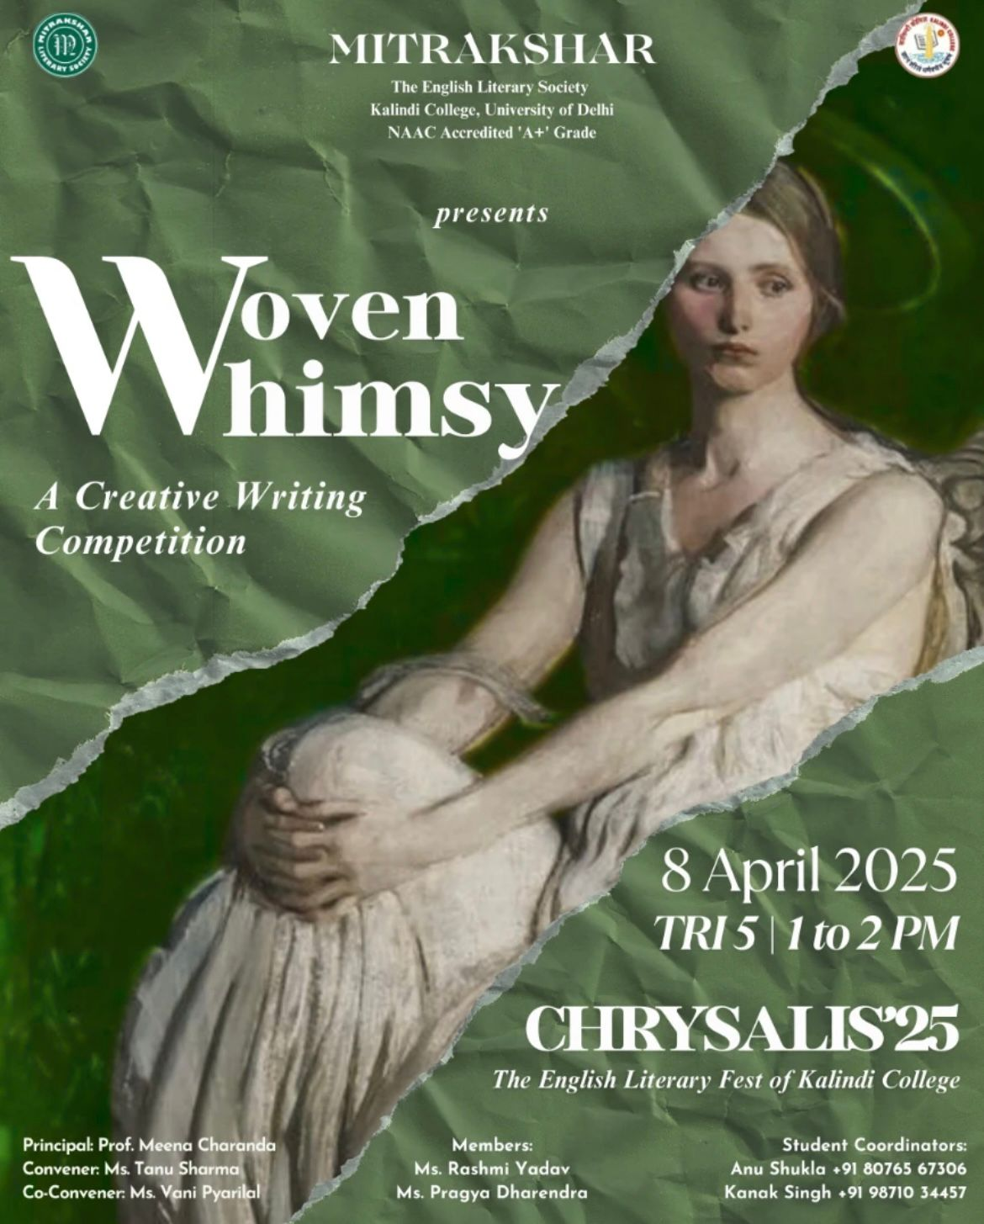
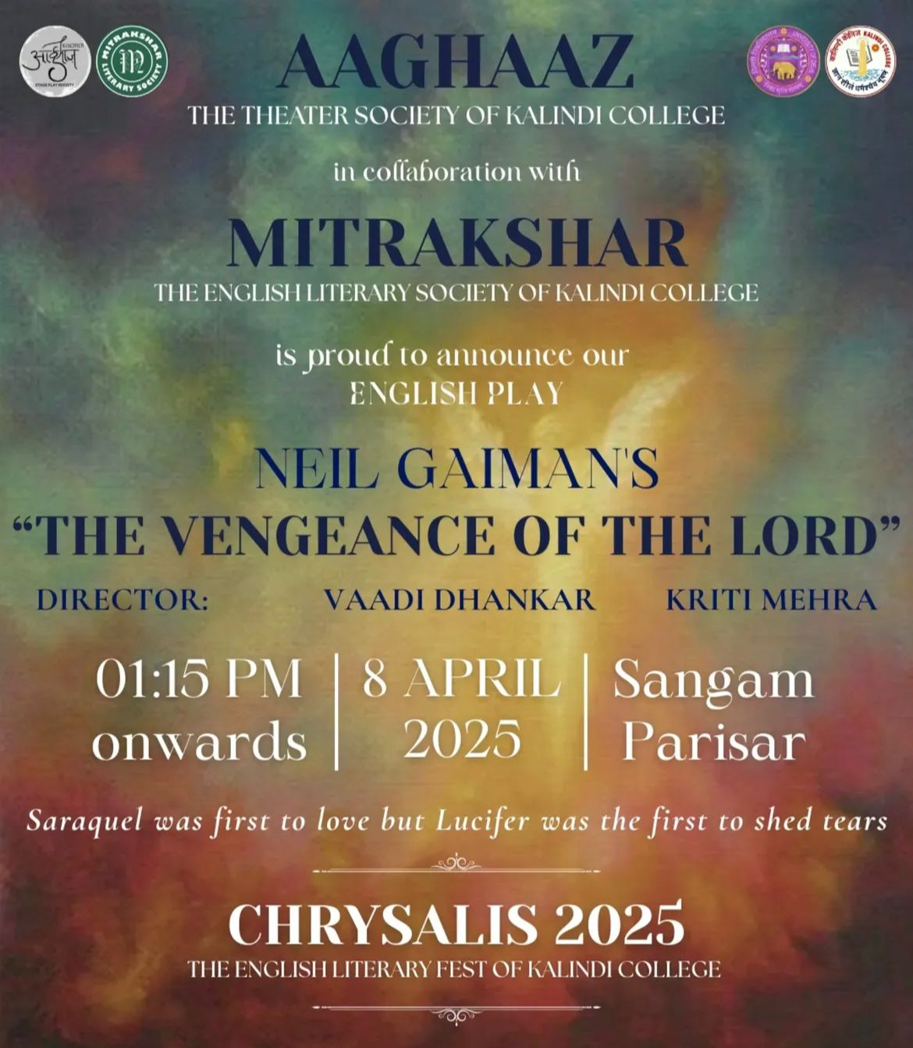
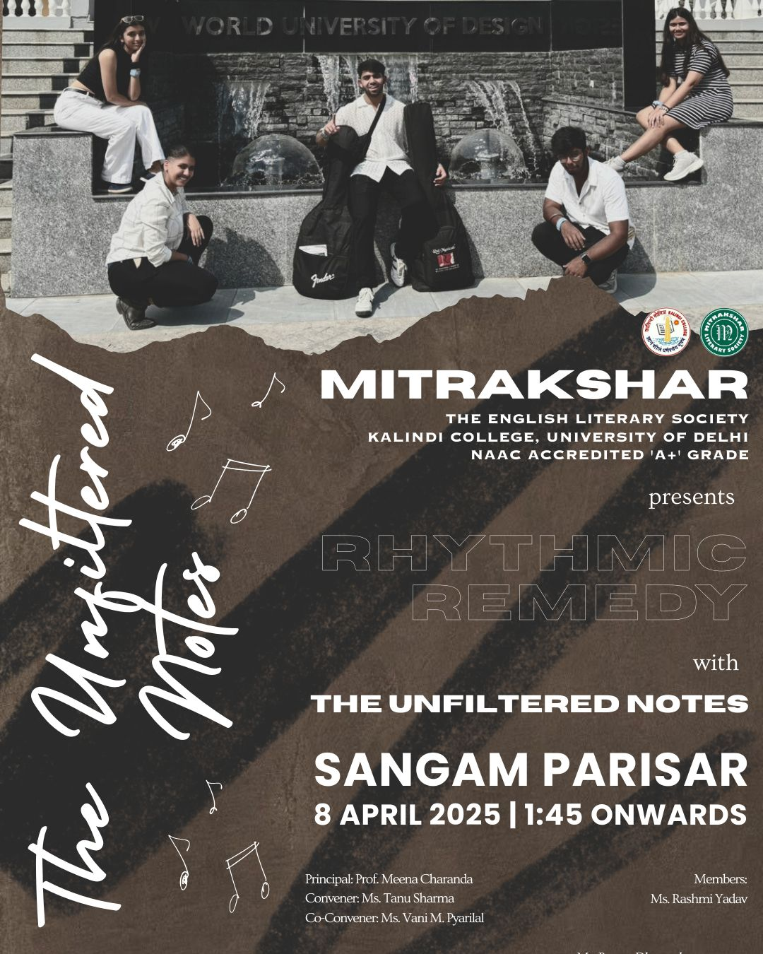
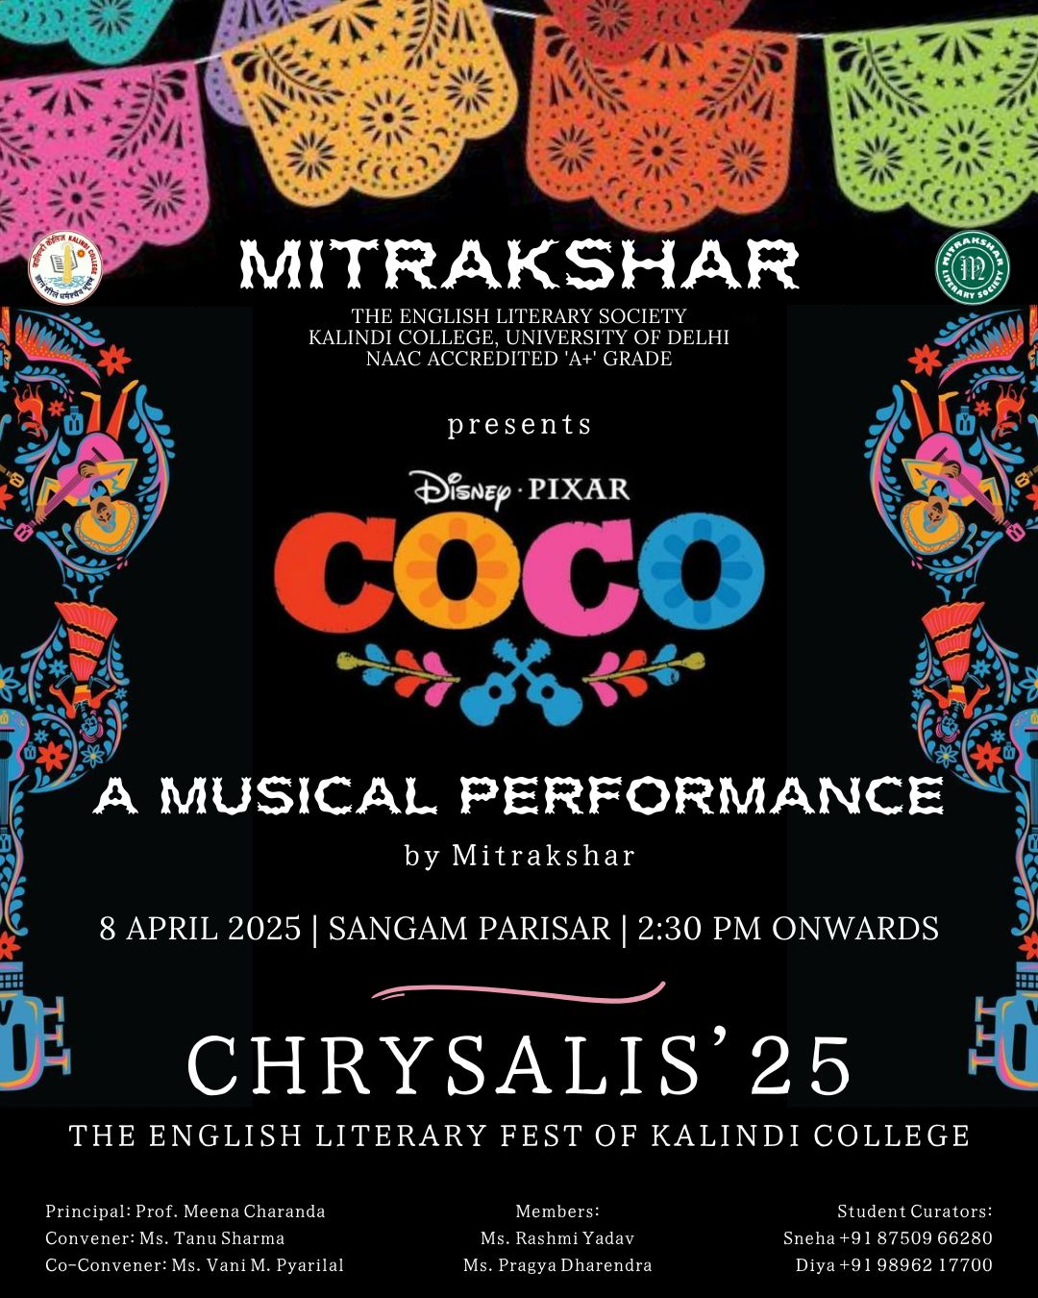

- Google Attendance Sheet of all the participants if online;
and if offline, attendance sheet with signature of all the participants:

- Names of the Resource Person/s: -

- Detailed Report:

The English Department of Kalindi College hosted its much-awaited annual literary fest, Chrysalis 2025, a vibrant celebration of literature, performance, and imagination. This year’s fest was a dynamic blend of insightful author sessions, exciting competitions, and a rich array of performances
Author Sessions
The fest featured two deeply engaging author sessions that allowed students to interact with contemporary voices in Indian writing:
Dr. Anuradha Marwah opened the festival with a compelling session centered around her latest novel The Aunties of Vasant Kunj: Fantasy and Reality. She not only read excerpts from her book but also guided the audience through the intricacies of her characters—three women navigating the strange duality of surreal experiences and the weight of everyday realities. Through anecdotes and interaction, Dr. Marwah invited students to reimagine what it means to be an “aunty” in Indian society, unearthing hidden layers of identity, yearning, and quiet rebellion. Her session concluded with an enthusiastic Q&A that further deepened the audience’s understanding of her literary vision.

Ms. Vaishnavi Roy led the second author session, offering a moving and intimate account of her personal writing journey and her book Unwind. The session focused on mental health narratives, with Ms. Roy emphasizing the need to normalize conversations around emotional well-being. She spoke candidly about the healing power of writing and storytelling, and how literature can serve as both refuge and resistance. Her empathy and openness resonated deeply with the audience.

- Competitions
Chrysalis 2025 featured three major competitions that tested and celebrated the imaginative capabilities of students from across the college.

Cinematic Cityscapes, a short film-making competition, asked participants to create original films based on spontaneous prompts. The submissions ranged from urban fantasies to dystopian reflections, each showcasing unique cinematic flair.

- Winners:
1st Prize- Sneha Chauhan
2nd Prize- Samyak
3rd Prize- Muskan Pal

Woven Whimsy, the creative writing competition, provided an exciting challenge: participants had to draw two chits—one with a fantastical trope and another with a magical element—and weave them into a compelling narrative on the spot. The results were wildly imaginative, merging dragons with heartbreak, portals with postmodernism, and everything in between.

- Winners:
1st Prize- Deeksha Gupta
2nd Prize- Nirananda Jindal
Special Mention- Divyansha Batra

Ghibli Trivia, a quiz competition based on the beloved films of Studio Ghibli, brought out the inner child and the film buff in every participant. Covering classics from Spirited Away to Howl’s Moving Castle, the competition was fierce and full of laughter.

- Winners:
1st Prize- Nandita Rawat and Trisha Barman
2nd Prize- Chavi Yadav and Mohini

- Performances
Between events, the English Department students kept the energy flowing with lively filler performances—poetry readings, short skits, and unplugged musical interludes that captured the spirit of the fest beautifully.
The evening segment featured larger stage performances:
The Unfiltered Notes, a student band, delivered a soulful jamming session that filled the amphitheatre with rhythm and joy, setting the perfect mood for the night.

Aaghaz, the theatre society of Kalindi College, in collaboration with Mitrakshar, presented their debut English-language play The Vengeance of the Lord. Directed by Vadi Dhankar and Kirti Mehra, the play was an intense and thought-provoking production that explored themes of justice, divinity, and retribution.

The fest concluded with a musical performance by Mitrakshar, inspired by the heartwarming tale of Coco. Written by the society’s president and directed by both the president and vice-president, the musical paid tribute to memory, music, and intergenerational bonds. It was an emotional and melodic finale to an already enriching day.

Chrysalis 2025 was more than just a literary fest—it was a heartfelt expression of the creative spirit of Kalindi College. It brought together storytellers, thinkers, performers, and dreamers under one banner, reminding everyone that literature isn’t just read—it’s lived.

- Certificates of 10 participants: -
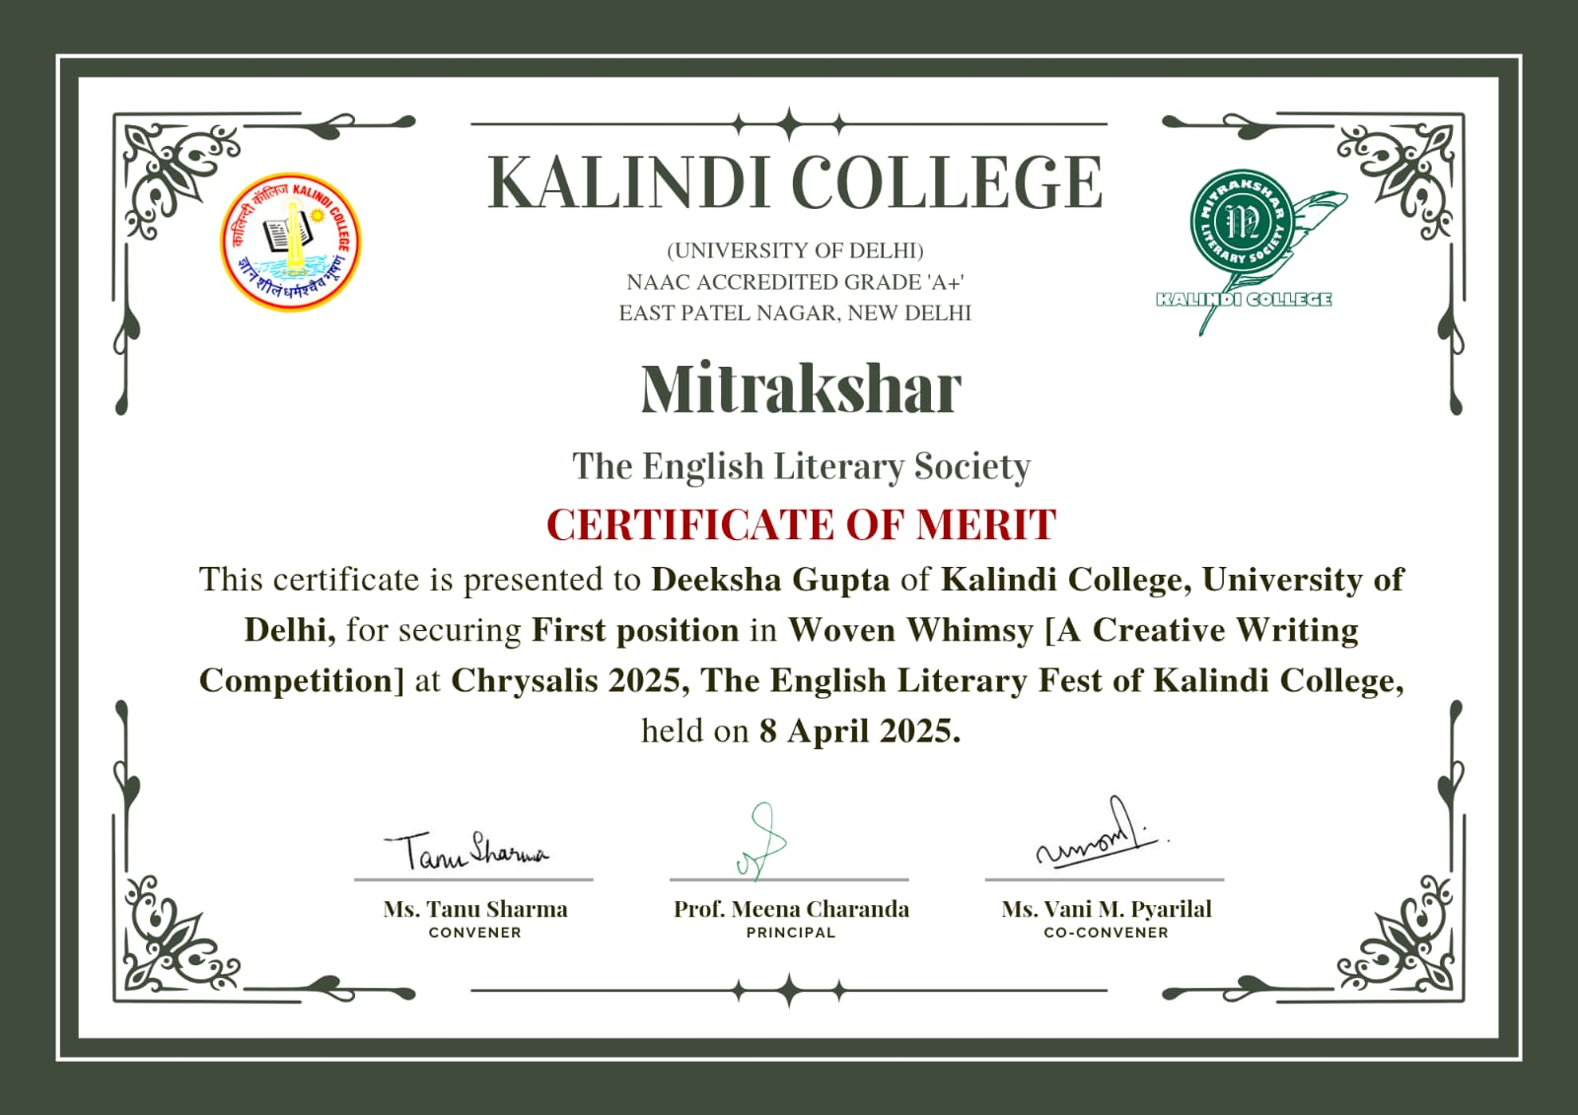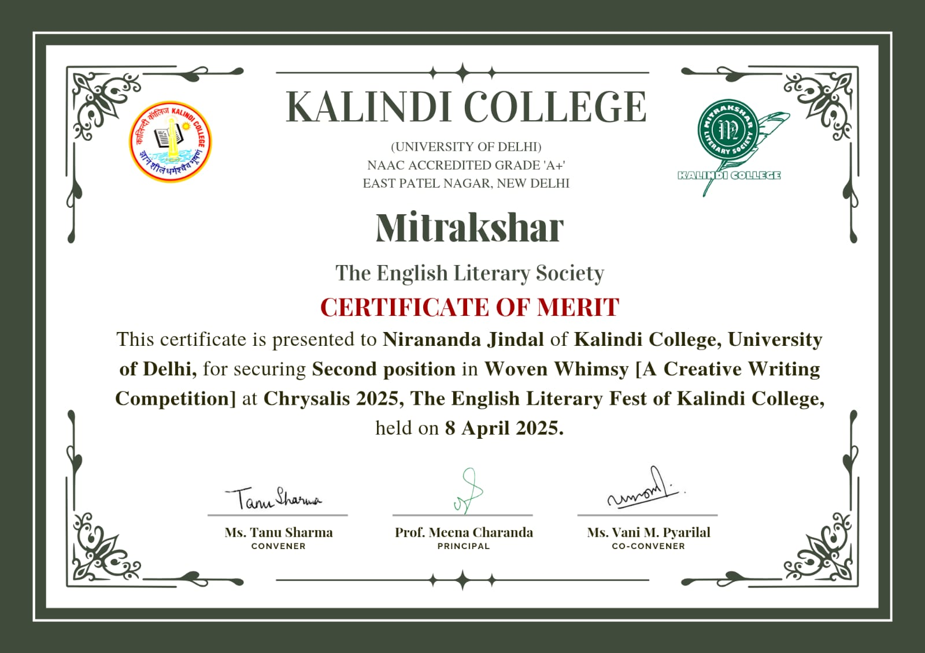
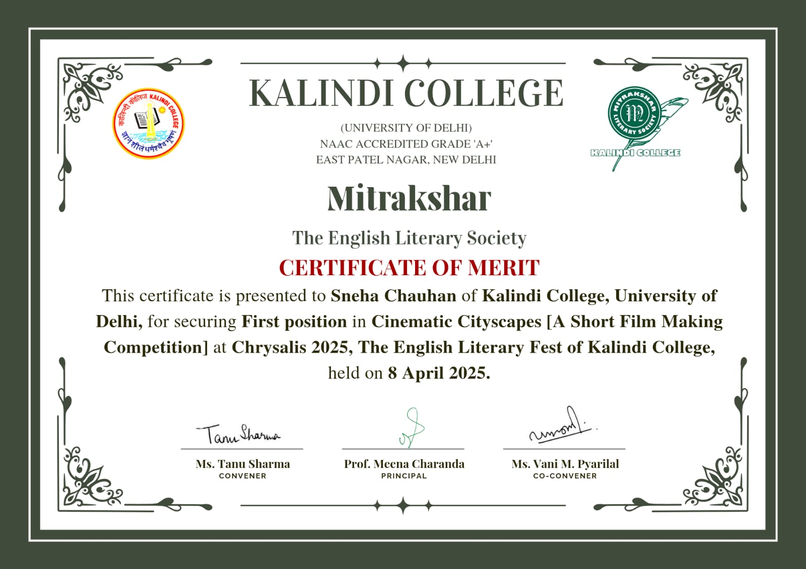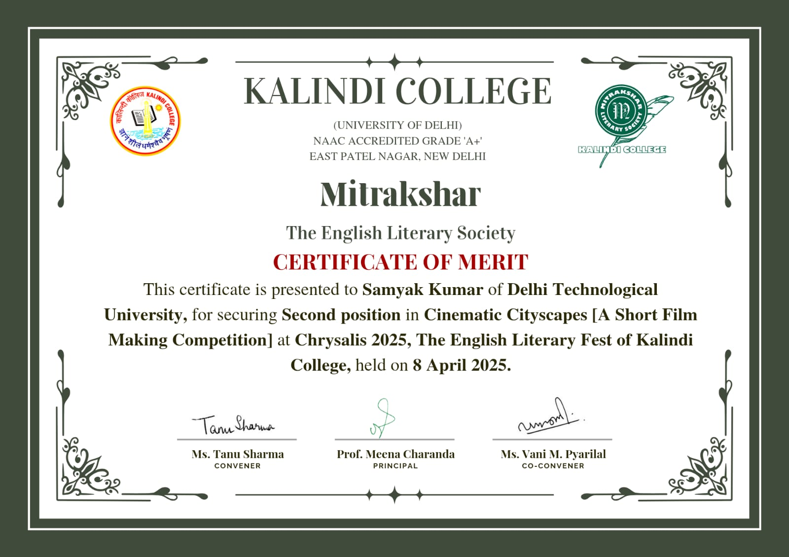
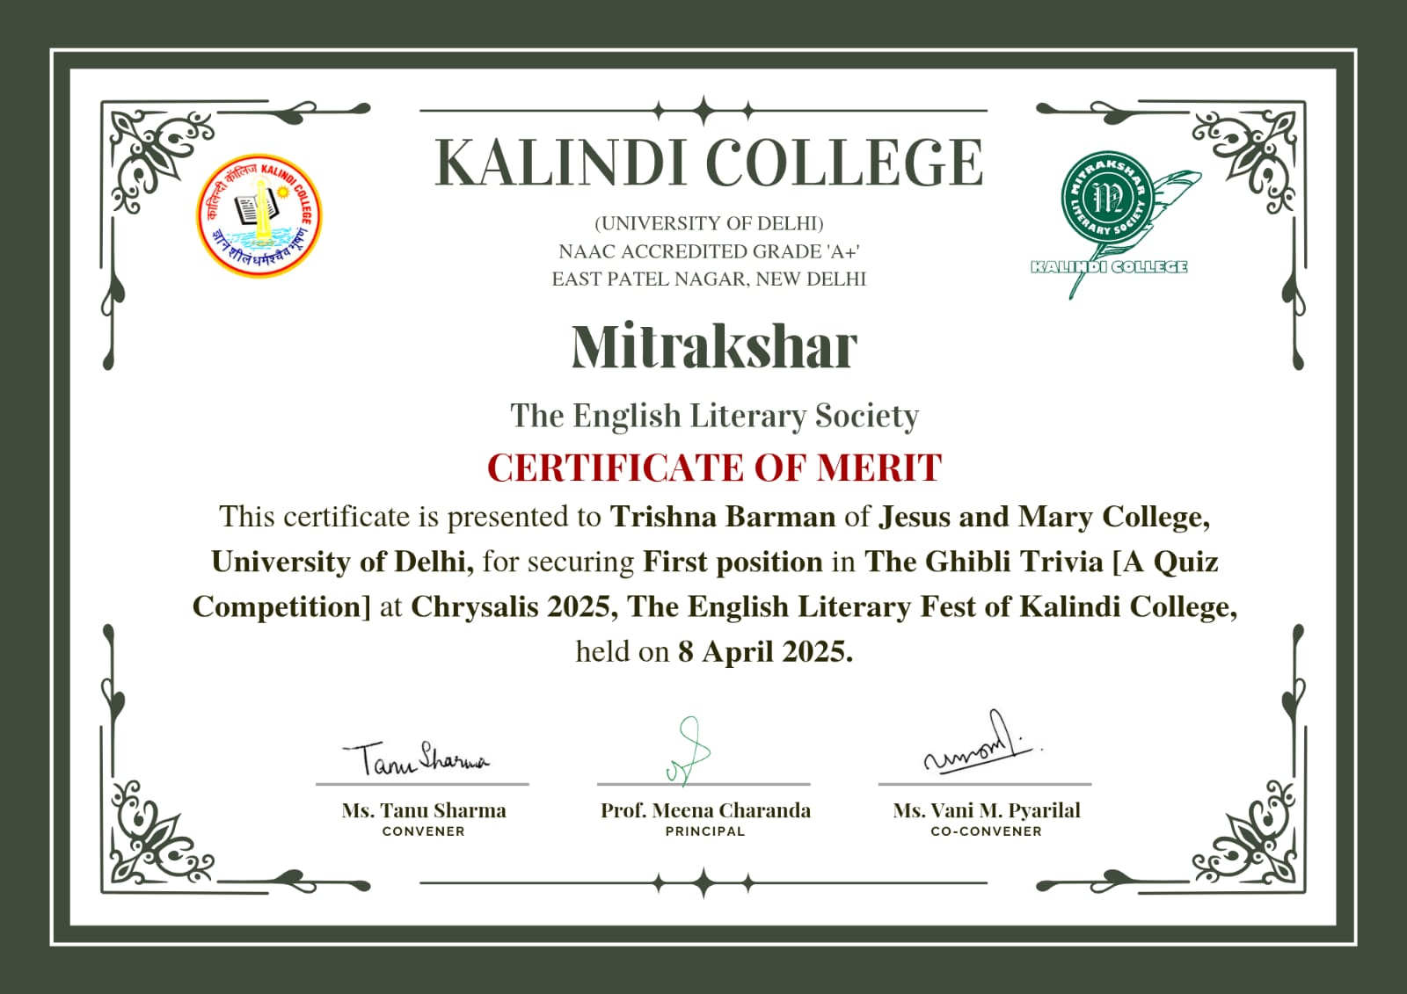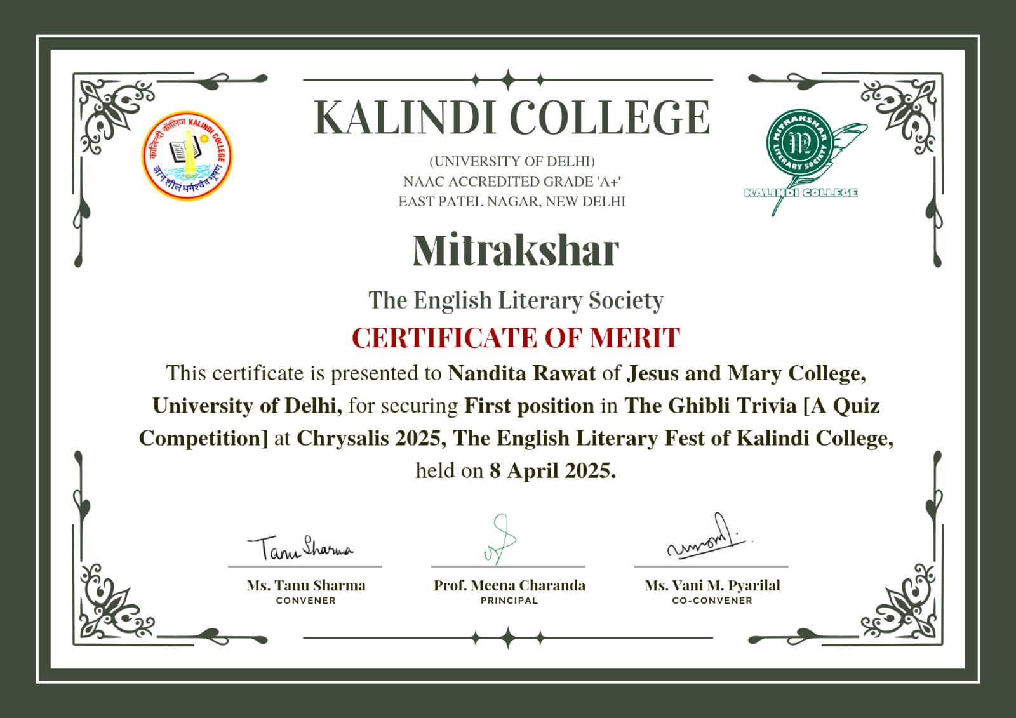
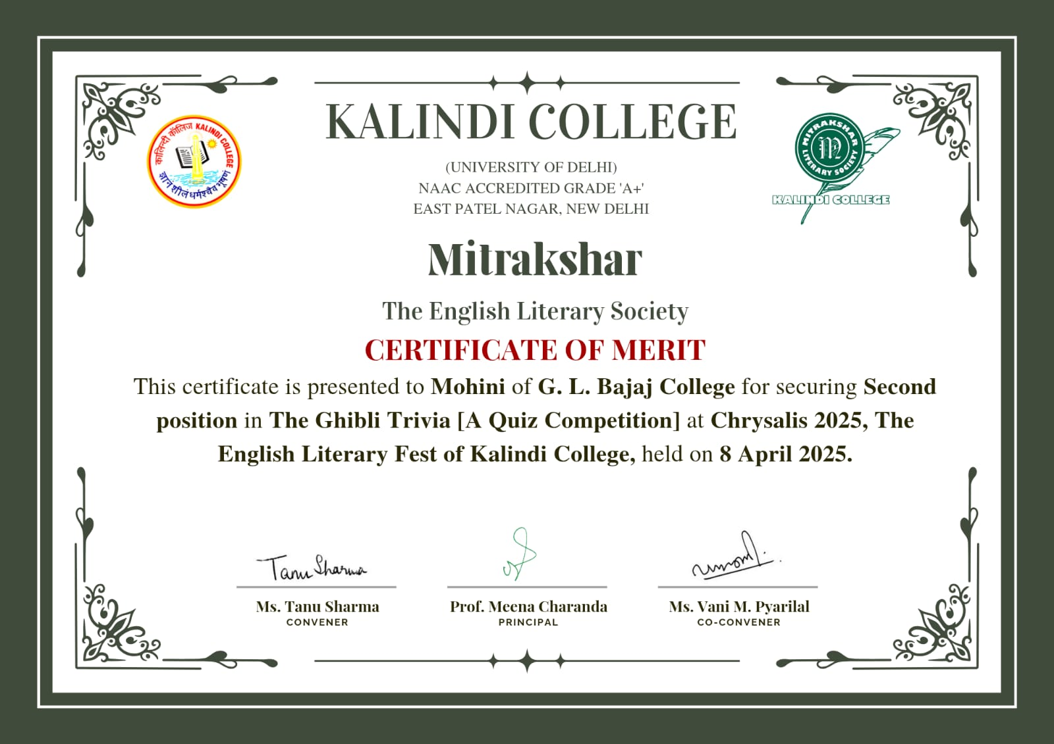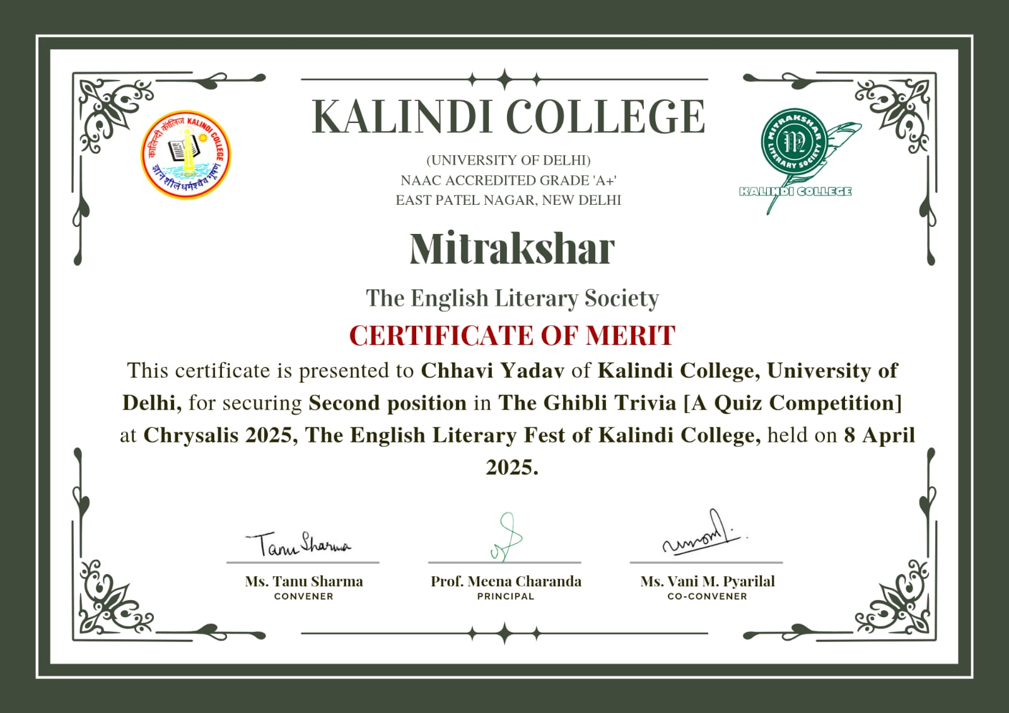

- Geo tagged Photographs with captions:
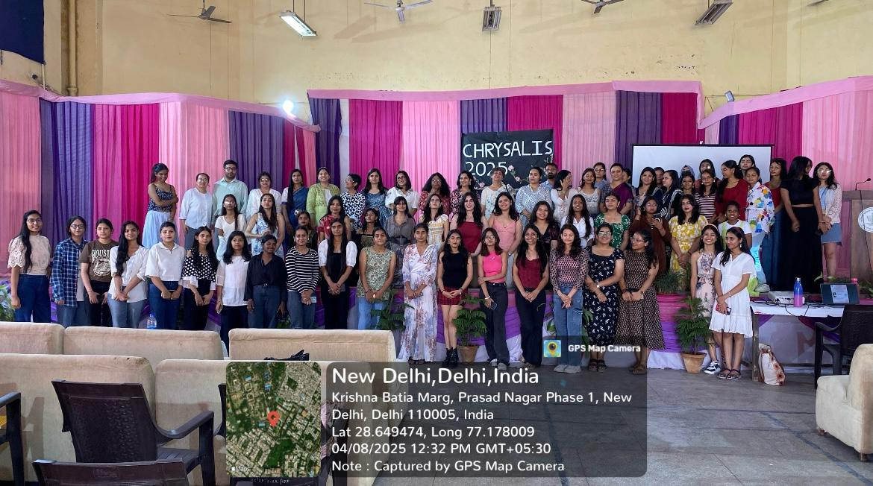 *Chrysalis 2025
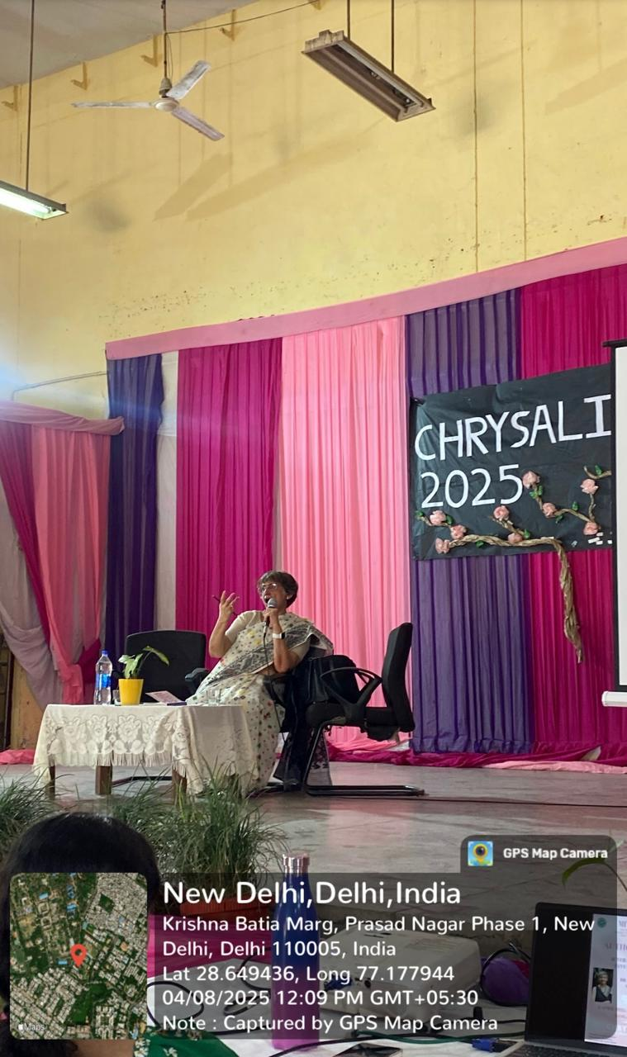 *Dr. Anuradha Marwah’s author session.
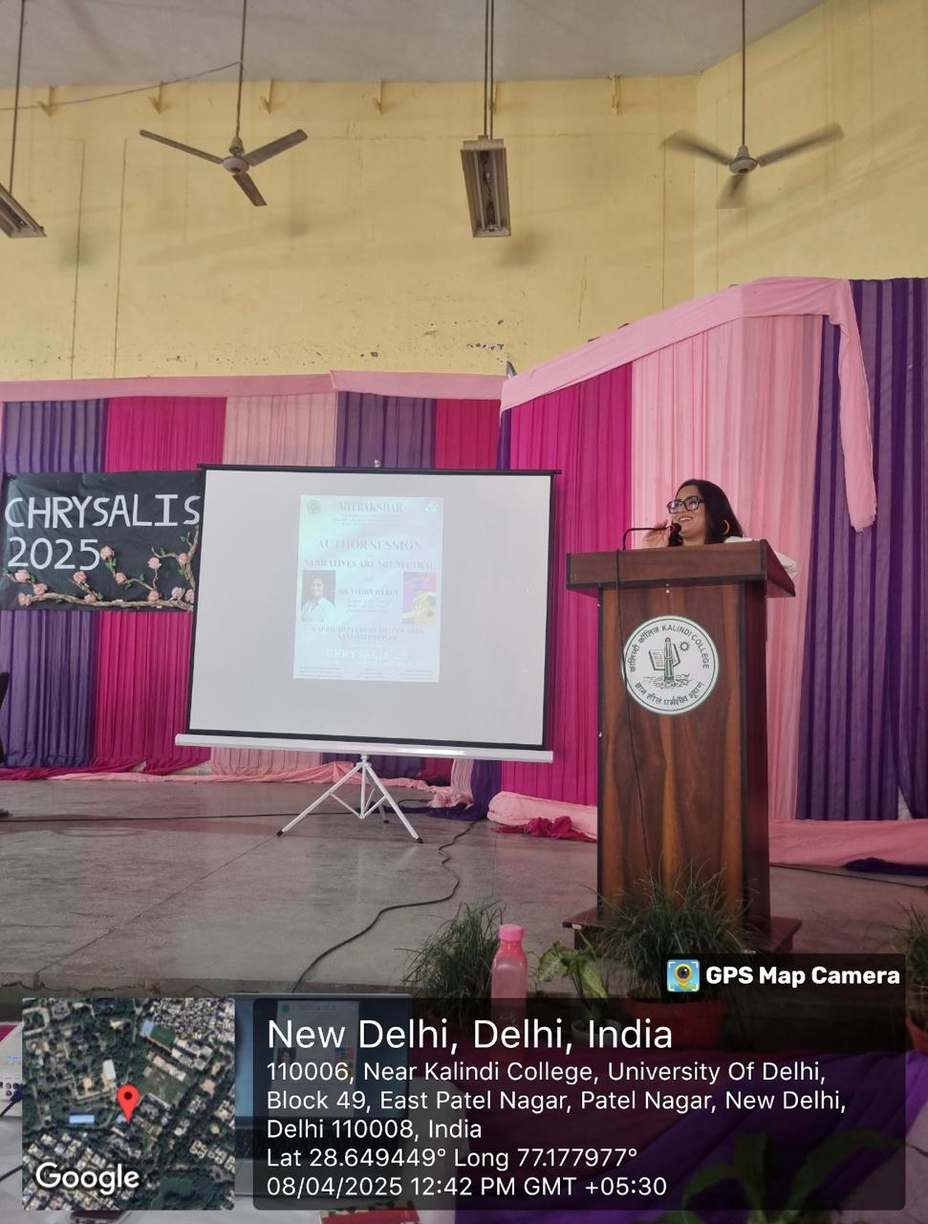 *Ms. Vaishnavi Roy’s author session.
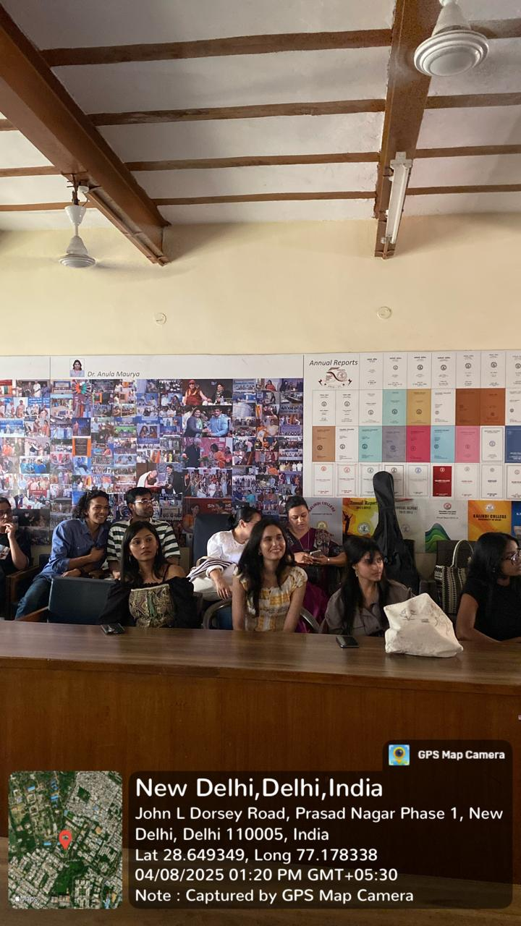 *Attendees and Participants at Cinematic Cityscapes.
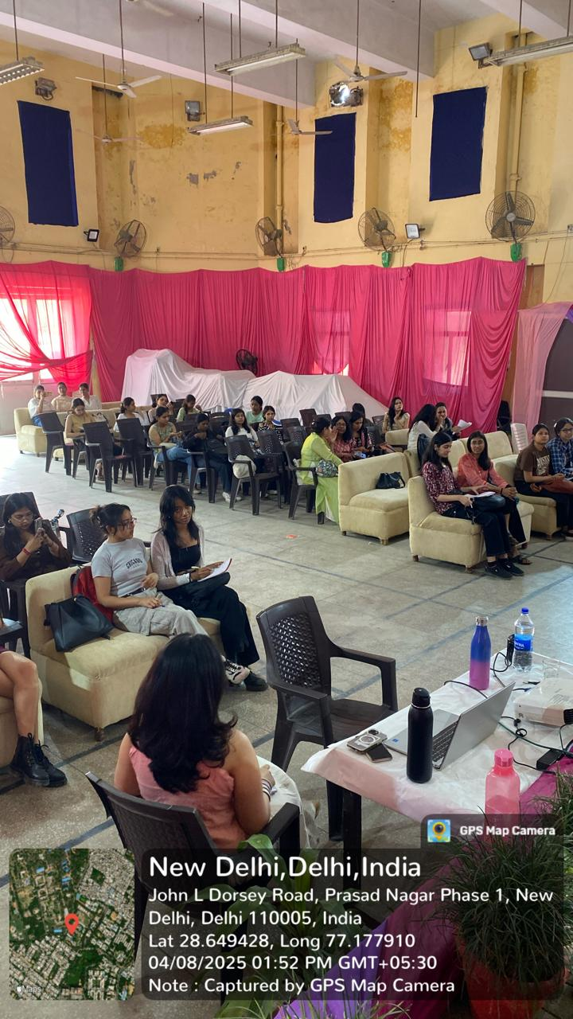 *Attendees and Participants at Ghibli Trivia.
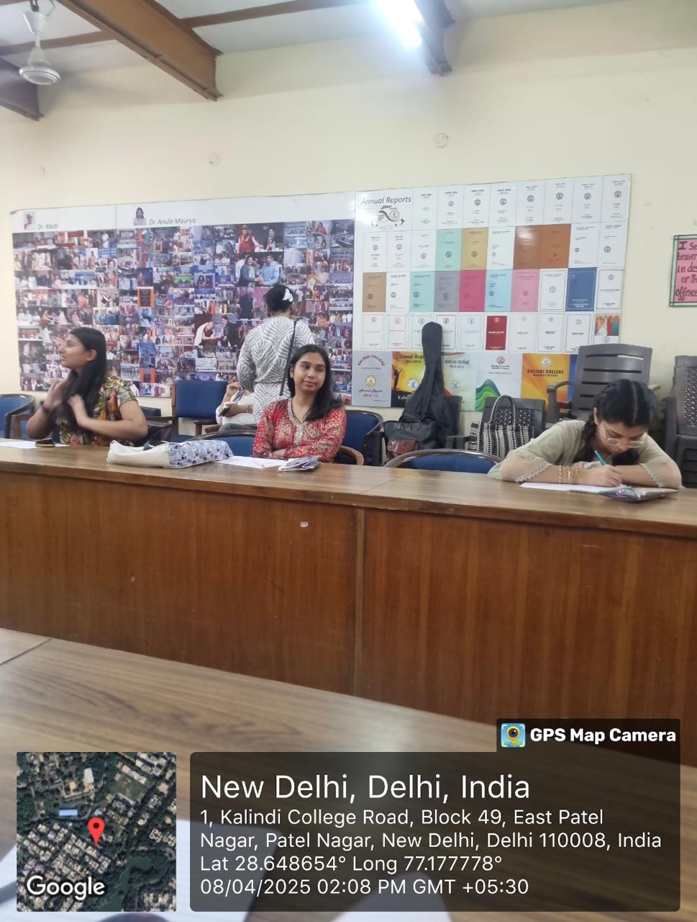 *Attendees and Participants at Woven Whimsy.
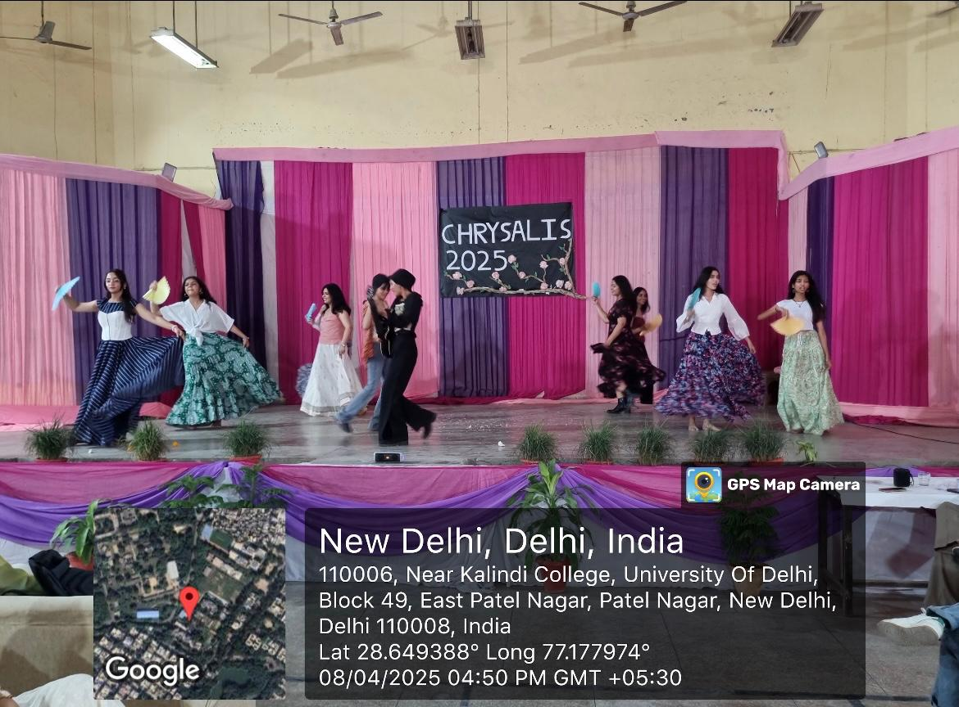 *Coco, a Musical Performance.

- Newspaper clip or photograph if published: -

Performa for Submission of Activities From TIC/ Convener/ Co-Convener
/Organizer /Coordinator/Nodal Officer Etc.

- Department/Committee/Cell/Cultural Clubs, Others: Mitrakshar, the English Literary Society of Kalindi College, University of Delhi
- Name of the activity: “Vini Vedi Amavi”
- Funding Agency (Internal/External) and Amount:
- Name of the TIC/Convener/Coordinator/Nodal Officer/Other: Ms. Tanu Sharma (Convener), Ms. Vani M. Pyarilal (Co-convener)
- Date/s (-to-) and time (-to-) of activity: 25 April 2024 and 10:30 am to 04:00 pm
- Collaborating agency if any:
- Number of students and teachers: 70 students, and 16 teachers.
- Number of participants outside Kalindi College:

- Proofs to be included

Poster/Banner/Flyer/Circular/Brochure etc.:

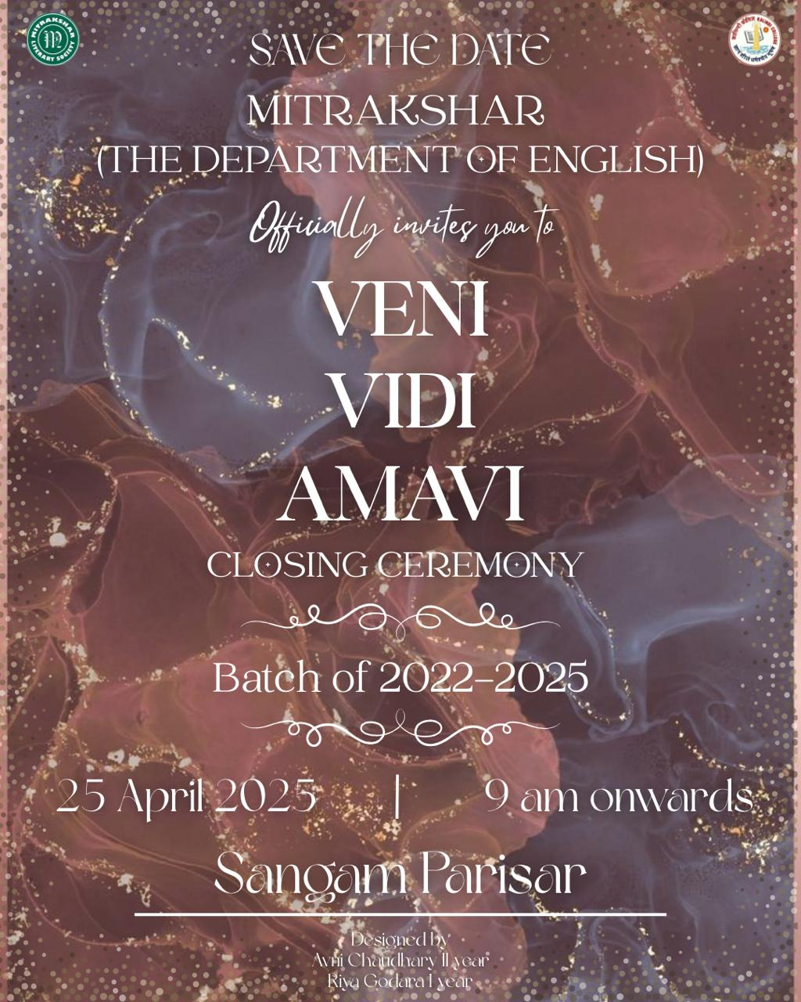

Google Attendance Sheet of all the participants if online;
and if offline, attendance sheet with signature of all the participants:

Names of the Resource Person/s:
- Detailed Report:

On the 25th of April 2025, the Department of English, Kalindi College, hosted its closing ceremony titled “Veni Vidi Amavi”, a deeply moving tribute to the graduating batch of 2022–2025. Organised by Mitrakshar, the English Literary Society, the event was held at Sangam Parisar and served as a culmination of three remarkable years marked by learning, friendship, and shared growth. The title, meaning We came, we saw, we loved, beautifully captured the spirit of the day—a celebration of journeys lived together and memories etched into the fabric of the department.

The ceremony commenced with a gracious welcome extended to the faculty, and students.
The Teacher-in-Charge addressed the gathering with a message of pride and encouragement, reflecting on the individual and collective growth she had witnessed among the students over the years. She spoke of the irreplaceable role that literature plays in shaping thought, empathy, and identity, and urged the graduating cohort to carry forward the values nurtured within the department. Her words were followed by addresses from other faculty members, each of whom spoke with affection, admiration, and gentle humour about their time spent with the students. These reflections, filled with anecdotes and wisdom, resonated deeply with all present.

One of the most heartfelt moments of the event came through the speeches delivered by the graduating students and their juniors.

Interspersed throughout the ceremony were a series of performances by students across all three years. The third-year students offered deeply personal pieces—poems, songs, and dramatic monologues—that captured the emotional weight of the moment.

“Veni Vidi Amavi” was not simply a celebration; it was a collective pause to look back with love and ahead with hope. It served as a reminder that the essence of the Department of English lies not only in its academic rigour but also in the warmth of its community and the richness of shared experience. The event came to a close with a sense of fulfilment and quiet reflection, leaving everyone present with the memory of a morning that was as tender as it was unforgettable.

Certificates of 10 participants: -

Geo tagged Photographs with captions:
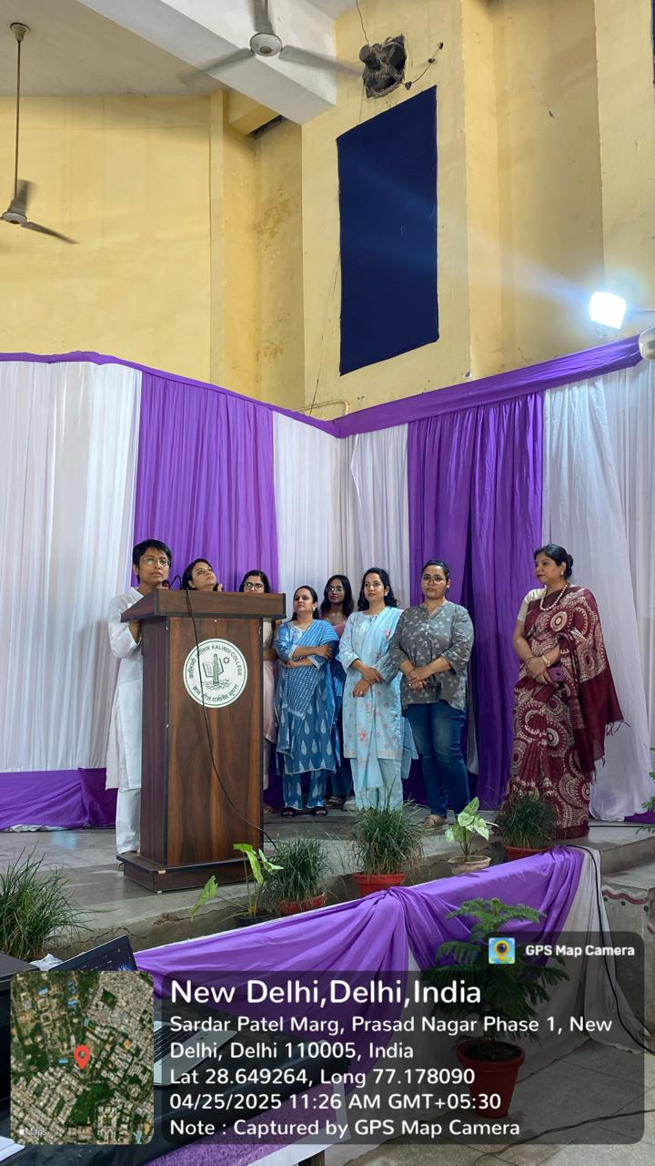 *The Faculty addressing the batch of 2022-25.
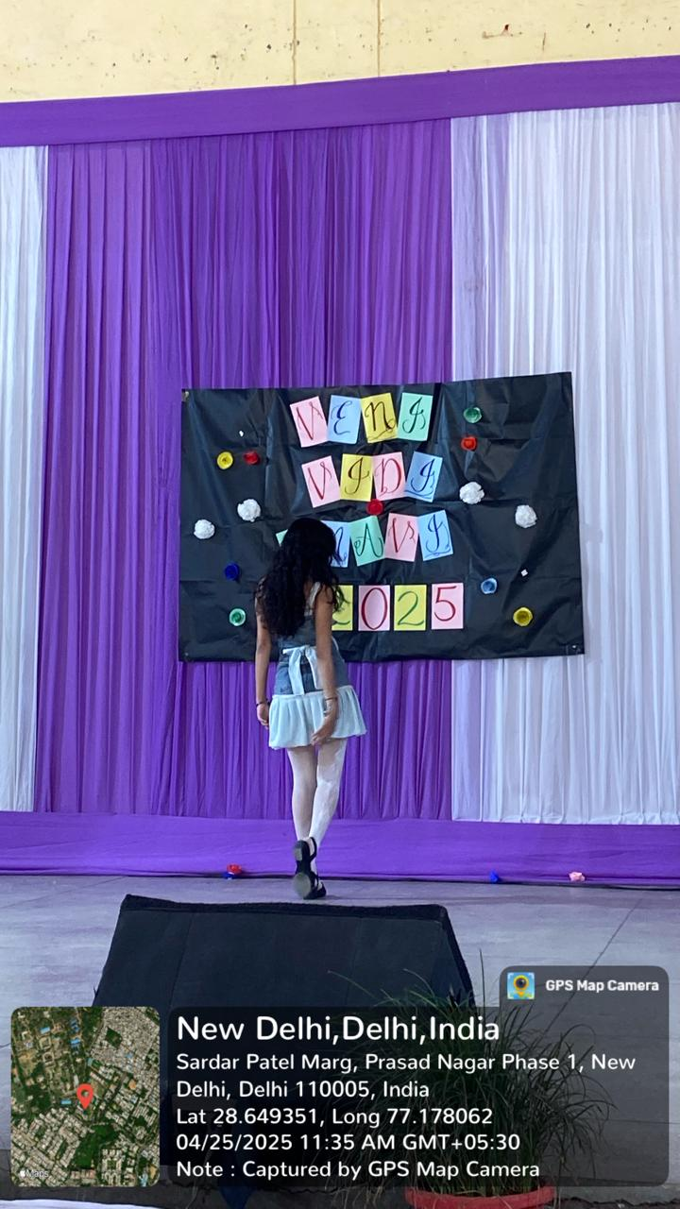 *A second year performing

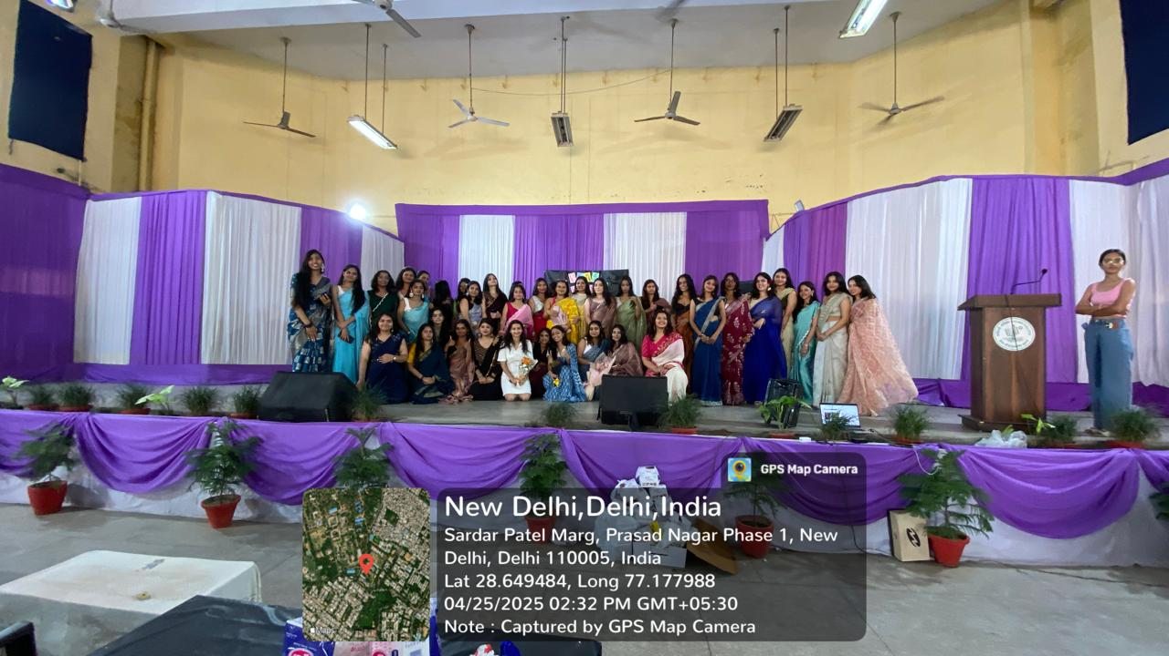 *The batch of 2022-25

