Annual Report 2022-23

The Department of Geography has always committed for excellence, perfection and provides a magnificent environment to the students for overall development. The new academic session began with a warm welcome to all the first-year students through an orientation programme held in Geo Lab on 3rd Nov 2022. The TIC Dr. Seema Sahdev introduced the new students to the academic and cultural activities of the department through an engaging presentation.

RESUME WRITING AND ONLINE PERSONAL BRAND MANAGEMENT

A workshop was organized on 9th September 2022 by Jaipuria Institute of Management in Department of Geography, Kalindi College, on the topic “Resume writing and online personal brand management “. It started with the introduction of Dr. Prashant Sharma, associate professor (finance) and program director. He explain dos and don’ts in a resume building and what are the common mistake an individual makes while building a resume.

WORLD OZONE DAY:

World Ozone Day has been organized by the Department of Geography, Kalindi College, University of Delhi on the occasion of World Ozone Day on 16th September 2022. First of all a short film was played and it depicted the facts of Ozone layer and the cons of Ozone being depleted. After the short film a Quiz Competition was organized to save world

WORLD HABITAT DAY
World Habitat Day was organized by the Department of Geography on 30 September 2022 on the theme, ‘Mind the gap. Leave no one and place behind.’ organized a photography competition
Habitat is necessary, it isn’t a choice but choosing to share it wisely is! To nudge a reminder towards our responsibility and power to shape our World as a healthy habitat. World Habitat Day was designated by the United Nations on First Monday of October every year to emphasize on our right to adequate Shelter. In 2022 World Habitat Day is under reflecting the challenges of human settlements. Addressing the theme Department of Geography, Kalindi College, University of Delhi organized a photography competition.

Annual Geo Fest- ‘Resurgence 2023’-

On 10th and 11th February, the Department of Geography organised its annual fest ‘RESURGENCE 23’ on the theme “SINKING DOMIANS OF NATURE: A LIGHT ON JOSHIMATH EVENT”. Our honourable chief guest were Prof. Bindhy Wasini Pandey (Department of Geography, Delhi School of Economics), Dr. Deep Narayan Pandey (Assistant Prof., Special Center for Disaster Management, Jawaharlal Nehru University), and Mrs. Indu Sinha (Vedic Farmer, Entrepreneur). The following activities were organized.

Panel Discussion-

Program began with a panel discussion by our Chief guests who delivered informative insights along with detailed presentations on the Joshimath issue. Dr Bindhy Wasini Pandey enlightened students about the Ladakh study area via a Presentation, informing about how it is slowly becoming a desert and the causes, impacts of it. He linked the significance of Himalayas with religion, geology, demography and resource base. Dr Deep Narayan Pandey shared his insight on the past and present of Joshimath’s demographic and geological structure, urbanisation, rise in tourism, and spike in business and commercial activities at Joshimath. He discussed about the capacity building, traditional and sustainable modes of living, and not pushing the threshold of mountains. He also talked about how generations gaps and how the knowledge of older generations to cope with disasters have been forgotton. He enlightened the students about the differences between Climate Change and Climate Variability. Mrs Indu talked about how overcrowding, negative aspects of development effect the environment, society as well as sustainability of it for future generations. As infrastructure in plains and mountains should be considerably different but hardly pondered upon she shared her idea of using light materials for building houses so that in earthquake prone area loss of lives due to collapse of buildings could be reduced.

Debate Competition

Debate competition was organized on the topic Environmentalists want India to rethink its Hydropower Projects on the wake of Joshimath Tragedy. Some participants argued for the motion and some against the motion. Students from various colleges of Delhi University came and participated in the event. Judges of the event were Dr Karuna shree (Kirorimal College) and Ms Varsha Yadav (Physics Department, Kalindi College).

Climate Cooking
Cooking is one of the sweetest gestures of care and if this is incorporated with climate change, it's going to be interesting, so keeping this in mind we came up with the Climate Cooking in which Participants had to make a dish (one or more than one) without using any kind of fuel or electronic devices. The judges for the competition Climate Cooking were Dr. Karuna Shree from Department of geography, Kirorimal College and Dr. Varsha from Department of physics, Kalindi College, University of Delhi.

Waste to Wonder

On the second day an event as ‘Waste to Wonders' was held. The event was based on creating thing from waste materials in the allotted time period. Students showcased their talent by turning scraps and waste materials into something wonderful and useful resource. It was initiated to examine the minds of young generations along with their ability to create environmental friendly models that conveyed their message. The event was Judge by the Dr. Nagma Praveen from Botany Department Kalindi College.

Mr. and Ms. Earth

The judge for the competition Mr. and Ms. Earth was Ms. Ritu Tehariya (Entrepreneur) . There were three rounds in the competition. The contestants had to perform rampwalks followed by open mic and stage performances where the participants danced, sang and portrayed various other talents. The last round consisted of ‘Q and A’ round where multiple questions were asked related to geographical knowledge.

Treasure Hunt
Our last event namely “Khajane ki Khoj” or Treasure hunt was held. About 250 students participated in the event. The game was full of riddles and fun. The group that solved the riddles and found their treasure first was the winner of this event.

List of Winners

S. No. | Name of Event | Position | Name of Winners | Name of College
1 | Quiz competition on World Ozone Day | I | Stuti Pandey | Kalindi College
 |  | II | Riya | Kalindi College
 |  | III | Jyoti | Kalindi College
2 | photography competition on World Habitat Day | I | Mehak Mongia | Kalindi College
 |  | II | Aarya Chaturvedi | Kalindi College
 |  | III | Devojani neog & Diya sabrin | Kalindi College
3 | Debate Competition  in Annual Geo Fest- ‘Resurgence 2023’ | I | Khushi Tyagi | SPM College
 |  | II | Shivani Singh & Anchal | Sri Venkateshwara college
4 | Climate Cooking  in Annual Geo Fest- ‘Resurgence 2023’ | I | Sulipsa Jena & Isha Saharan | SPM College
 |  | II | Kashish & Dev Dhama | Sri Aurobindo College eve
5 | Waste to Wonder  in Annual Geo Fest- ‘Resurgence 2023’ | I | Karan Dwivedi  Priya Kumari | Sri Venkateshwara college
 |  | II | Gargi Roy  Dimple Gupta | Kalindi College
6 | Mr. And Ms. Earth  in Annual Geo Fest- ‘Resurgence 2023’ | Mr. Earth | Bhanu Pratap Singh
 |  | Ms. Earth | Ankita | Kalindi College
7 | Treasure Hunt  in Annual Geo Fest- ‘Resurgence 2023’ | I | Chetan Singh,  Utkrisht Kumar,  Rajat Mahal,  Muskan,  Kavita,  Ishika Dey | Ram Lal Anand  Moti Lal Nehru College  ARSD College  Kalindi College  Kalindi College  Kalindi College
 |  | I | Ishika  Mahak  Sneha  Gargi  Jyoti  Dimple  Dev Dhama | Kalindi College  Kalindi College  Kalindi College  Kalindi College  Kalindi College  Kalindi College  Sri Aurobindo College eve
 |  | II | Chahat  Bhanauri gain  Satyam Bansal  Arun  Riya Yadav  Sneha Bharti | SGGSCC  SGGSCC  SGGSCC  NCU  Kalindi College  Kalindi College

Panel Discussion “Sinking Domains of Nature: A Light on Joshimath Event

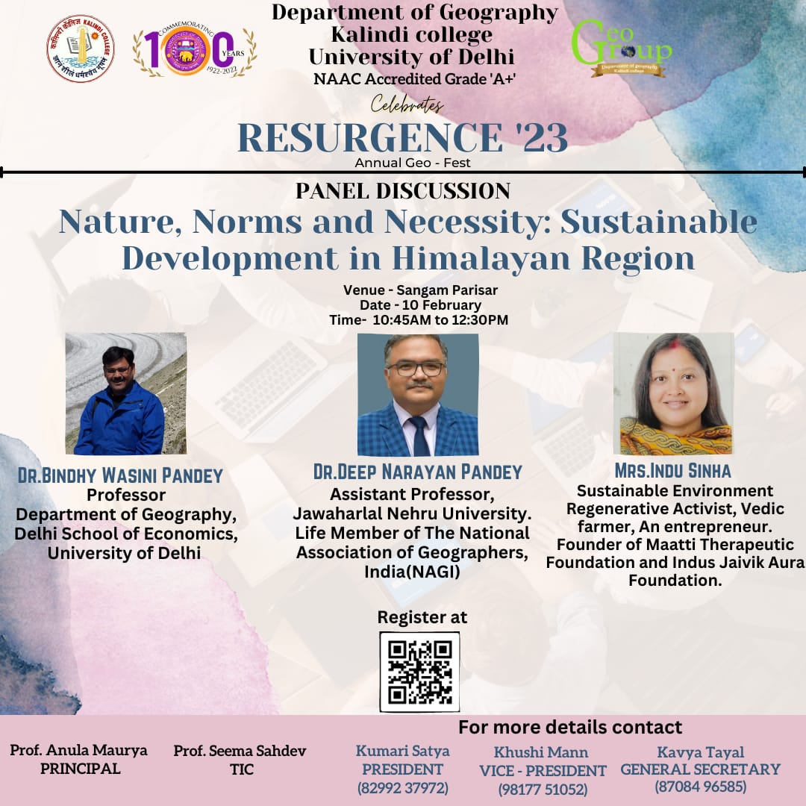

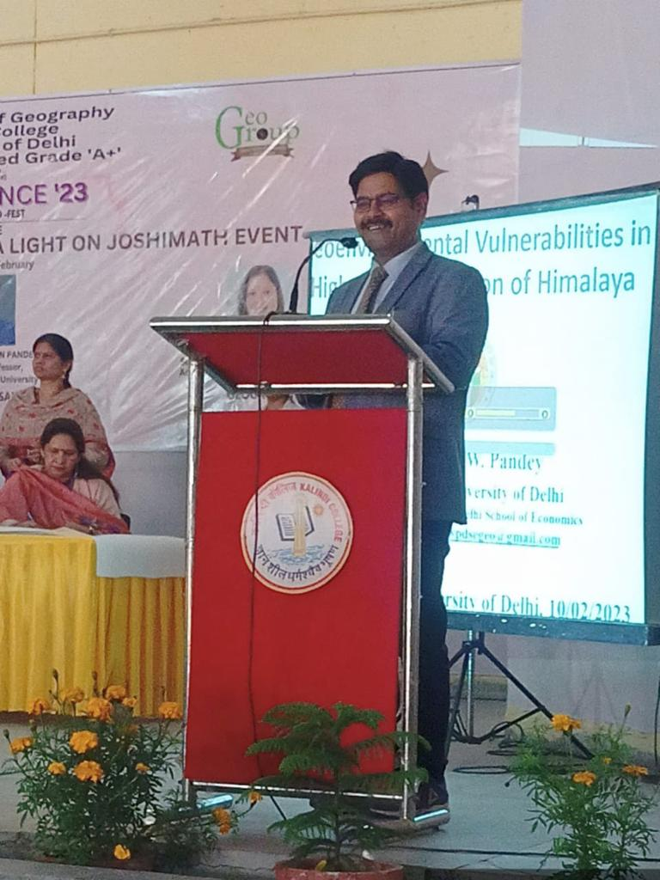
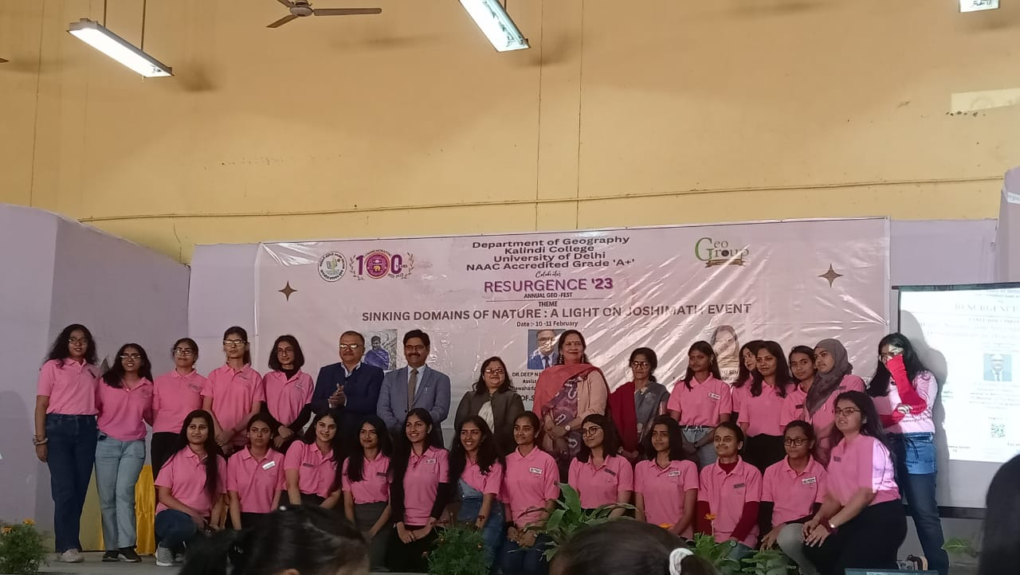
Debate Competition on topic Environmentalists want India to rethink its Hydropower Projects on the wake of Joshimath Tragedy

Students conveying their message on the issues of Joshimath through a play

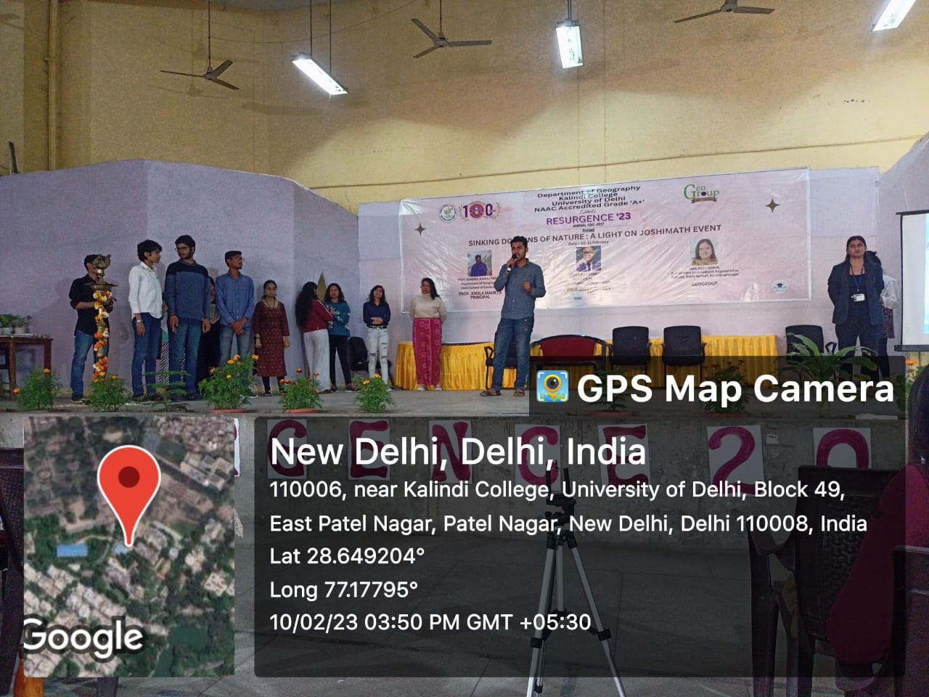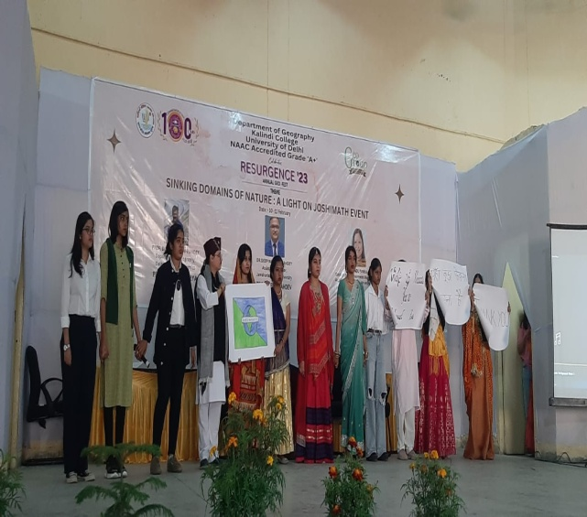

Participants explaining the theme and concept of their creativities on Waste to Wonders

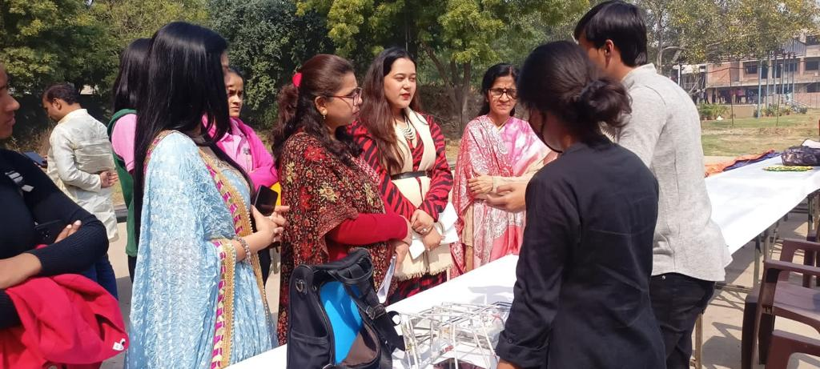

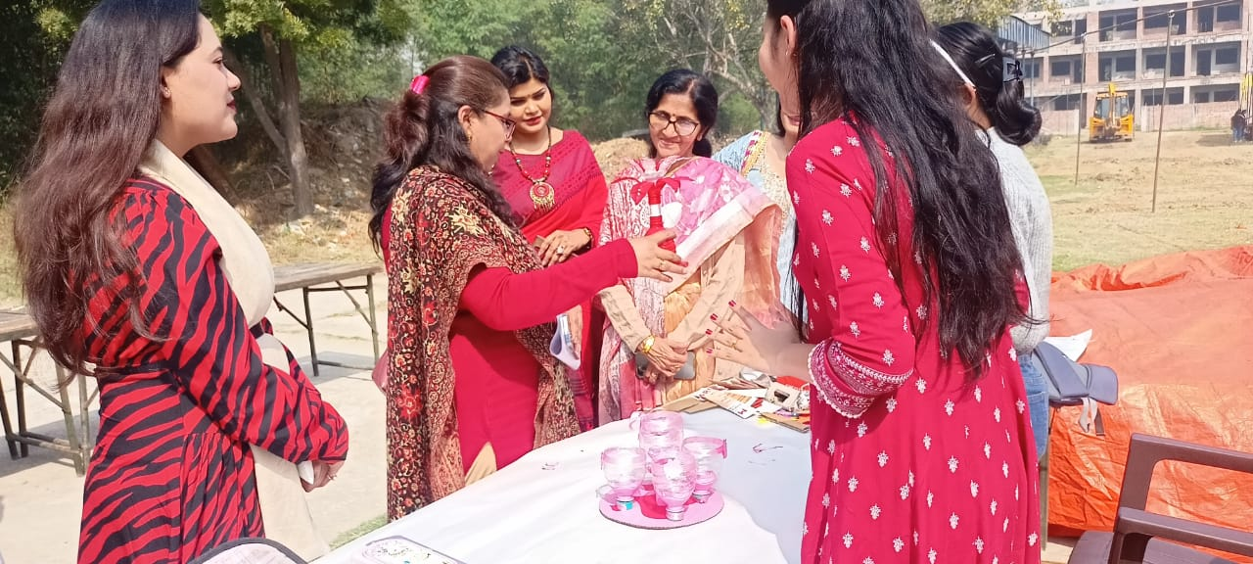

Food Prepared by students on climate cooking competition

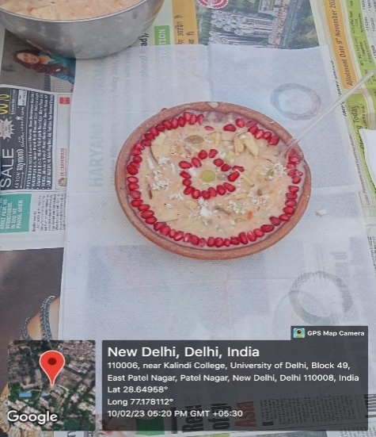
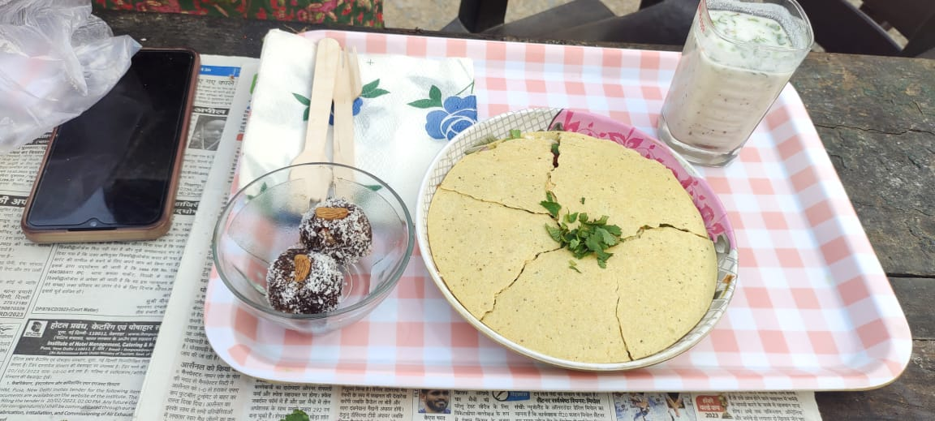
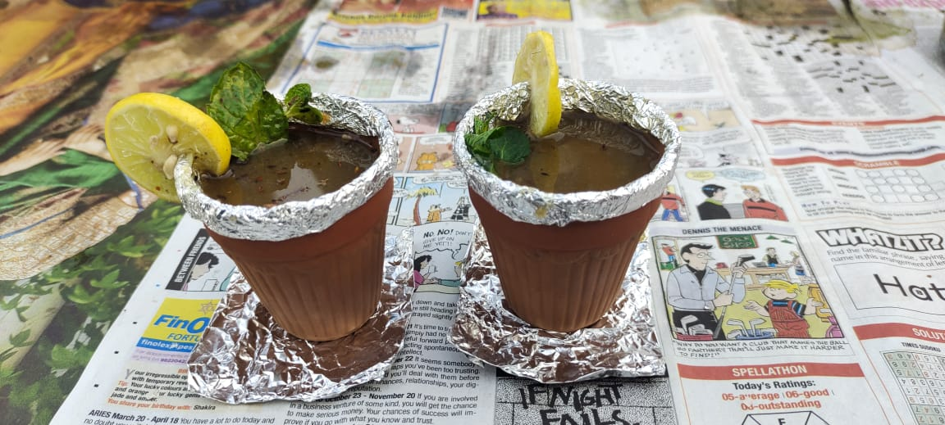
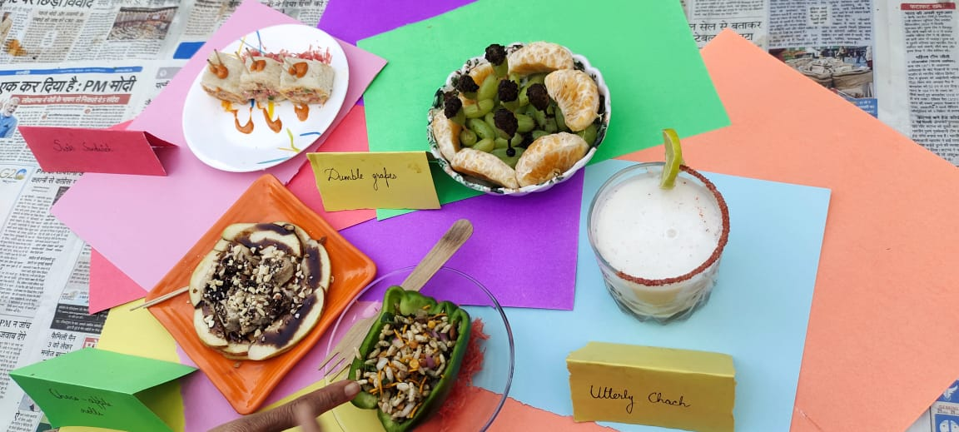
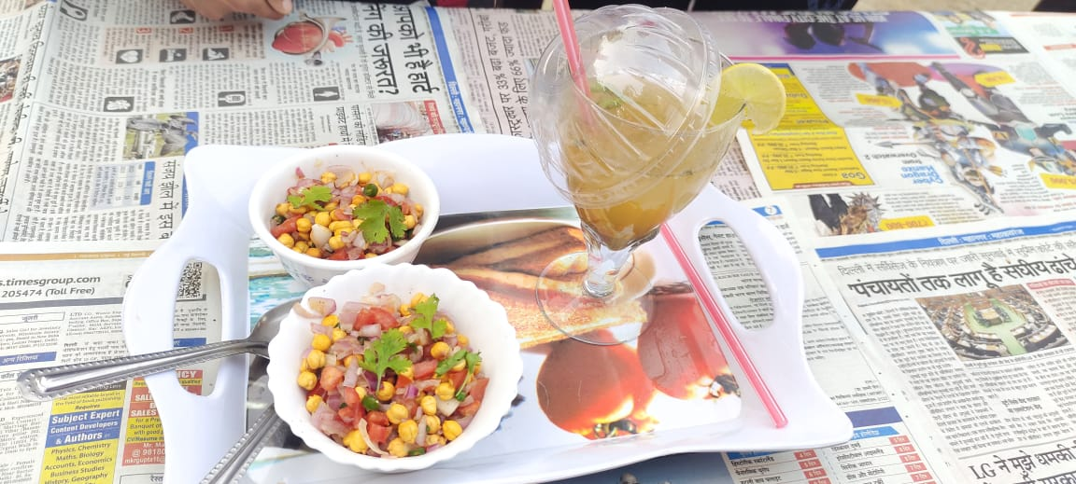

World Ozone Day
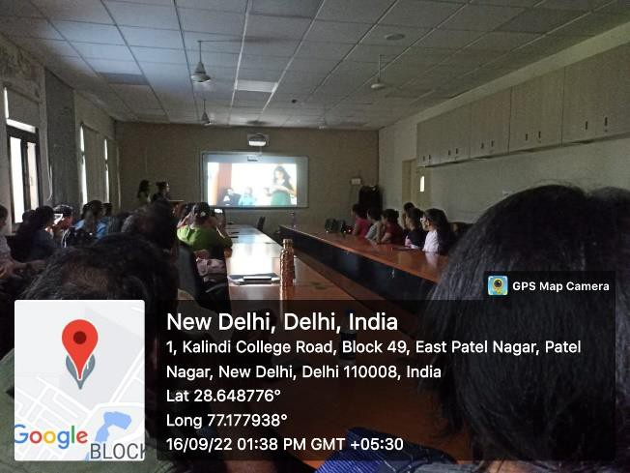

Resume Writing and Online Personal Brand Management Report

