REPORT ON VISIT TO NATIONAL PHYSICAL LABORATORY(NPL)
- Department/Committee/Cell/Cultural Clubs, Others: PHYSITHON SOCIETY
- Name of the activity: Visit to National Physical laboratory
- Funding Agency (Internal/External) and Amount: 0/-
- Name of the Convener: Dr. Aravind Kumar
- Name of the Co-Conveners: Dr. Rashmi Menon and Prof. Monika Bassi
- Name of Teacher Coordinators: Prof. Pushpa Bindal, Prof. Rachana Kumar, Prof. Seema Gupta, Ms. Pooja Devi
- Date/s (-to-) and time (-to-) of activity: 17th October 2025
- Collaborating agency if any: NONE
- Number of students and teachers: 22 students, 4 Teachers
- Number of participants outside Kalindi College: No

Detailed Report on Visit to National Physical laboratory (NPL)

On 17 October 2025, the Department of Physics, Kalindi College, organized an educational visit to the National Physical Laboratory (NPL). A group of students from the department participated in this informative tour aimed at providing exposure to cutting-edge technologies and their applications in various scientific fields.
The group arrived at NPL in the morning and attended a brief orientation session, followed by an insightful presentation by an expert from the laboratory. The expert provided an overview of NPL’s history, mission, and its pivotal role in maintaining national and international measurement standards. The National Physical Laboratory is widely recognized for its pioneering work in metrology—the science of measurement—and its significant contributions to research in areas such as quantum technologies, environmental monitoring, and material science.
Glimpses of the Visit:
- Biomedical Metrology
In Biomedical Metrology section participants were introduced to the precise measurement tools used in healthcare and medical device calibration.
- Sensor Devices and Metrology
Here researchers presented some of the most innovative sensor technologies currently being developed at NPL. The staff demonstrated how sensors are calibrated to detect minute environmental changes and how this technology is applied in sectors such as healthcare, environmental monitoring, and manufacturing.
- Solar Park Visit
The tour guide explained the role of metrology in optimizing solar panel performance, working of solar cell and solar panel.
- Rheology Lab
Participants were introduced to the study of the flow of matter, particularly non-Newtonian fluids. The researchers explained how they test the viscosity and deformation of materials under stress.
- X-ray Diffraction Lab
In the X-ray Diffraction Lab, participants learned about the techniques used to determine the atomic structure of materials.
- Ultrafast Laser Lab
In this lab, researchers work on high-speed laser technology. This technology has applications in fields such as material processing, medicine, and telecommunications.
The educational visit to the National Physical Laboratory was a truly insightful and rewarding experience. It served as a bridge between classroom learning and real-world scientific applications, deepening our appreciation for physics and its significance in everyday life. The tour not only expanded our understanding of advanced measurement techniques and research but also inspired a greater curiosity and enthusiasm for exploring the frontiers of science and technology.
Attendance Sheet
- List of Teachers and Student for CSIR-NPL visit October 2025
Total no. of Teachers = 4, Total no. of students = 22
S.No. | Name of Student | Course
1. | Anushka | Physics Hons. , 3rd year
2. | Divyanka Rana | Physics Hons. , 3rd year
3. | Anjali | Physics Hons. , 2nd year
4. | Tanya Solanki | Physics Hons. , 3rd year
5. | Aditi Sharma | Physics Hons. , 3rd year
6. | Ziya Farooq | Physics Hons. , 2nd year
7. | Bhumi Dwiwedi | Physics Hons. , 3rd year
8. | Madhu | Physics Hons. , 3rd year
9. | Diya | Physical science, 3rd year
10. | Samaira Fatima | Physics Hons. , 3rd year
11. | Alankrita Yadav | Physics Hons. , 3rd year
12. | Ishita Sharma | Physics Hons. , 2nd year
13. | Yashasvi Sharma | Physics Hons. , 2nd year
14. | Anjali | Physics Hons. , 2nd year
15. | Anshika | Physics Hons. , 2nd year
16. | Gaurangi Gaur | Physics Hons. , 2nd year
17. | Tanishka Thapa | Physics Hons. , 2nd year
18. | Kanika Gupta | Physics Hons. , 2nd year
19. | Megha Chaudhary | Physics Hons. , 2nd year
20. | Drishti Daw | Physics Hons. , 2nd year
21. | Mahak Yadav | Physics Hons. , 2nd year
22. | Tanu Sharma | Physical science , 2nd year

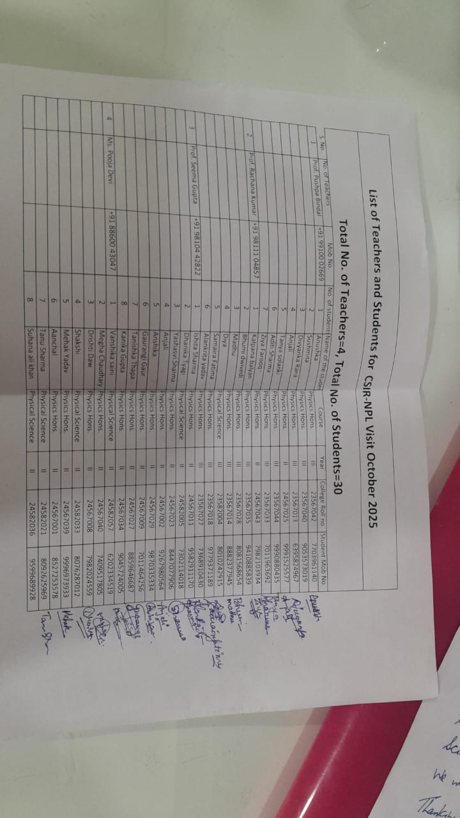
Geo tagged Photographs:
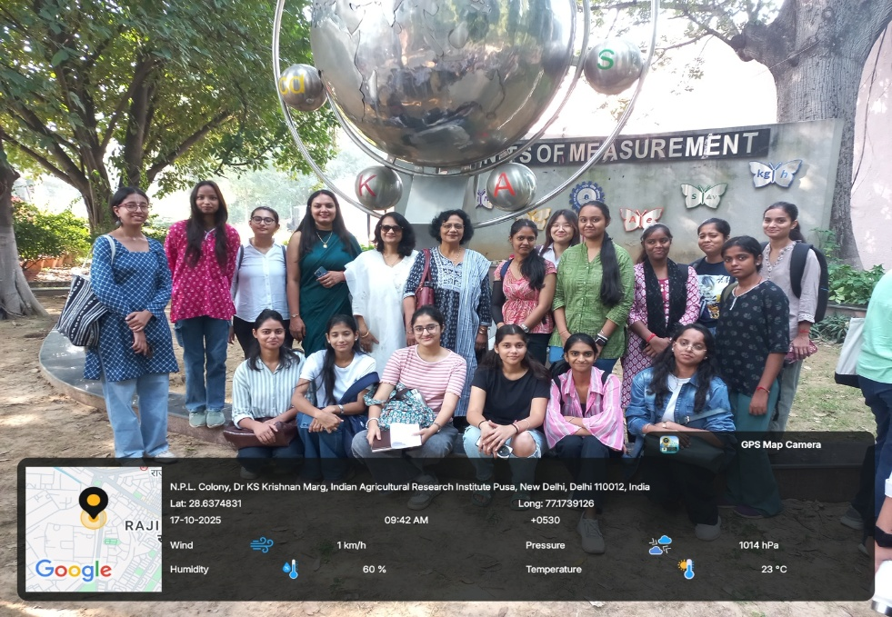
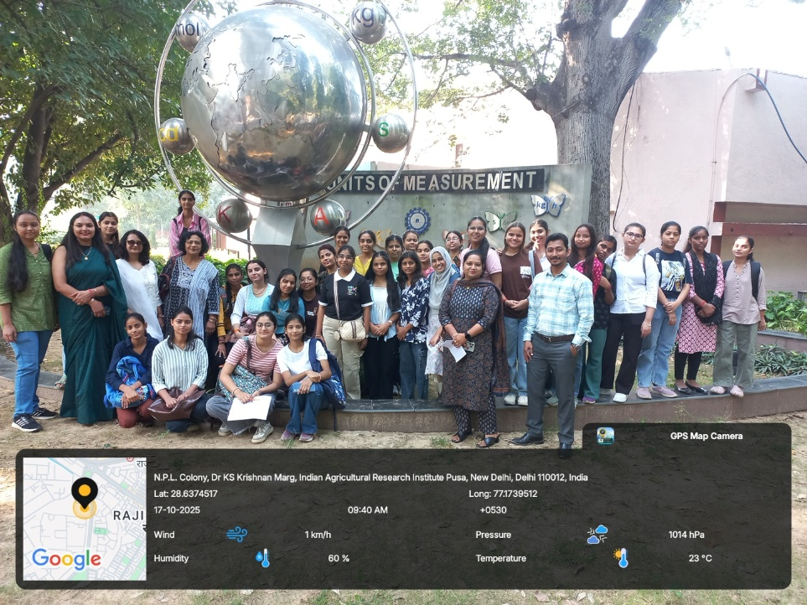
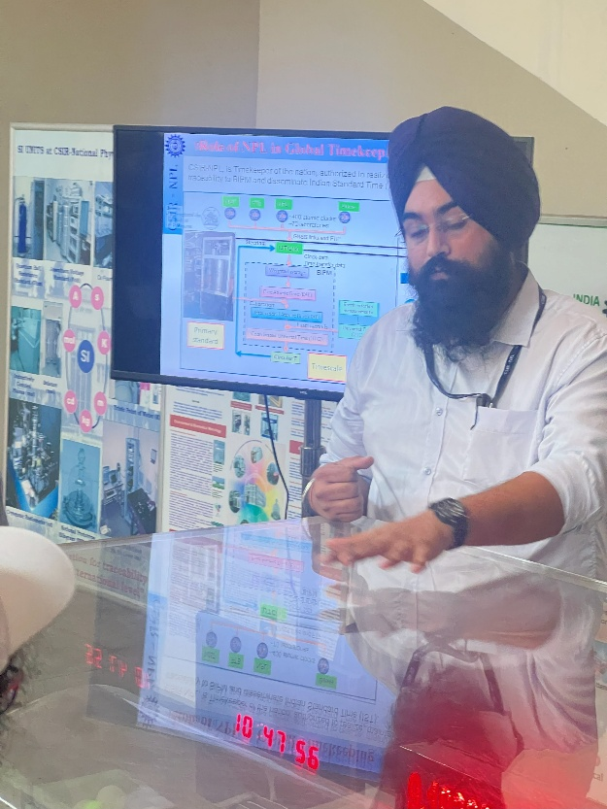
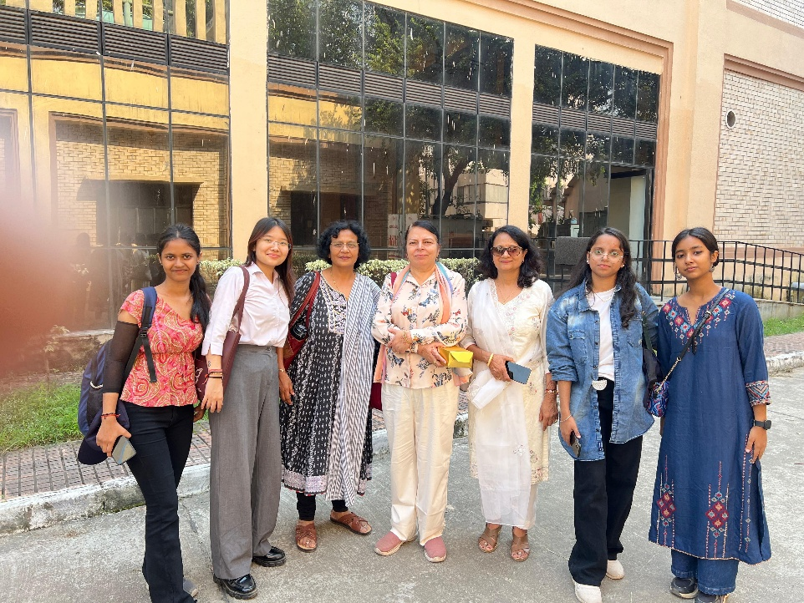
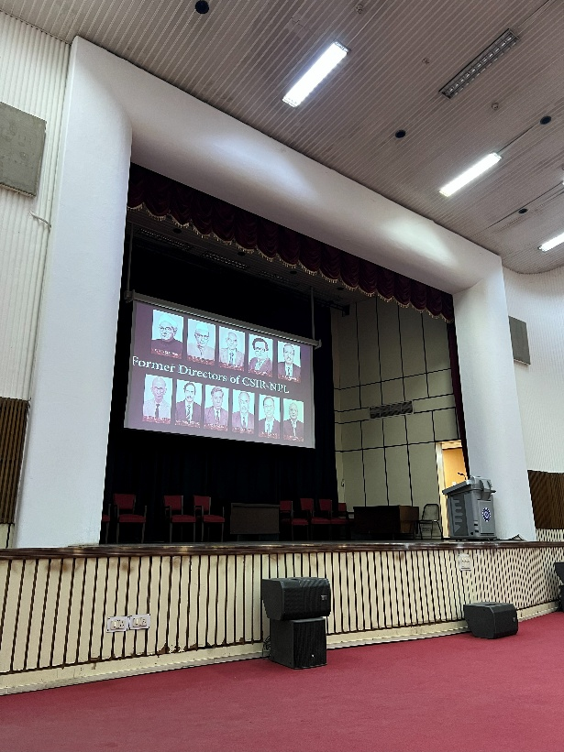
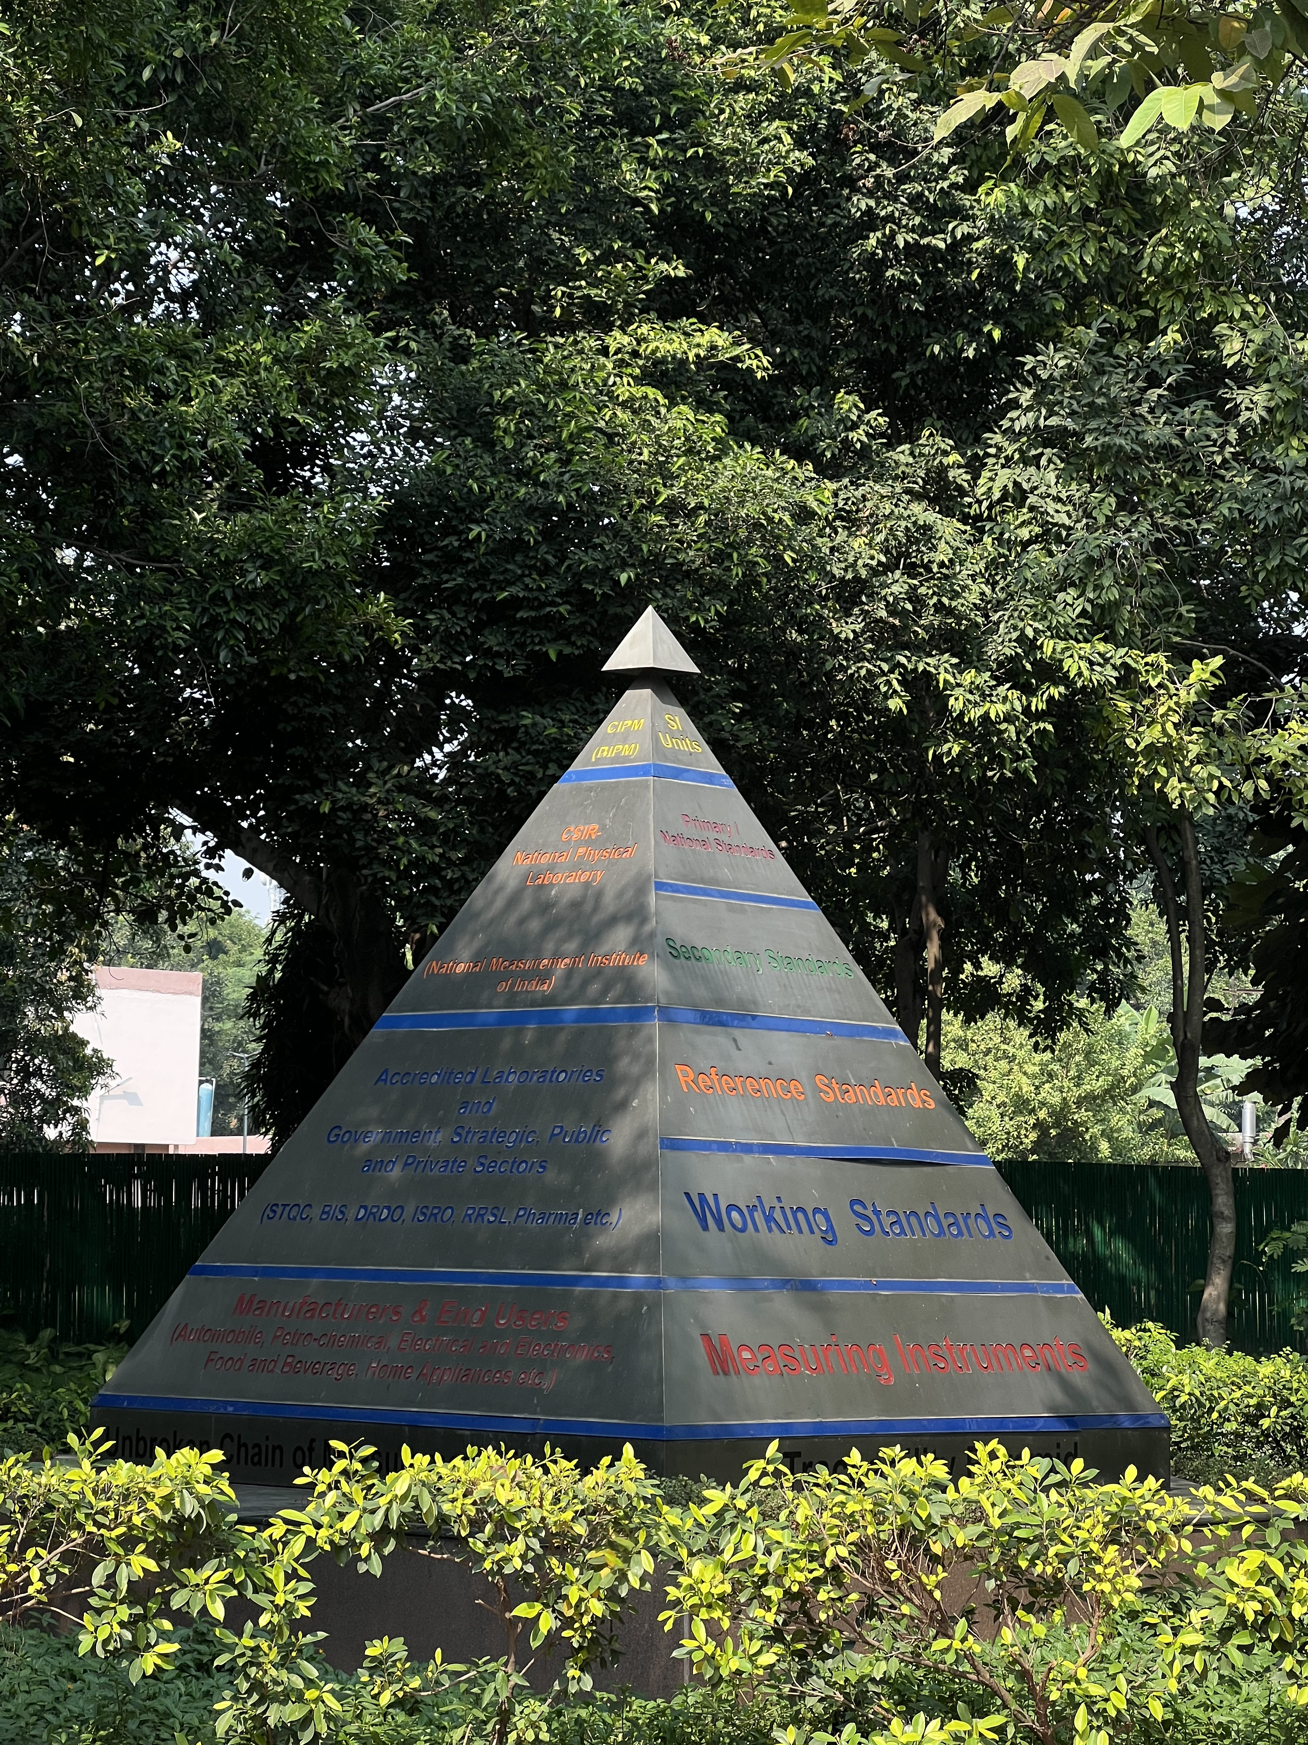

REPORT ON E-POSTER MAKING COMPETITION

- Department/Committee/Cell/Cultural Clubs, Others: PHYSITHON SOCIETY
- Name of the activity: E-poster Making
- Funding Agency (Internal/External) and Amount: 0/-
- Name of the Convener: Dr. Aravind Kumar
- Name of the Co-Conveners: Prof. Monika Bassi ,Dr. Rashmi Menon
- Name of Teacher Coordinators: none
- Date/s (-to-) and time (-to-) of activity: 8th October 2025 to 11th October 2025
- Collaborating agency if any: NONE
- Number of participants : 156

POSTER OF THE EVENT

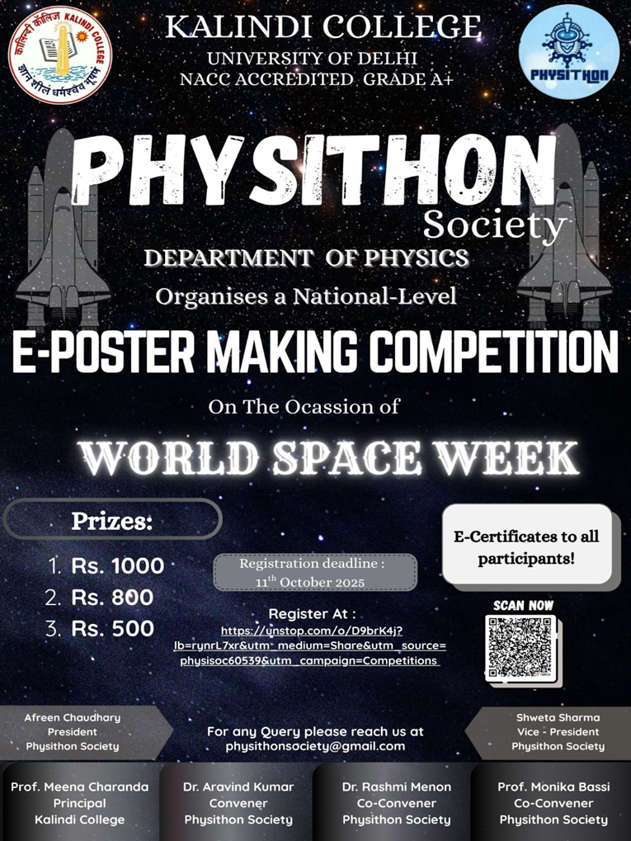

Detailed Report on E-poster Making Competition

- BRIEF TO THE EVENT

An E-Poster making competition was organized by physithon society of Physics Department ,Kalindi College on the occasion of World space week in order to make society aware about sciences and technology along with that the event aims to unveil the hidden artist behind the students and make the students to unleash their creativity and artistic skills . An e-poster (electronic poster) is essentially a digital version of a traditional paper poster. Instead of being printed and physically displayed, it is designed to be viewed on a digital screen. The competition was organized on an Online website name unstop, exciting cash prizes were also announced for winners and some constellation prizes were also given to participants, which motivated students to participate for the event , the event recorded a total of 156 participants out of which winners were announced for winner Rs. 1000 was announced as cash prize, for 1st runner- up cash prize was Rs. 800 for 2nd runner up prize the amount was Rs. 500, along with that certificates for all the participants and consolation prizes were also there.

LIST OF WINNERS AND CONSOLATION PRIZES ALONG WITH THEIR DETAILS

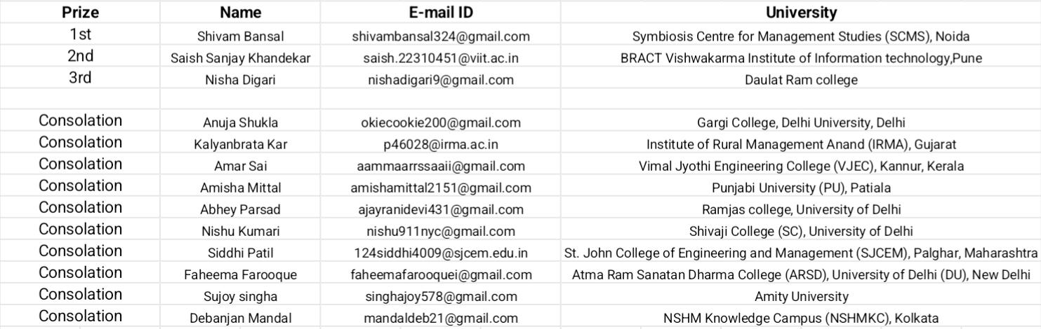

A VIEW TO THE WINNING POSTERS OF E-POSTER MAKING COMPETITION

- WINNER
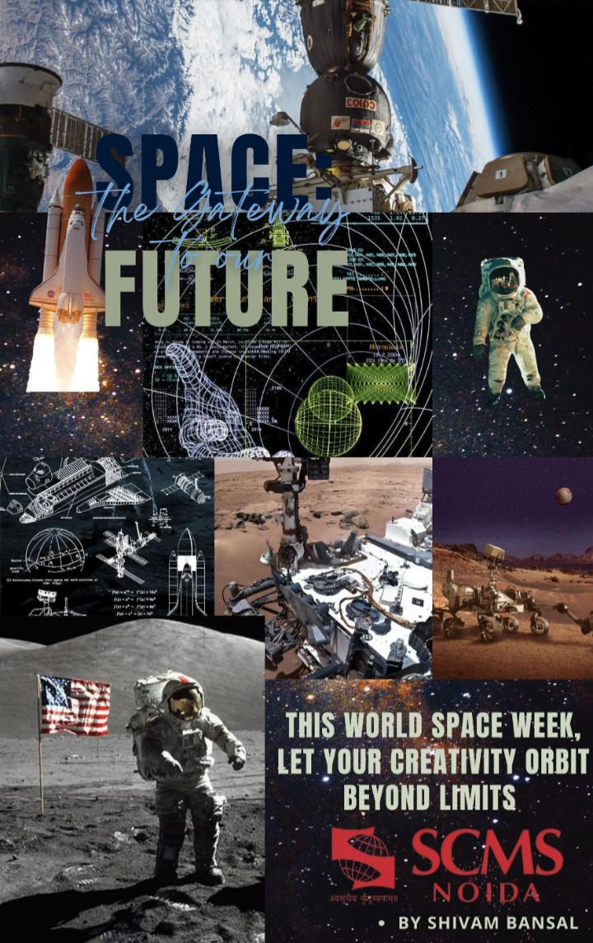

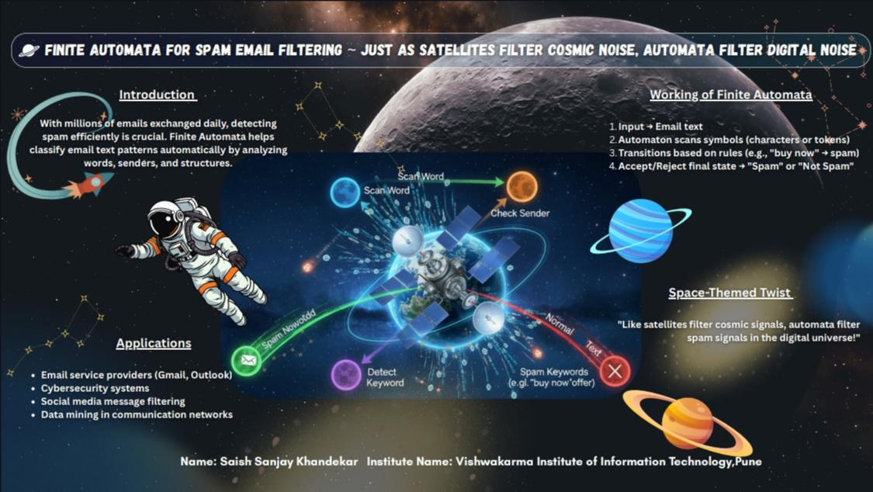
- 1ST RUNNER UP

- 2ND RUNNER UP

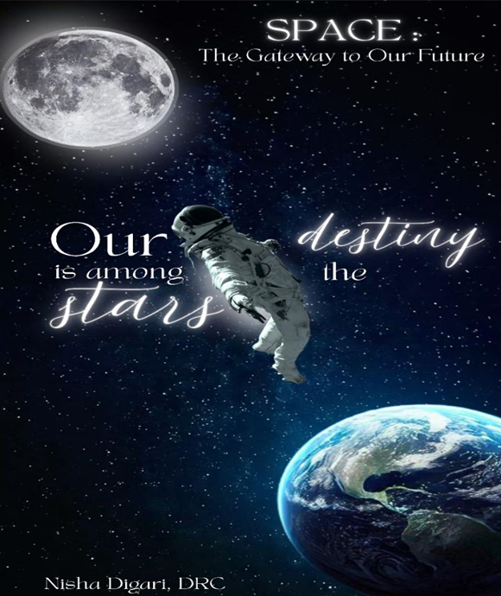
KALINDI COLLEGE

REPORT ON INTER COLLEGE SEMINAR ON ARTIFICIAL INTELLIGENCE AND OATH CEREMONY

- Department/Committee/Cell/Cultural Clubs, Others: PHYSITHON SOCIETY
- Name of the activity: Inter-college Seminar on Artificial Intelligence- SYNAPSE
- Funding Agency (Internal/External) and Amount: 0/-
- Name of the Convener: Dr. Aravind Kumar
- Name of the Co-Conveners: Prof. Monika Bassi ,Dr. Rashmi Menon
- Name of Teacher Coordinators: none
- Date/s (-to-) and time (-to-) of activity: 6th November 2025
- Collaborating agency if any: NONE
- Number of participants : 76

POSTER OF THE EVENT
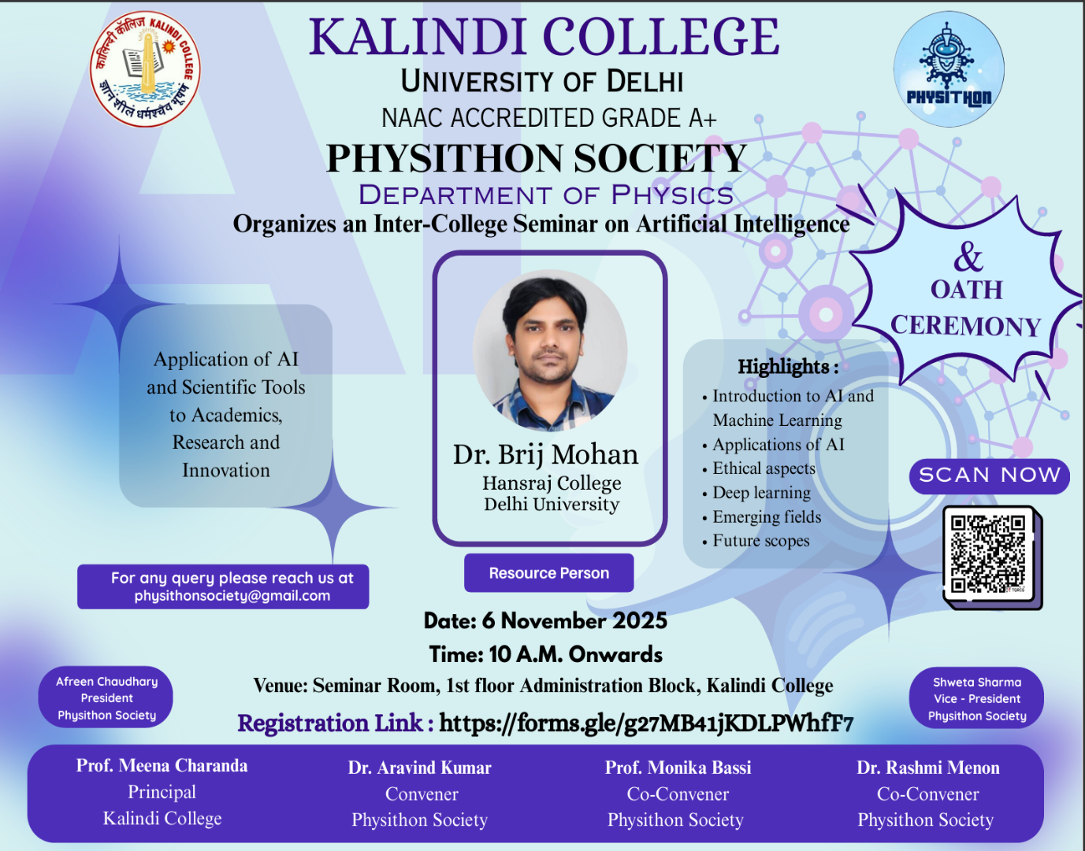
Detailed Report on Inter-College Seminar on Artificial Intelligence (AI) AND OATH CEREMONY

- BRIEF TO THE EVENT
An Inter-College Seminar on Artificial Intelligence (AI) was organized by the Department of Physics of Kalindi College, to make students aware about the latest developments in the field of science and technology. Dr. Brij Mohan, an expert in the field of Artificial Intelligence was invited as the guest speaker, who delivered an insightful lecture on Artificial Intelligence and its vast applications beyond robotics. The main aim of the seminar was to encourage students and make them to explore various dimensions in the field of AI.
During the seminar, Dr. Brij Mohan explained the relationship among AI, Machine Learning (ML), Deep Learning (DL), and Generative AI, highlighting how these areas are interconnected and form the foundation of modern intelligent systems. He also discussed Agents for Travelling AI, explaining how AI is applied in travel planning, route optimization, and decision-making. Furthermore, he introduced various Tools for AI used in research and industry and gave insights into Neural Networks, describing their role in mimicking the human brain. The session also covered the use of AI in Research, Data Analysis, and Modelling, showing how AI helps in handling big data and predicting outcomes. The seminar was highly informative and motivated students to explore the vast potential of Artificial Intelligence in various fields.
Along with the seminar, an Oath Ceremony of the Physithon Society was also held, where the newly inducted members took an oath to uphold scientific curiosity, teamwork, and dedication towards learning in the field of Physics.
Several fun activities were also organized to engage the students. The first activity was a Quiz Relay, which tested the participants’ knowledge about AI and general science — it turned out to be very entertaining and competitive. The second activity, Simon Says, saw active participation from students who enjoyed themselves thoroughly. Many participants won exciting prizes. The event was filled with enthusiasm, learning, and creativity, making it both educational and enjoyable for everyone.

- Details of Competition
Activity | Details | Participants / Teams | Winners
Quiz Relay | A fun and competitive quiz testing knowledge of AI and general science. | Team 1: Arun Soni, Jatin, Ritesh  Team 2: Lokman, Harsh Goswami, Vishal  Team 3: Divyanka, Anushka, Samaira  Team 4: Sneha, Aditi, Bhumi | Winning Team: Team 3 (Divyanka, Anushka, Samaira)
Simon Says | An interactive and entertaining activity focusing on alertness and coordination. | Around 20–25 students participated. | Winners: Yashasvi and Kritika

- Attendance
Name | Course | College name
Himanshi | BA programme | Kalindi college
Nidhi yadav | BA PROGRAMME | Kalindi college
Lakshmi | B. A. Programme | Kalindi college
Aditi Chaurasia | B.A program political science +Music | Kalindi college
Nitya yadav | Ba program | Kalindi college
Chahak Yadav | BA program | Kalindi college
Khushboo | Ba program (history+political science) | Kalindi college
Rachna Rathaur | BA (programme) | Kalindi college
Srishti | B.A program | kalindi college
Rachna Rathaur | BA (programme) | Kalindi college
Swasti Verma | Ba programme- political science+economics | Kalindi college
Akanksha Sharma | BA program | Kalindi college
Nisha Meena | B.A.Programme | Kalindi College
Priya Kanaujiya | BA Program | Kalindi college
Sunanda kumari | BA program | Kalindi College
Sakshi Gupta | Bsc physics honors | Kalindi college
Anshika | Bsc physics honours | Kalindi college
Dhanika | Bsc ps with cs | Kalindi college
Jiya | Physics (hons) | Kalindi college
Pooja | B.sc hons physics | Kalindi college
Nidhi Yadav | Ba programme | Kalindi college
Mahak | Physics hons | Kalindi College
Anjali | B.sc physics honours | Kalindi College
Ishita Sharma | Bsc. Physics hons | Kalindi college
Gaurangi Gaur | Bsc physics honours | Kalindi college
Angel Singh | Physics honours | Kalindi college
Aanchal | Bsc Hons Physics | Kalindi College
Mahak Bhati | B.Sc. Physics(Hons) | Kalindi College
Anushka | Bsc physics hons | Kalindi college
Harshita kumari | B.sc physics honours | Kalindi college
Gauri | BSC hons physics | Kalindi college
Tanya | Bsc physics hons | Kalindi college
Ziya Farooq | B.Sc(Hon.) Physics | Kalindi College
Tanishka Thapa | B.Sc(Hon.) Physics | Kalindi College
Sonam | Physics honours | Kalindi College
Sneha Kumari | Bsc physics hons ,3rd year | Kalindi College
Prachi | Bsc. Physical science with computer science | Kalindi College
Megha kumari | Bsc physics honours | Kalindi college
Akshita Chauhan | Bsc (hons) physics SEM1 | Kalindi college
Suhana Ali khan | Bsc. Physical science with computer science | Kalindi college
Divyanshi Pathak | Bsc(hons) physics | Kalindi college
Vanshika Saini | Bsc physical science with computer science | Kalindi college
Sanskriti | Bsc . Hons physics | Kalindi college
Deeksha Ravesh | BSc hons physics | Kalindi college
Anshika Gupta | Bsc Hons physics | Kalindi college
Udita raj | Bsc physical science with computer science | Kalindi college
Nisha Meena | B.A.Programme | Kalindi College
Gungun Kushwaha | Physics honours | Kalindi college
Laxmi | B. A. Programme | Kalindi college
Mahima Dubey | B.sc. (hons.) physics | Kalindi college
SABRIN ANISH | Semester 1st B. Sc. (Hons) | Kalindi college
Khushboo | Ba.program (history+political science) | Kalindi college
Rachna Rathaur | BA(programme) | Kalindi college
Muskan Thakur | Bsc Physical Science with Computer Science | Kalindi college
Poorti Pandey | Bsc physical science with cs | Kalindi college
Aditi Sharma | Bsc. Physics Hons | KalindiCollege
Yashasvi Sharma | BSc physics hons | Kalindi college
Khushi Tiwari | Ba program | Kalindi college
Yugti Rishi | B.A English honours | Kalindi college
Divyanka Rana | Bsc physics honours | Kalindi College
Chandni | Sankrit+history | Kalindi college
Afreen Chaudhary | B.Sc(Hon.) Physics | Kalindi College
Shweta Sharma | B.Sc(Hon.) Physics | Kalindi College
Samaira | B.Sc(Hon.) Physics | Kalindi College
Shakshi | B.Sc Physical Science | Kalindi College
Bhoomi Dwivedi | B.Sc(Hon.) Physics | Kalindi College
Tanu Sharma | B.Sc Physical Science | Kalindi College
Dhanika | B.Sc Physical Science | Kalindi College
Ankur Kushwaha | Bsc.hons physics | Kirori mal college
Lokman Jha | Bsc(prog) physical science with computer science | Shyam lal college
Vishal pal | B.Sc physical science with computer science | Shyam lal college
Harsh Goswami | B.SC P Computer science | Shyamlal (M) college
Raksha kumari | B.A programme | Deshbandhu collage
Anshu kumari | B.A program (his +pol science) | Deshbandhu
Ritesh Kumar | Life Sciences | Sri Venkateswara Collage
Arun Soni | Bsc physics hons | Kirori mal college
Jatin | BA programme | Motilal Nehru

- Some Glimpse of the Event
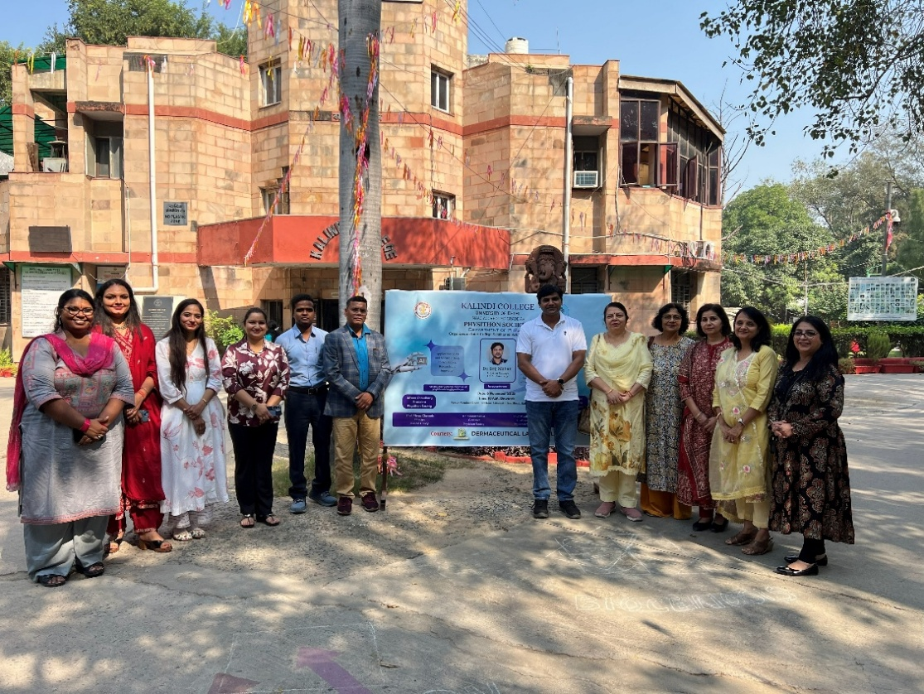

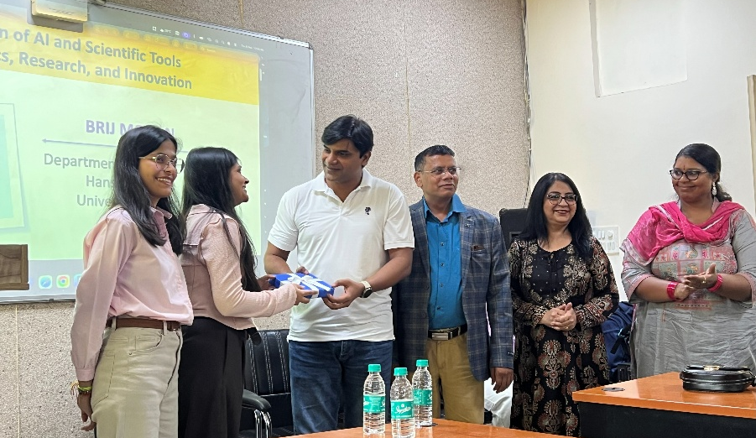
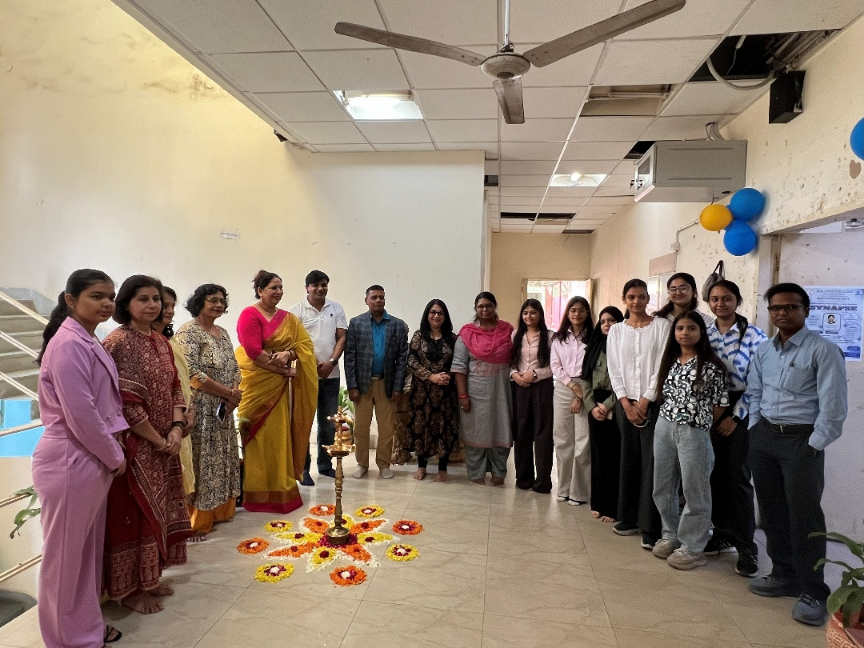
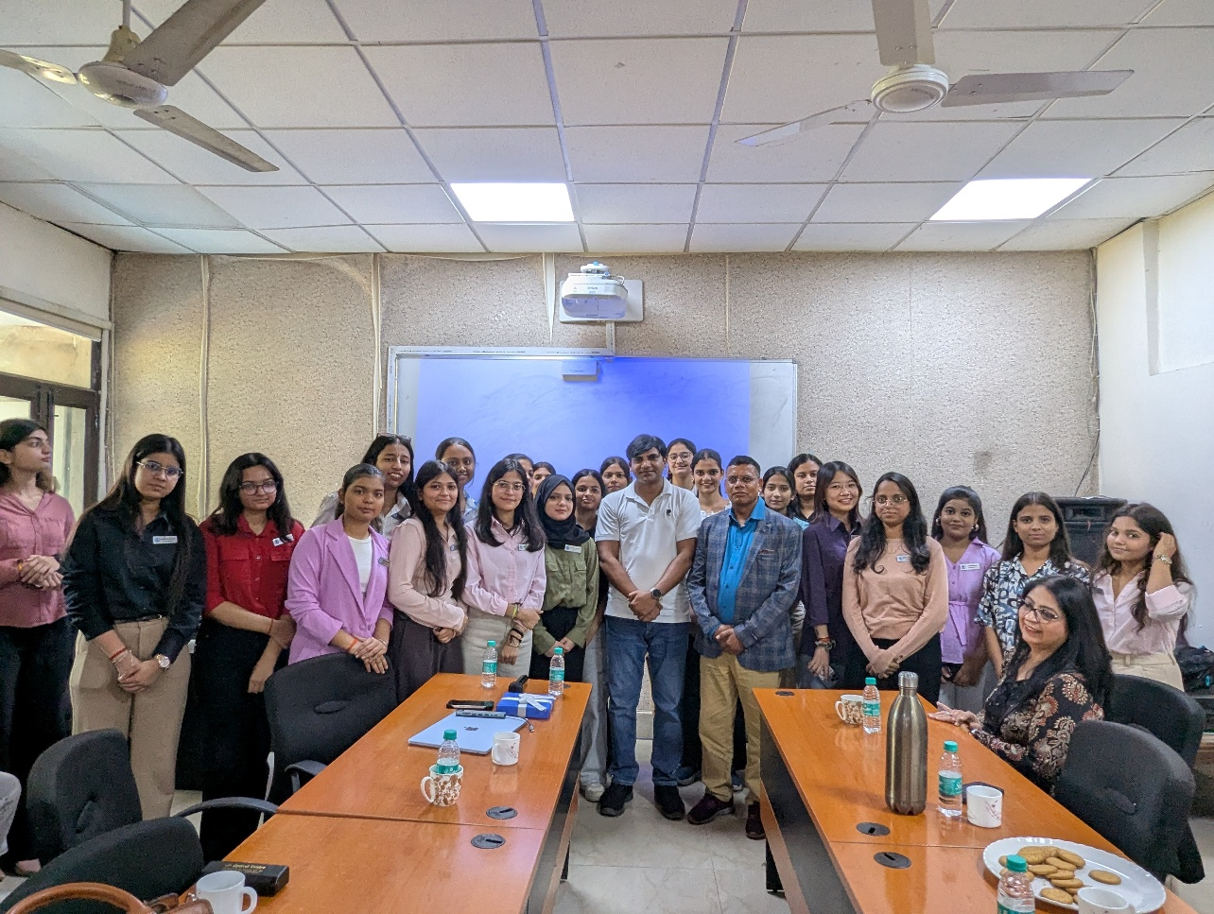
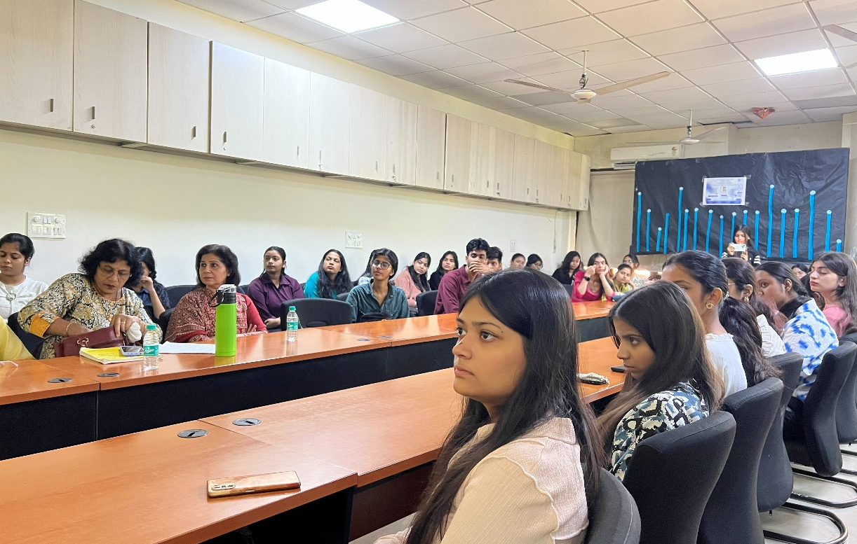
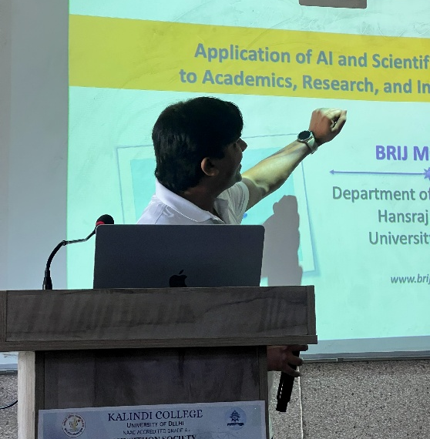
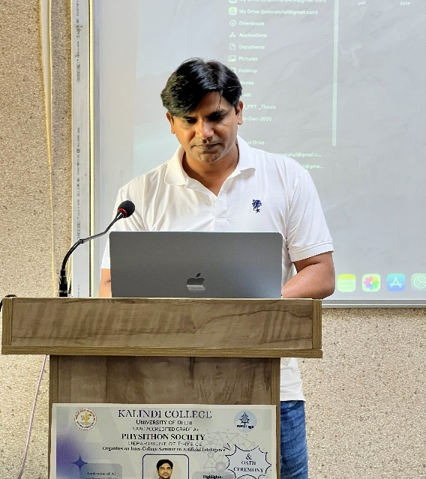
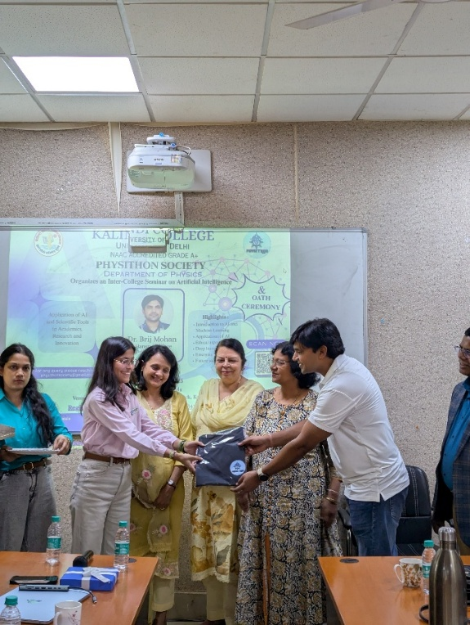
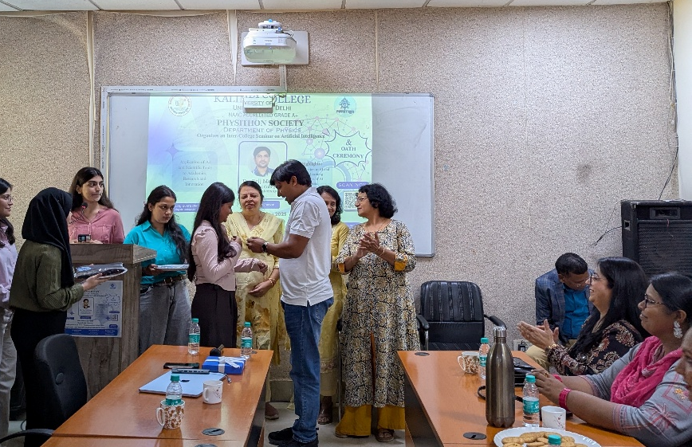
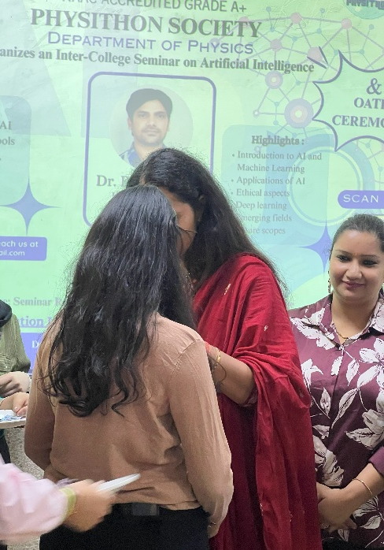
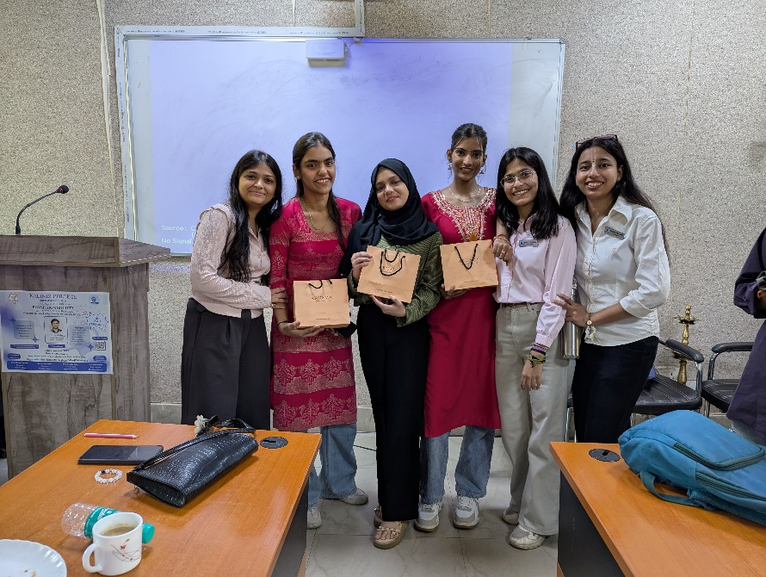
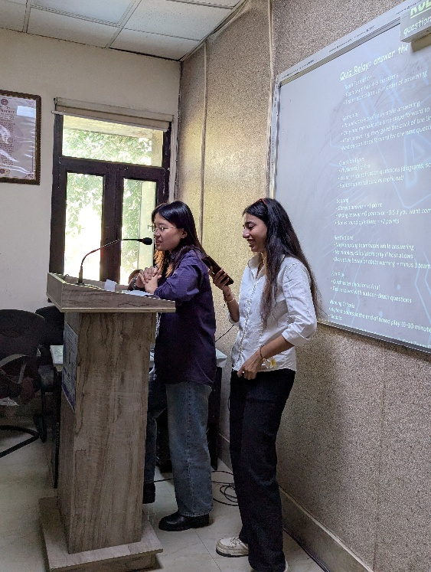
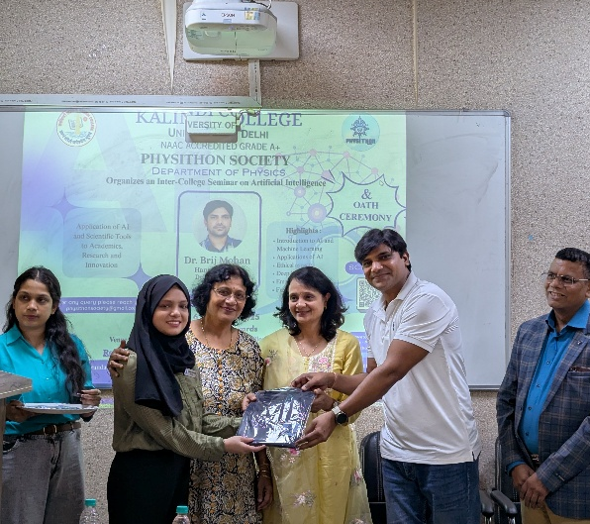

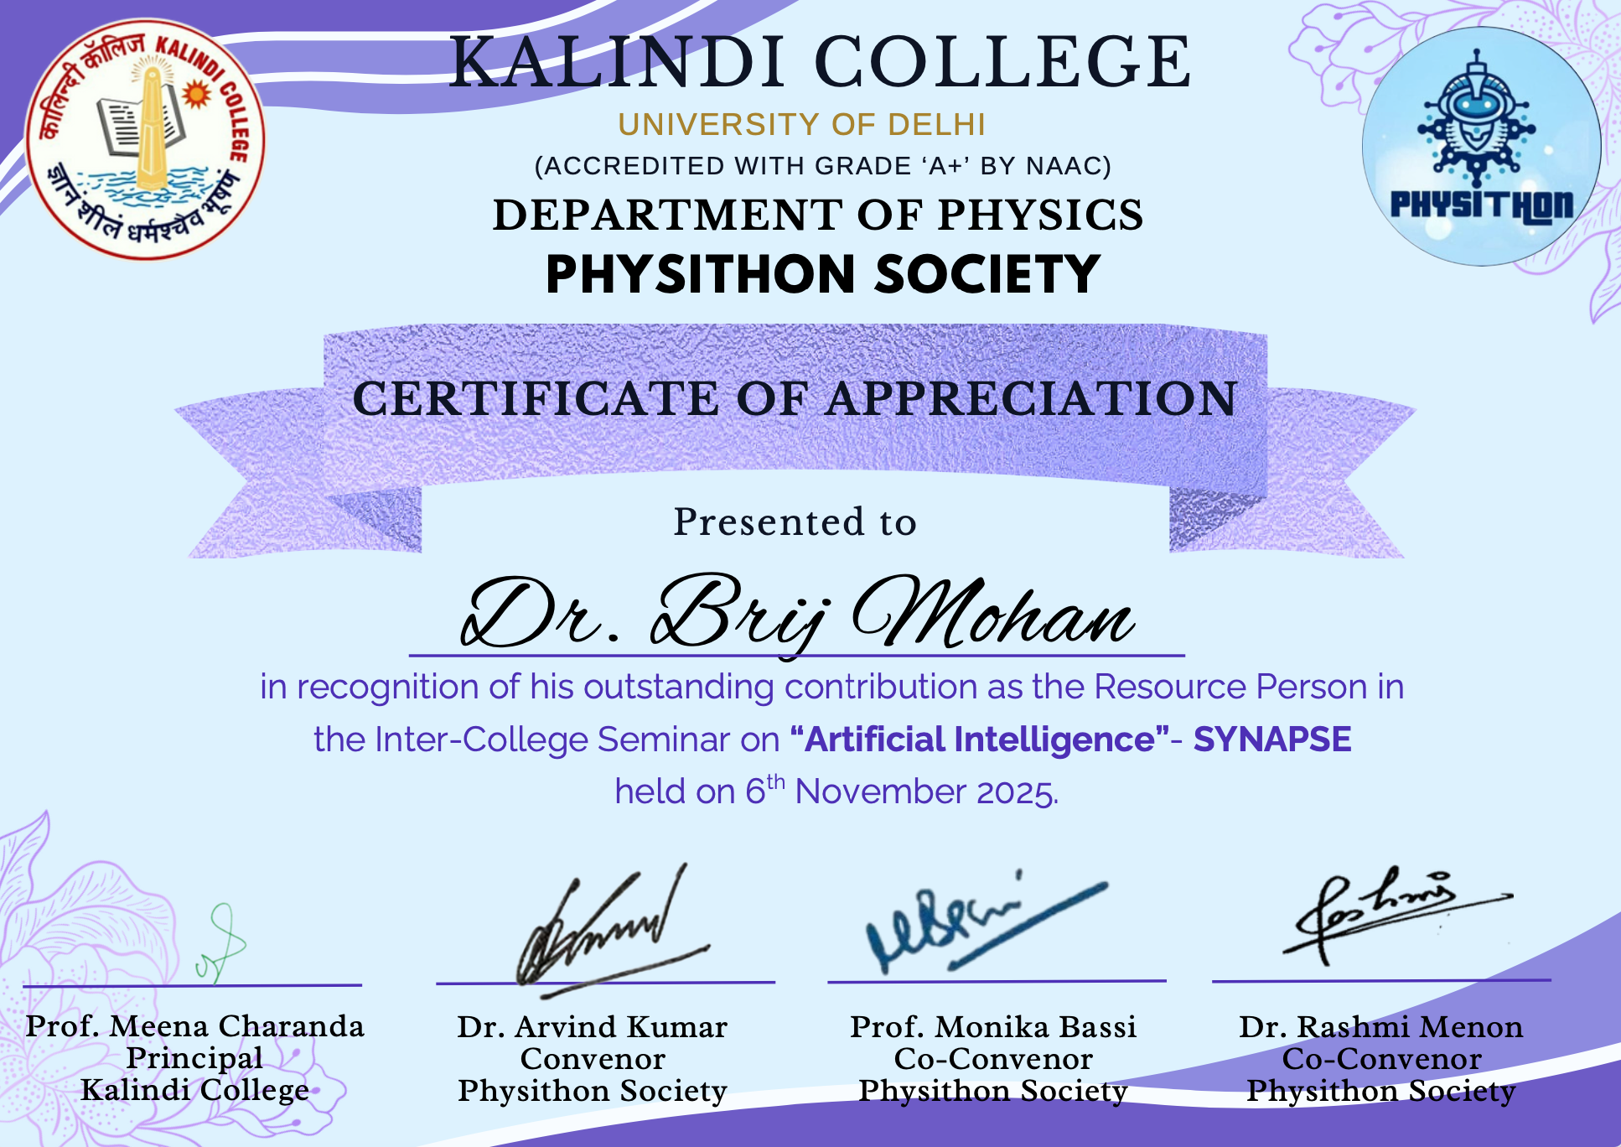
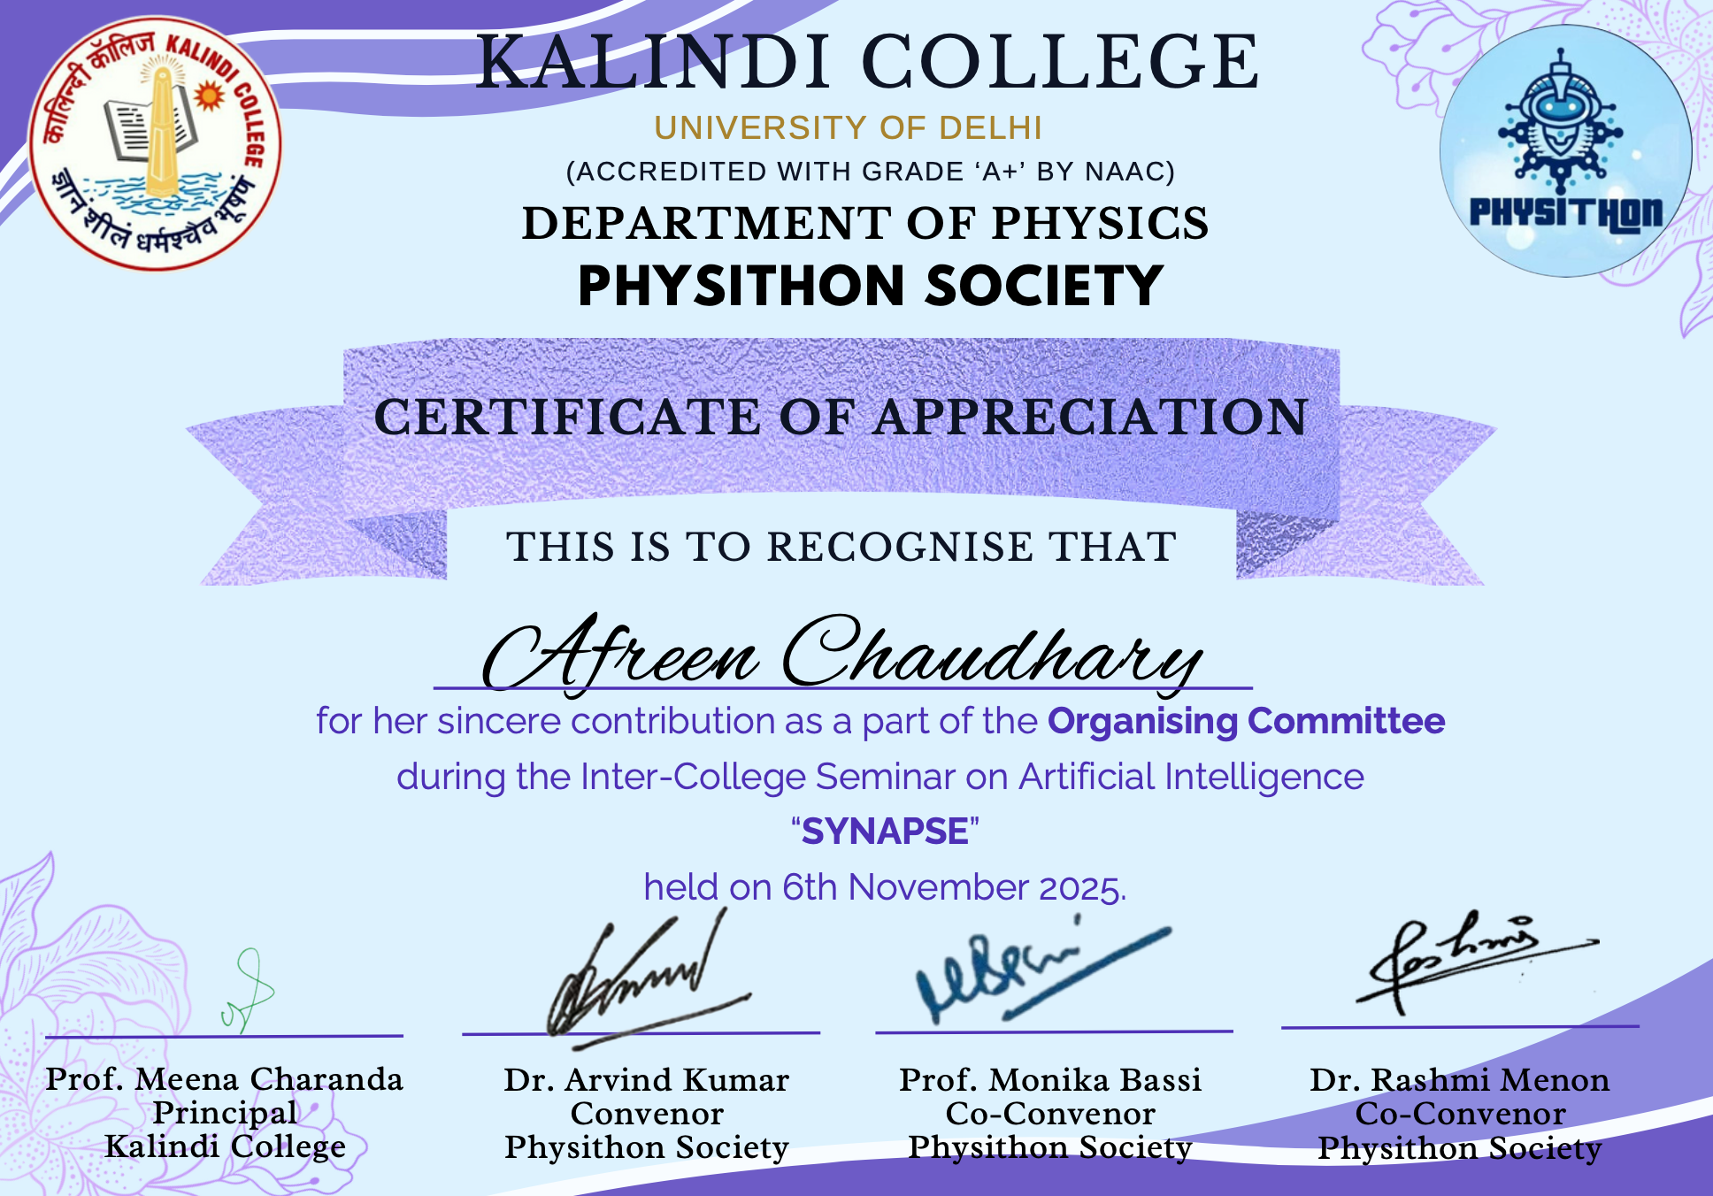

KALINDI COLLEGE

REPORT ON NATIONAL SCREENING EVENT

- Department/Committee/Cell/Cultural Clubs, Others: PHYSITHON SOCIETY
- Name of the activity: STRANGER THINGS SCREENING
- Funding Agency (Internal/External) and Amount:
  - Internal (Kalindi College)- Rs 0/-
  - External (Sponsorship)- Rs 2,000/-
- Name of the Convener: Dr. Aravind Kumar
- Name of the Co-Conveners: Prof. Monika Bassi, Dr. Rashmi Menon
- Date/s (-to-) and time (-to-) of activity: 16th January 2026, 10:00 am to 2:00 pm
- Collaborating agency if any: NONE
- Number of participants : 50

POSTER OF THE EVENT
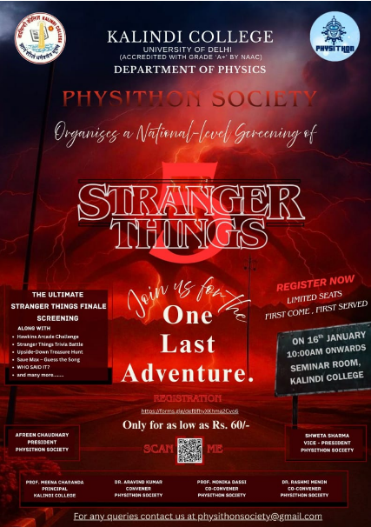

Detailed Report on STRANGER THINGS

A seminar and screening session based on the popular web series Stranger Things was organized in our college. The purpose of this screening was not merely entertainment but to use a contemporary cultural work as a medium for learning, discussion, and analysis. Stranger Things is widely known for its engaging storyline, strong character development, and blend of science fiction, mystery, and emotional themes, making it suitable for academic observation.
The primary reason for organizing the Stranger Things screening was to demonstrate how modern visual media can be used as an effective educational tool. The series incorporates elements of science, psychology, friendship, teamwork, and ethical decision-making, which are relevant to students from different academic backgrounds.
Another important reason was to encourage critical thinking and analytical skills among students. Through the screening, students were able to observe narrative structure, symbolism, character arcs, and the impact of storytelling techniques. This helped them understand how media influences perception, emotions, and social behavior.
The screening was also conducted to highlight the role of teamwork, courage, and resilience shown by the characters in challenging situations. These values are essential for personal growth and align with the moral and social development goals of higher education.
Additionally, the event aimed to make learning more engaging and relatable. By using a popular series familiar to many students, the seminar successfully created interest and active participation, proving that learning can be both informative and enjoyable.

ATTENDENCE OF THE EVENT

Name | Course | College name
Afreen Chaudhary | B.Sc. (Hons) Physics | Kalindi college
Shweta Sharma | B.Sc. (Hons) Physics | Kalindi college
Samaira Fatima | B.Sc. (Hons) Physics | Kalindi college
Tanya Solanki | B.Sc. (Hons) Physics | Kalindi college
Harshita Kumari | B.Sc. (Hons) Physics | Kalindi college
Deeksha Ravesh | B.Sc. (Hons) Physics | Kalindi college
Anshika Gupta | B.Sc. (Hons) Physics | Kalindi college
Khushboo | B.Sc. (Hons) Physics | Kalindi college
Simran | B.Sc. (Hons) Physics | kalindi college
Ziya | B.Sc. (Hons) Physics | Kalindi college
Aanchal | B.Sc. (Hons) Physics | Kalindi college
Anjali | B.Sc. (Hons) Physics | Kalindi college
Anjali | B.Sc. (Hons) Physics | Kalindi College
Tanu Sharma | B.Sc. Physical Science | Kalindi college
Vanshika Saini | B.Sc. Physical Science | Kalindi College
Shakshi | B.Sc. Physical Science | Kalindi college
Suhana | B.Sc. Physical Science | Kalindi college
Prachi | B.Sc. Physical Science | Kalindi college
Ujal | B.Com (Hons) | Kalindi college
Aditi Sharma | B.Sc. (Hons) Physics | Kalindi college
Madhia Ghyaas | B.Sc. (Hons) Physics | Kalindi college
Sneha Kumari | B.Sc. (Hons) Physics | Kalindi College
Tanya Solanki | B.Sc. (Hons) Physics | Kalindi College
Pooja | B.Sc. (Hons) Physics | Kalindi college
Ashika | B.Sc. (Hons) Physics | Kalindi college
Sabrin Anish | B.Sc. (Hons) Physics | Kalindi college
Mahima Dubey | B.Sc. (Hons) Physics | Kalindi College
Sneha | B.Sc. (Hons) Physics | Kalindi College
Sanskriti | B.Sc. (Hons) Physics | Kalindi college
Divyanshi | B.Sc. (Hons) Physics | Kalindi college
Nisha | B.Sc. (Hons) Physics | Kalindi college
Kanishka | B.Sc. (Hons) Physics | Kalindi college
Megha | B.Sc. (Hons) Physics | Kalindi College
Anushka | B.Sc. (Hons) Physics | Kalindi College
Kalpana | B.Sc. (Hons) Physics | Kalindi College
Sakshi Chaudhary | B.Sc. (Hons) Physics | Kalindi College
Tanishka Thapa | B.Sc. (Hons) Physics | Kalindi College
Mahi Chauhan | B.Sc. (Hons) Physics | Kalindi college
Gaurangi Gaur | B.Sc. (Hons) Physics | Kalindi college
Ishita | B.Sc. (Hons) Physics | Kalindi college
Archita Jena | B.Sc. Physics with electronics | Rajdhani college
Sheetal Kumari | B.Sc. Physics with electronics | Rajdhani college
Ritesh | Life Sciences | Sri Venkateswara College
Govind Singh | B.Com (Hons) | Sri Venkateswara College
Vishal | B.Com (Hons) | Sri Venkateswara College
Tanu Choudhary | Llb | Lloyd law College
Amaan Chaudhary | B.A.LL.B | Imirc College of law
Urjal | B.Com (Hons) | Kalindi College
Arun Soni | B.Sc. (Hons) Physics | Kirori mal College
Ankur Kushwaha | B.Sc. (Hons) Physics | Kirori mal College

Some Glimpse of the Event

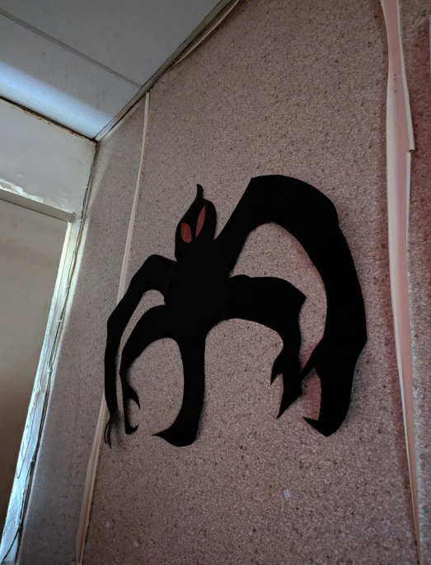
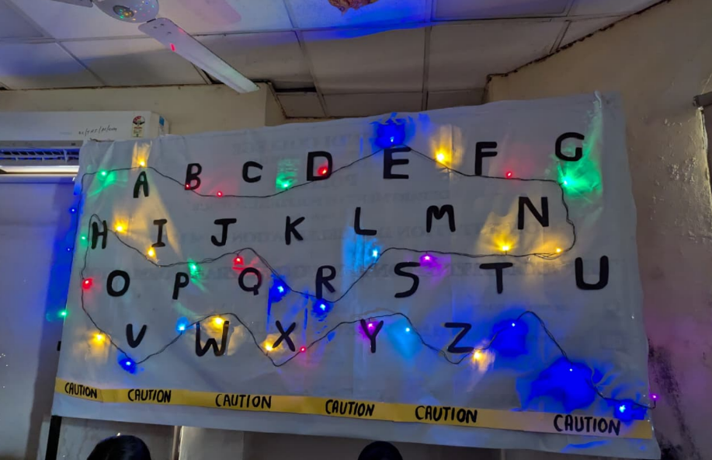

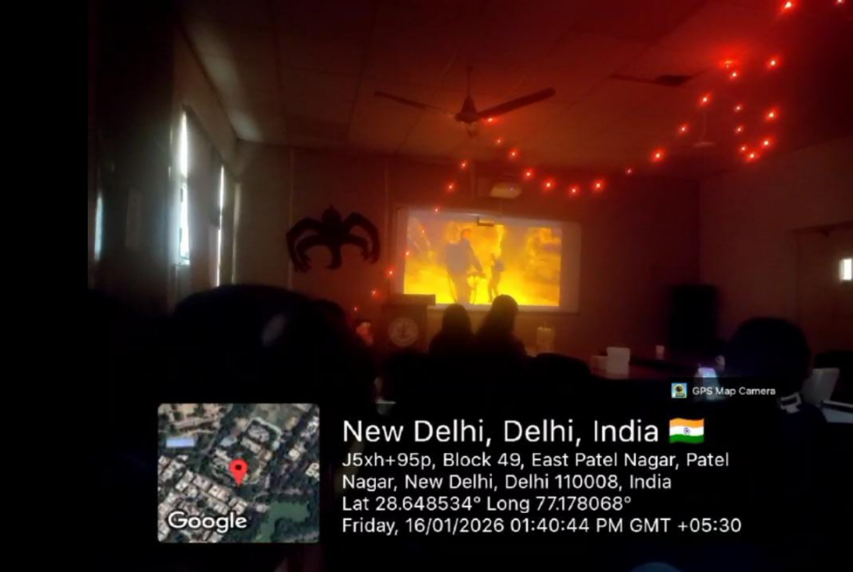

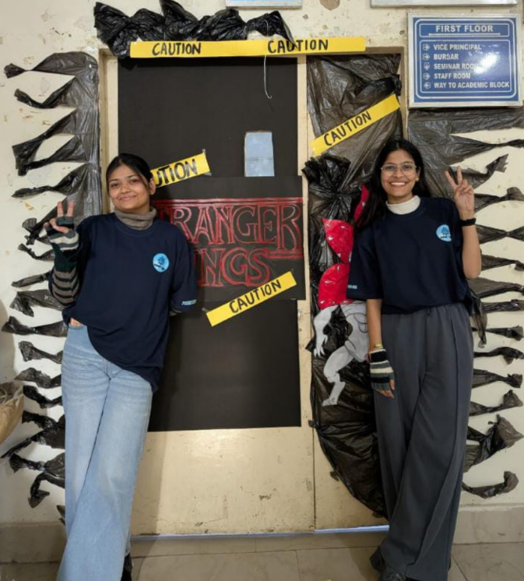

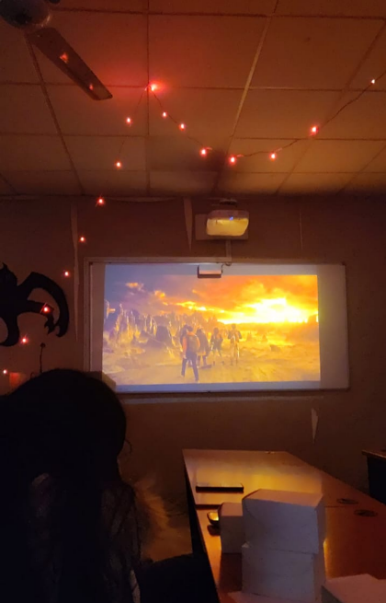

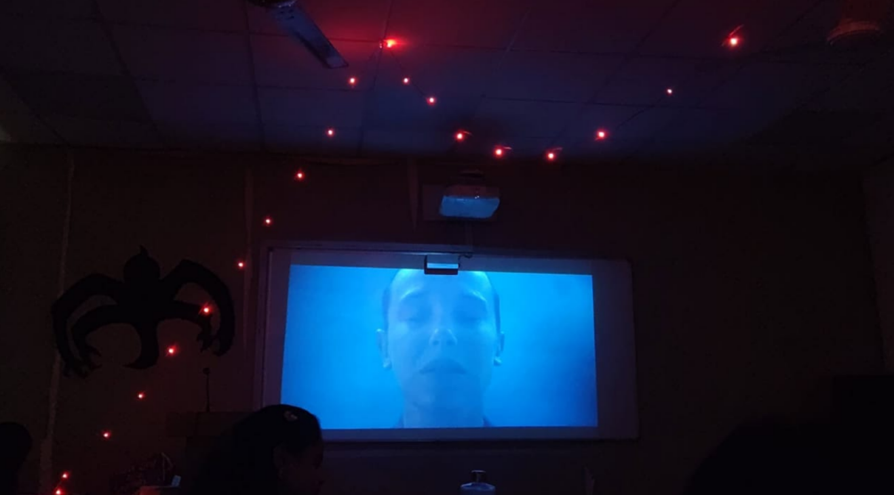

KALINDI COLLEGE

REPORT On National-Level AI Training Workshop &
Poster Making Competition

- Department/Committee/Cell/Cultural Clubs, Others: PHYSITHON SOCIETY
- Name of the activity: AI TRAINING WORKSHOP AND POSTER MAKING COMPETITION
- Funding Agency (Internal/External) and Amount:
  - Internal (Kalindi College)- Rs 0/-
  - External (Sponsorship)- Rs 0/-
- Name of the Convener: Dr. Aravind Kumar
- Name of the Co-Conveners: Prof. Monika Bassi, Dr. Rashmi Menon
- Date/s (-to-) and time (-to-) of activity: 6th Feb 2026, 10:00 am Onwards
- Collaborating agency if any: IQAC KALINDI COLLEGE
- Number of participants: 22

POSTER OF THE EVENT
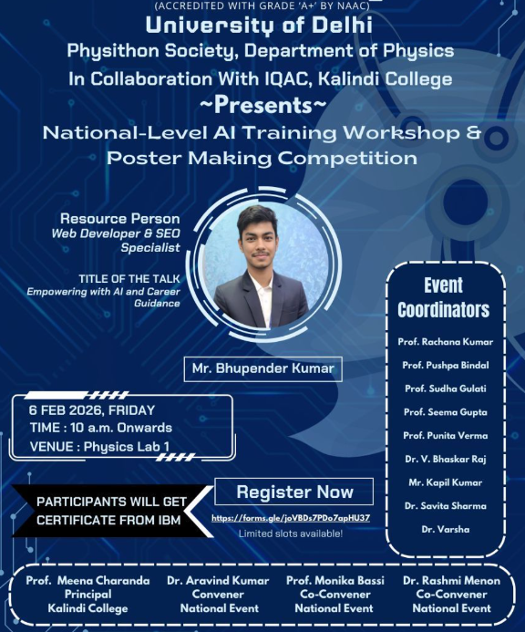

Detailed Report on AI TRAINING WORKSHOP AND POSTER MAKING
An AI Training Workshop and Poster Making Competition was organized in our college to create awareness about Artificial Intelligence and its growing importance in today’s world. The main objective of the event was to introduce students to the basic concepts of AI and encourage creativity through poster presentations.
The workshop began with an introductory session on Artificial Intelligence. The resource person explained the meaning of AI, its applications in daily life, and its role in different fields such as education, healthcare, business, and technology. Students learned about machine learning, data analysis, and automation in a simple and understandable way.
The session was interactive, and students were encouraged to ask questions. Practical examples and demonstrations helped the participants understand how AI tools are used in real-life situations. The workshop was very informative and motivated students to explore AI further.
After the workshop, a poster making competition was conducted. Students created posters based on themes related to Artificial Intelligence, such as “AI in Future,” “Benefits of AI,” and “AI in Education.” The competition allowed students to express their ideas creatively through drawings, slogans, and informative content.
The AI Training Workshop and Poster Making Competition was a successful and meaningful event. It enhanced students’ knowledge about Artificial Intelligence and provided a platform to showcase their creativity. The event was both educational and engaging, and it helped students understand the importance of AI in shaping the future.
Overall, the event was well-organized and beneficial for all the participants.

ATTENDENCE OF THE EVENT

Name | Course | College name
Afreen Chaudhary | B.Sc. (Hons) Physics | Kalindi college
Shweta Sharma | B.Sc. (Hons) Physics | Kalindi college
Samaira Fatima | B.Sc. (Hons) Physics | Kalindi college
Harshita Kumari | B.Sc. (Hons) Physics | Kalindi college
Deeksha Ravesh | B.Sc. (Hons) Physics | Kalindi college
Anshika Gupta | B.Sc. (Hons) Physics | Kalindi college
Khushboo | B.Sc. (Hons) Physics | kalindi college
Aanchal | B.Sc. (Hons) Physics | Kalindi college
Anjali | B.Sc. Physical Science | Kalindi college
Ashika | B.Sc. (Hons) Physics | Kalindi college
Divyanshi Pathak | B.Sc. (Hons) Physics | Kalindi college
Nisha Kumari | B.Sc. (Hons) Physics | Kalindi college
Sabrin anish | B.Sc. (Hons) Physics | Kalindi college
Jiya | B.Sc. (Hons) Physics | Kalindi college
Sushmita | B.Sc. (Hons) Physics | Kalindi college
Vanshika Yadav | B.Sc. (Hons) Physics | Kalindi college
Yashasvi Sharma | B.Sc. (Hons) Physics | Kalindi College
Pooja | B.Sc. (Hons) Physics | Kalindi College
Mahi Chauhan | B.Sc. (Hons) Physics | Kalindi College
Gauri | B.Sc. (Hons) Physics | Kalindi College
Shreya Kumari | B.Sc. (Hons) Physics | Kalindi College
Anjali | B.Sc. (Hons) Physics | Kalindi College

Some Glimpse of the Event
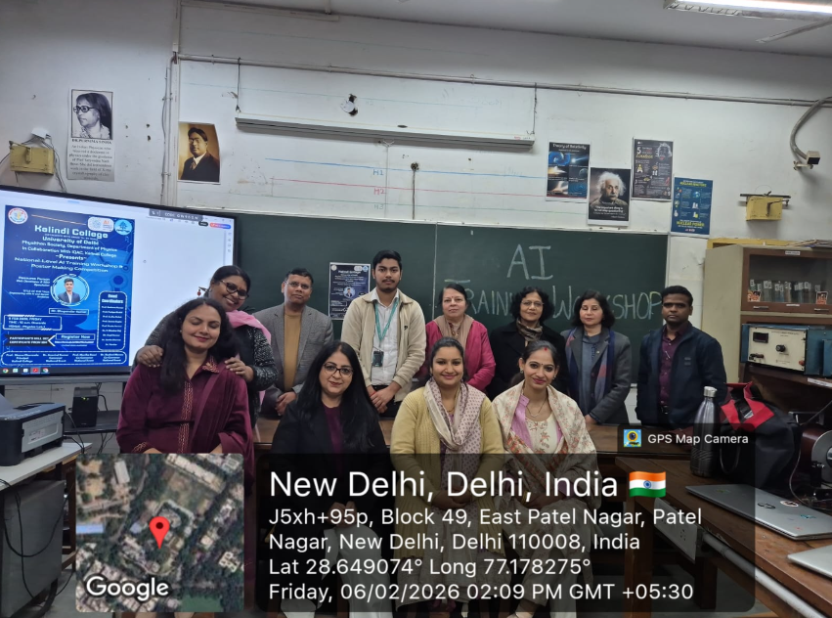

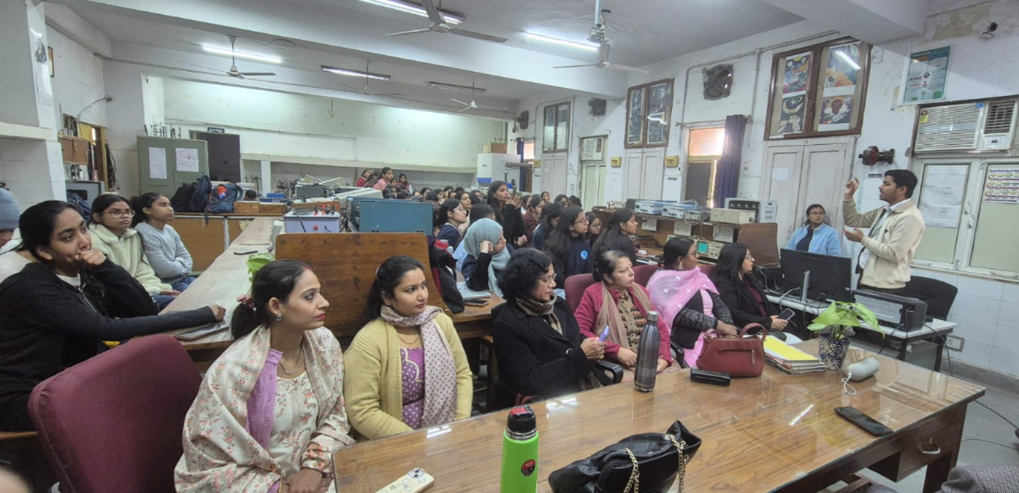
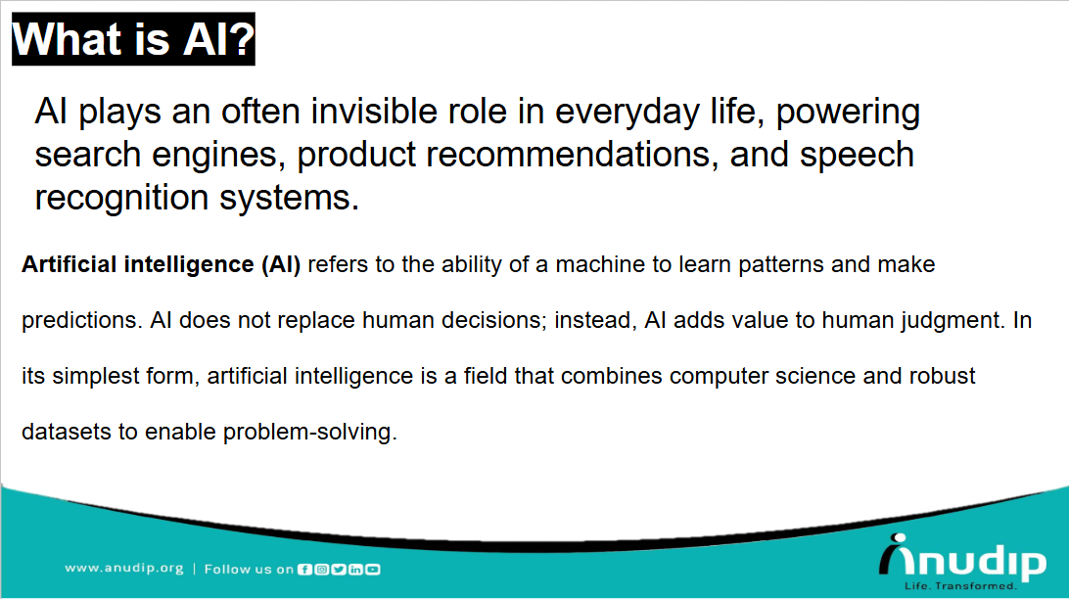
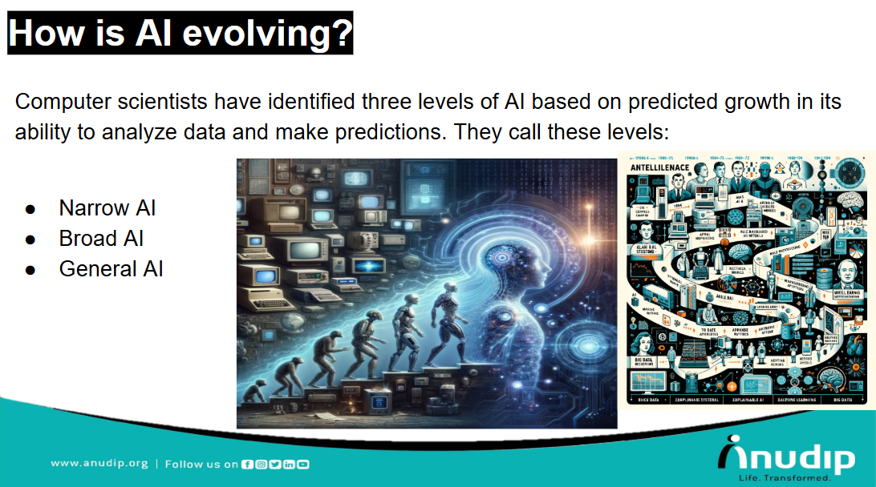
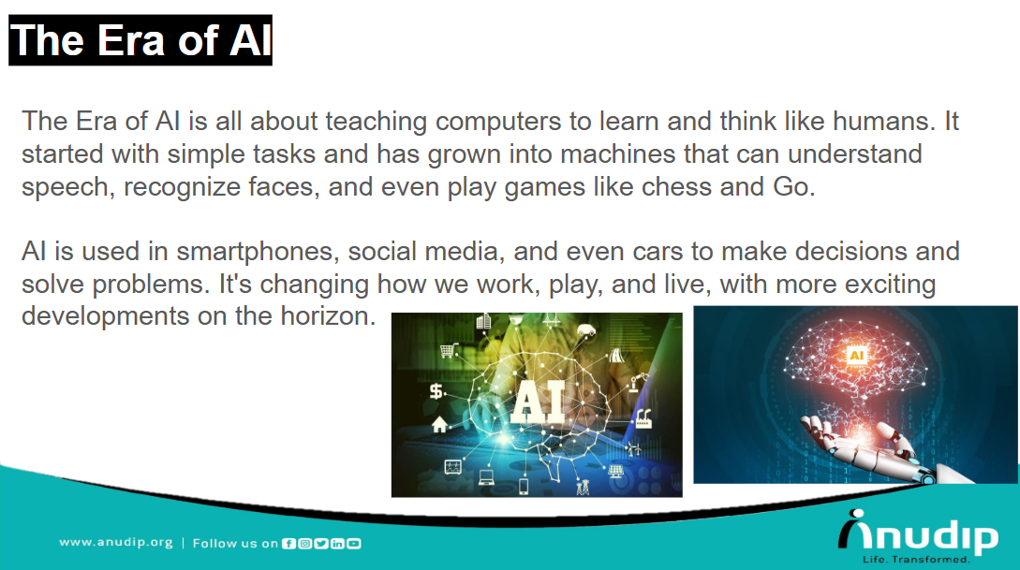
Certificates:
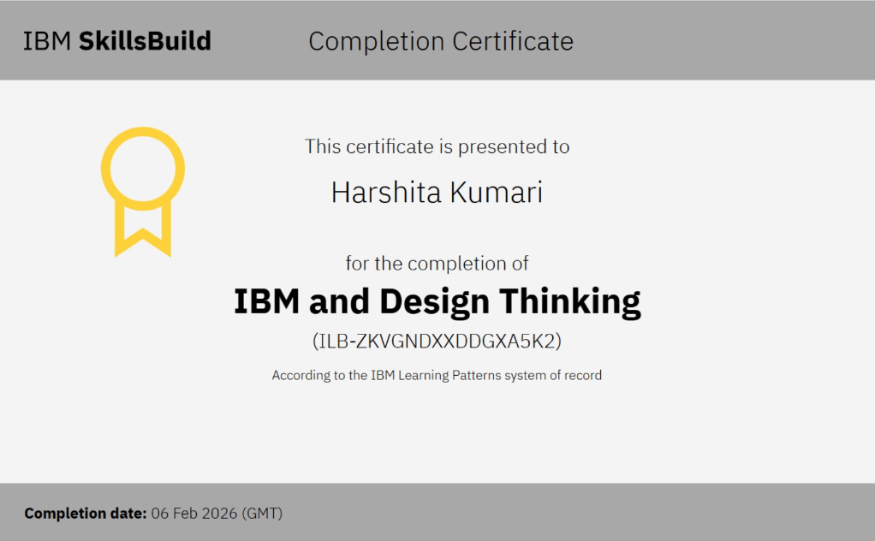
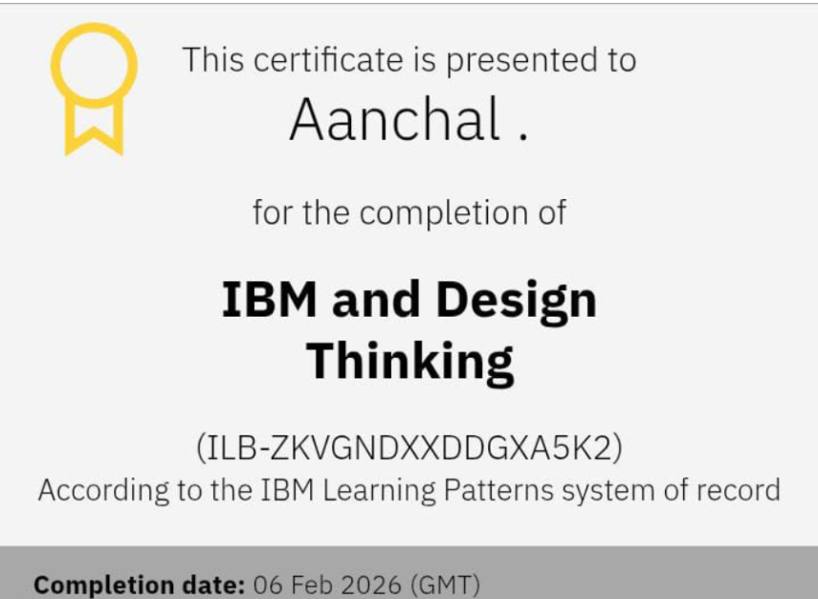
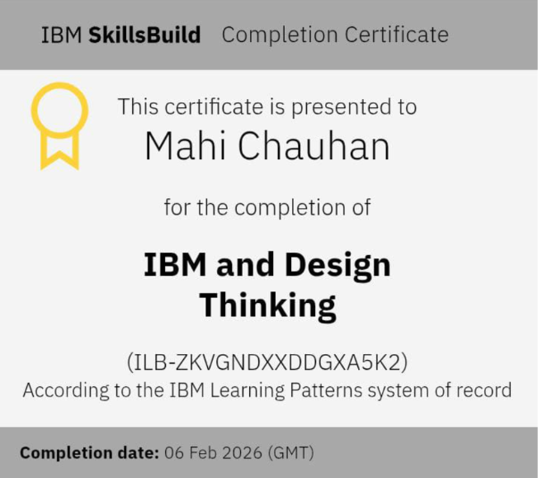
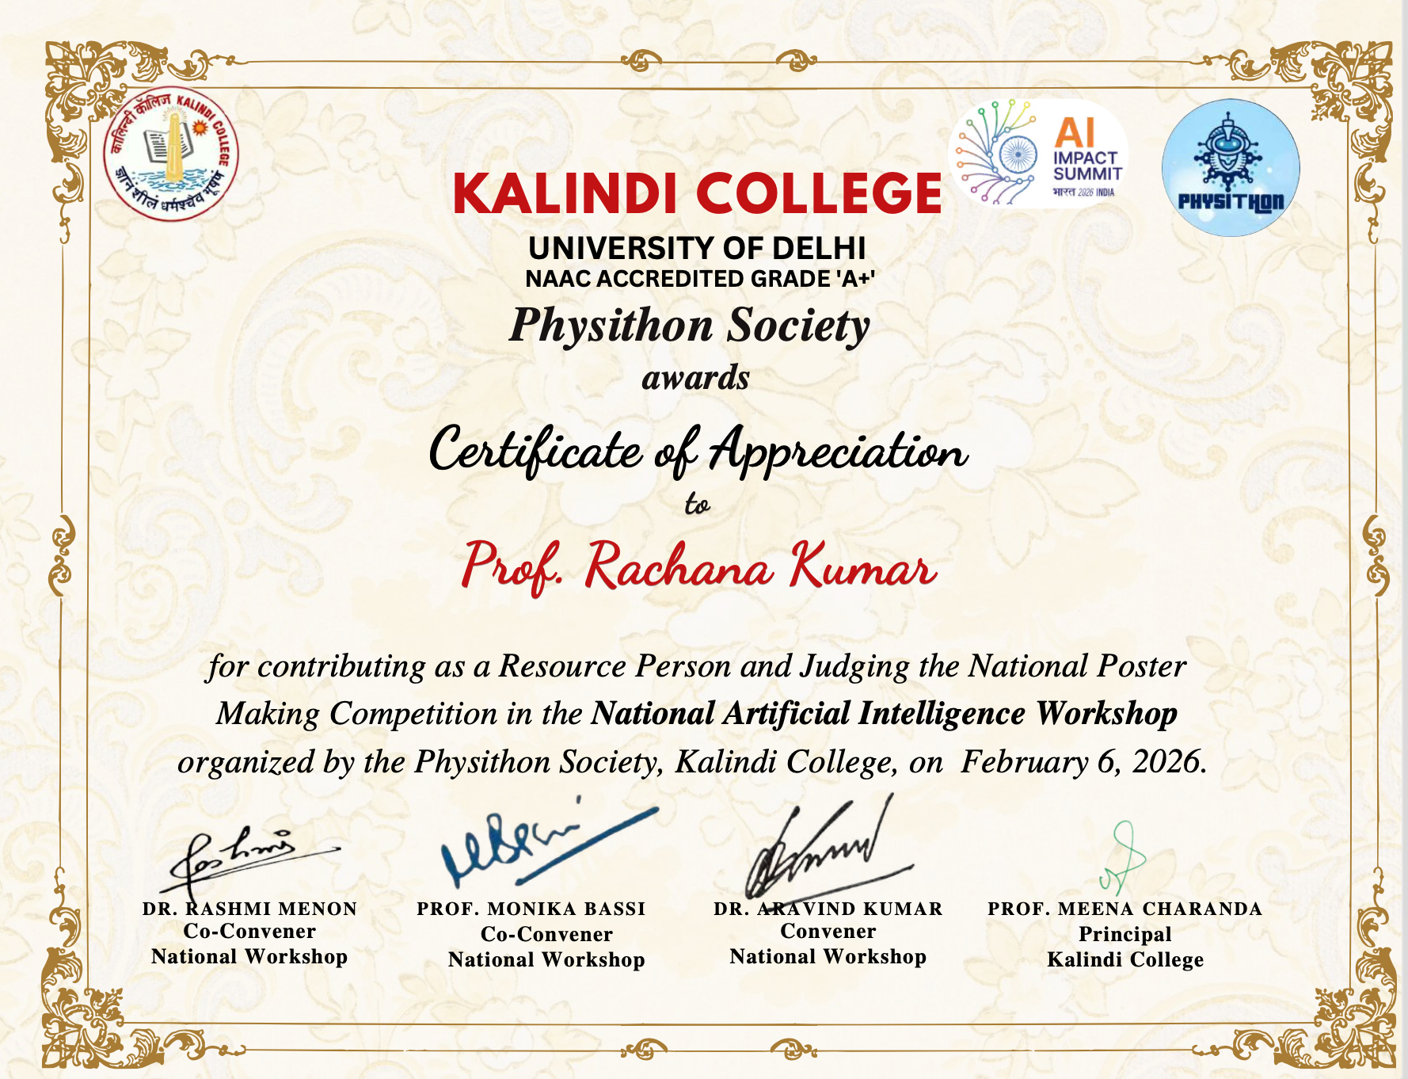
KALINDI COLLEGE

REPORT ON ALUMNI MEET ON THE OCCASSION OF NATIONAL SCIENCE DAY

- Department/Committee/Cell/Cultural Clubs, Others: PHYSITHON SOCIETY
- Name of the activity: Alumni meet – CAREER VARTALAAP
- Funding Agency (Internal/External) and Amount: 0/-
- Name of the Convener: Dr. Aravind Kumar
- Name of the Co-Conveners: Prof. Monika Bassi, Dr. Rashmi Menon
- Name of Teacher Coordinators: none
- Date/s (-to-) and time (-to-) of activity: 28th February 2026
- Collaborating agency if any: NONE

POSTER OF THE EVENT
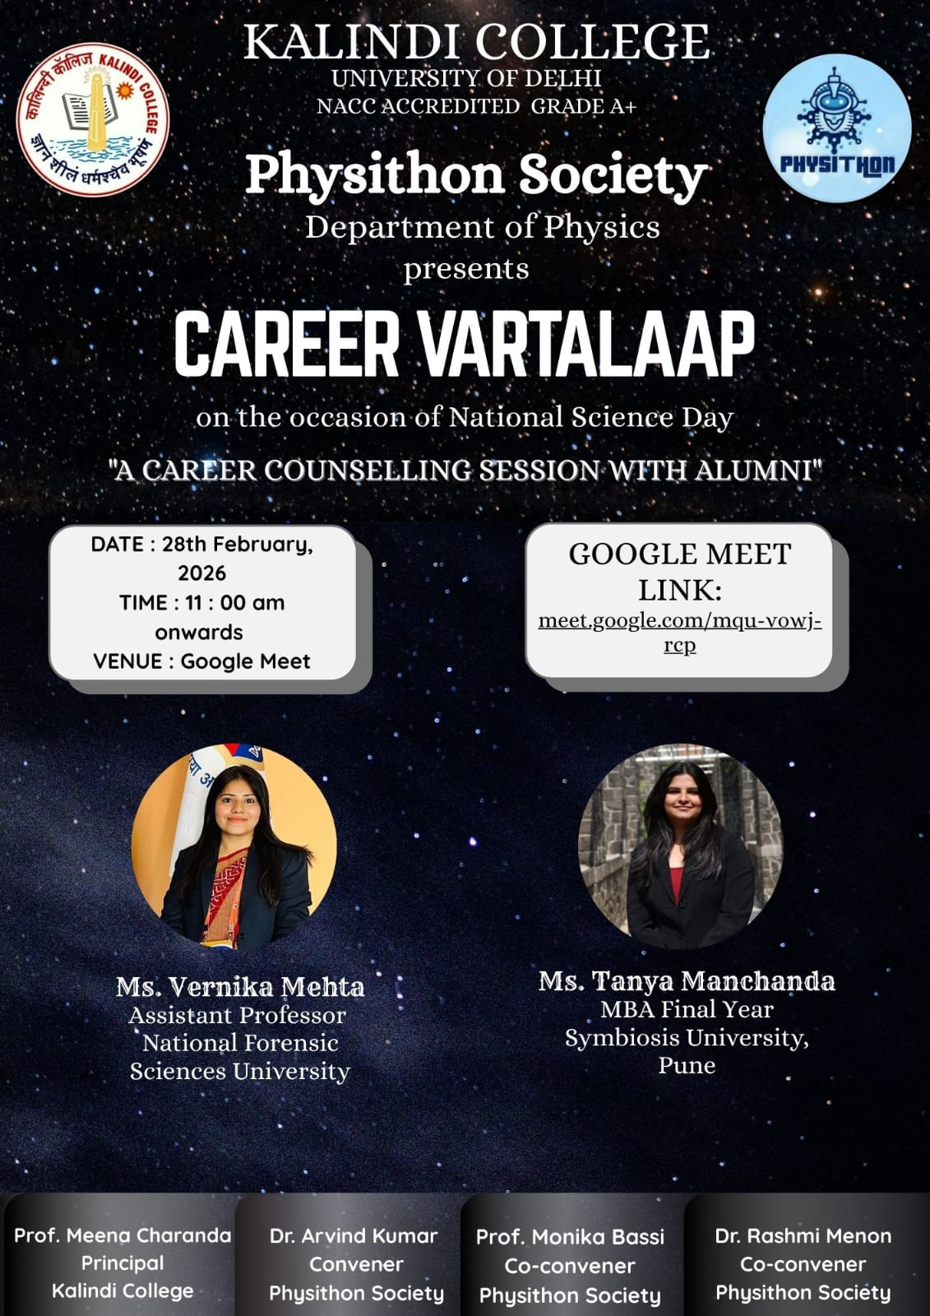

Detailed Report on Alumni meet
- BRIEF TO THE EVENT

An Inter-College Career Counselling Session titled “Career Vartalaap” was organized by the Department of Physics, Kalindi College, on the occasion of National Science Day (28th February 2026). The session aimed to guide students about diverse career opportunities and help them make informed decisions regarding their future.
The seminar featured distinguished guest speakers who shared their knowledge and experiences with the students. The first speaker focused on career options after pursuing B.Sc. Physics, highlighting various pathways such as higher studies, specialization in different domains of physics, and interdisciplinary fields. The speaker also discussed opportunities in research, government examinations, and other professional courses, encouraging students to explore both academic and non-academic career paths.
The second speaker delivered an insightful session on Artificial Intelligence (AI) and its growing importance in today’s world. The discussion included how students can build a career using AI, the relevance of AI across different industries, and ways to utilize modern technology effectively. The speaker emphasized the importance of skill development, adaptability, and staying updated with emerging technological trends.
The third speaker shared her personal college journey and experiences, providing students with a realistic perspective on academic life, challenges, and growth opportunities. Her interaction inspired students to stay motivated, actively participate in college activities, and make the most of their learning experiences.
The session was highly interactive and informative, giving students clarity about various career paths and the skills required to succeed in today’s competitive environment. It encouraged students to think beyond conventional choices and explore new possibilities.
Overall, the event proved to be a valuable learning experience, aligning with the spirit of National Science Day by promoting awareness, curiosity, and innovation among students.

- Glimpse of the event:
