Curriculum Plan: B. A. (P) III (Semester V) General Mathematics- 1 (GE-1)
Ms. Anshu Chotani  Department of Mathematics  Kalindi College, University of Delhi, Delhi- 110008  Mobile: +91-9810668790  E- mail: achotani@yahoo.com |  | 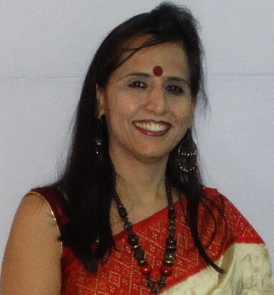 | Marks Distribution | Theory | 75 Marks
 |  |  |  | Internal Assessment | Assignments 10 Marks
 |  |  |  |  | Home Ex 10 Marks
 |  |  |  |  | Attendance 5 Marks
Reference | [1] | Andrilli, S., & Hecker, D. (2016). Elementary Linear Algebra (5th ed.). Elsevier India.
 | [2] | Gulberg, Jan. (1997). Mathematics from the Birth of _umbers. W. W. Norton & Company.
 | [3] | Puttaswamy, T. K. (2012). Mathematical Achievements of Pre-Modern Indian Mathematicians. Elsevier Inc. USA.
 | [4] | Srinivasiengar, C. N. (1988). The History of Ancient Indian Mathematics. The World Press Private Ltd. Calcutta. Digitized Book (2009).
Section | Week | Topics
Section 1 | 1st week, 16-21 AUG | A brief introduction to the lives and information on the works of the mathematicians  Aryabhata, Varahamihira, Brahmagupta.
 | 2nd week, 23-28 AUG | A brief introduction to the lives and information on the works of the mathematicians  Bhaskara I & II, Mahavira
Section 2 | 3rd week, 31 AUG-4 SEP | A brief introduction to the lives and information on the works of the mathematicians  Madhava, and Paramesvara.
 | 4th week, 6-11 SEP | Matrices, Basic concepts and algebraic operations, Types of matrices, Transpose of a matrix,
 | 6th week, 20-25 SEP | Symmetric and skew-symmetric matrices, Matrix multiplication and its properties
Section 3 | 7th week, 27 SEP-1 OCT | Powers of square matrices
 | 8th week, 4-9 OCT | Inverse square matrix and its properties
 | 9th week, 11-16 0CT | Determinant and its properties
 | 10th week., 18-23 OCT | Expansion by rowsand columns
 | 11th week, 25-30 OCT | Cofactors, Matrix singularity, Adjoint matrix
Section 4 | 12th week, 1-6 NOV | calculation of inverse
 | 13th week, 8-13 NOV | calculation of inverse
 | 14th week, 15-20 NOV | Cramer’s rule.
Section 5 | Revision | Cramer’s rule.
 | Revision | Problem Discussion

