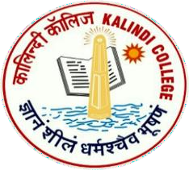 |  |  | Department of History, Kalindi College, University of Delhi |  |  |  |  |  |  |  |  | 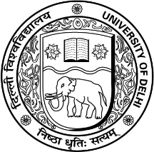
Title | Dr. |  |  | First Name | Kaushlendra Kumar |  |  | Last Name | Tiwari | Photograph
Designation |  |  |  | Assistant Professor |  |  |  |  |  | 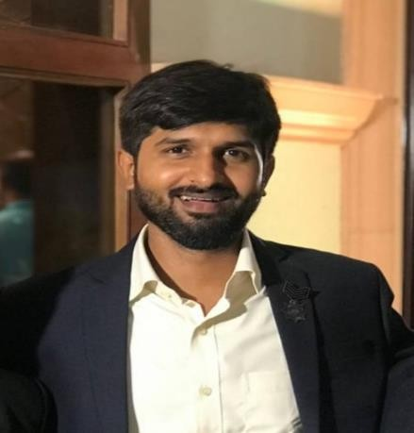
Address |  |  |  | Department of History, Kalindi College, University of Delhi
Phone no office
Residence  Mobile |  |  |  | +91-9650240449
Email |  |  |  | kaushlendra@kalindi.du.ac.in  kaushlendra16291@gmail.com
Web-Page |  |  |  | https://sites.google.com/view/drkaushlendrakum  artiwari/home
Educational Qualifications
Degree |  | Institution |  |  |  | Year | Details
Graduation |  | Rajdhani college University of Delhi |  |  |  | 2012 | B.A.(Hons.) History
Masters |  | South Campus  University of Delhi |  |  |  | 2014 | M.A. History
MPhil |  | Department of African Studies University of Delhi |  |  |  | 2017 | Somali Piracy and Joint Efforts of Nations to Eliminate it.
Ph.D. |  | Department of African Studies University of Delhi |  |  |  | 2022 | Penal transportation in India and South African with special reference to Andaman & Robben islands from 18th to 20th century
Academic Career Profile
Designation |  |  |  | From |  |  | to |  |  |  | Remarks
Assistant Professor |  |  |  | Feb 2024 |  |  | Till date
Areas of Interest / Specialization
Modern Indian History, History of Africa, Cultural History, Environmental History, History of Science

Subjects/ Course Taught
- B.A (H) History- History of USSR: The Soviet Experiences
- B.A. Prog. History- Medieval Societies
- VAC Paper- Political Leadership and Communication
- GE4 Paper- Educational Arrangements and Knowledge in Modern India
- BA (Prog) 5th Semester History of Europe 1789-1870,
- B.A. Part II: Cultural Transformations in Early Modern Europe-II
- BA (Prog) History of India 1858-1947
- GE Religious Traditions in Indian Sub-Continent
- B.A (H) History Fundamentals of Historical Methodology
- BA (Prog)7th Semester Fundamentals of Historical Methodology
- B.A (H) History- History of Africa 1840-1950
- BA (Prog)7th Semester Methods of Studying material Culture,

Awards and Honors
Young Environment Ambassador Award on behalf of the organizing committee of the 1st International YOUNG ENVIRONMENT AMBASSADOR AWARD organized by Let’s Do It India Foundation, in collaboration with Delhi University Students Union on 31 July 2023 at India Internation Center, New Delhi.
Research Projects (Major Grants/Research Collaboration)
Research Assistant in the project “Traditional Medicine in India and South Africa: A Comparative Study” under the aegis of SPARC, MHRD, Government of India in collaboration with School of Education, University of Witwatersrand, South Africa.
Resource Person for Seminar/Workshop/Conferences/FDP/e-Lectures
- Co-Convenor of Two days National Conference on Punyashloka Ahilyabai Holkar: Empowering Society through Values, Virtues, Compassion and Ledership; Feb. 2025
- Organizing Secretary of two days National Conference on “Innovation, Ownership, and Ethics in the age of AI Research, May 2025.

Conference/Seminar/Webinar/Workshop/FDP/ Presentations/Organization/Attended

- Presented paper entitled, “Africa in Uprising: A case study of Cote d’ Ivoire” at national Conference held on 18th - 19th February 2016 at the Delhi University.
- Participated in National Conference on African Studies Programme in India: Prospects and Challenges on 18th March, 2016.
- Participated in an international Exhibition on “Africans in India: From Slaves to Generals and Rulers” organized by UN.
- Presented a paper entitled, “Hindu- Buddhist cosmic beliefs in Thai Society” at the Indira Gandhi National Centre for the Arts on 31st March 2019. (National Conference)

- Presented a paper entitled, “the role of newspapers in exposing the colonial atrocities on freedom fighters in the Andamans” at national seminar held at IIMC in collaboration with ICHR, from April 27 to 28, 2022.
Publications/ Book/ Chapter/ Article
- Published a paper in the Journal of Research Administration (2023) entitled “The Cult of Baba Ghor and its Role in Shaping Identities in Gujarat” Vol. 5 No. 2, Page no. 11323-11331, ISSN: 1539-1590, E-ISSN:2573- 7104, Scopus Indexed International Journal.
- Published a paper in Bharat Manthan Multidisciplinary research journal (2023) entitled “Climate Change and cultural Discrimination: Unraveling the Impact on Vulnerable Communities” Vol. 03, issue 1, Page no. 19-25, ISSN:2583-634X. Peer Reviewed/ Refereed & Online Open Access Journal.
- Published an article entitled “penal transportation and colonial atrocities in the Andamans and Robben Island” in the Indian Journal of African Studies (2022), a peer-reviewed journal.
- Published a paper in the Internation Journal of History, (2021) entitled “Political Prisoners in the Andamans: A biographical analysis” was published in a peer reviewed journal. E-ISSN: 2706-9117, P-ISSN: 2706-9109, IJH 2021; 3(2): 143-147
- The article entitled, “Transportation of female convicts to the Andamans during British Raj” was published in 2018 in UGC listed journal name ‘International Journal of Applied Social Science. Vol. 5 (12), December
(2018) :2333-2340. ISSN: 2394-1405.

- Published two articles in the Diplomatist Magazine (2017) entitled “Political Relation between India and Ethiopia”. “Cultural Affinities and Commonalities between India and Ethiopia.”
Association With Professional Bodies
- Life Time Member of Akhil Bharatiya Itihas Sankalan Yojana, New Delhi

Administrative Assignments/Contribution to Corporate life
Deputy Superintendent to Examination of School of Open Learning; 2023-24, 24-2025.

Former member of Central Library Committee, University of Delhi.

Signature of Faculty Member

