PERMANENT FACULTY FACULTY PROFILE PROFORMA
Title  (Ms/Mr/Dr/Prof) | MS |  | FirstName | Pragya | Last  Name |  | Dharendra | Photograph
Designation | Assistant Professor |  |  |  |  |  |  | 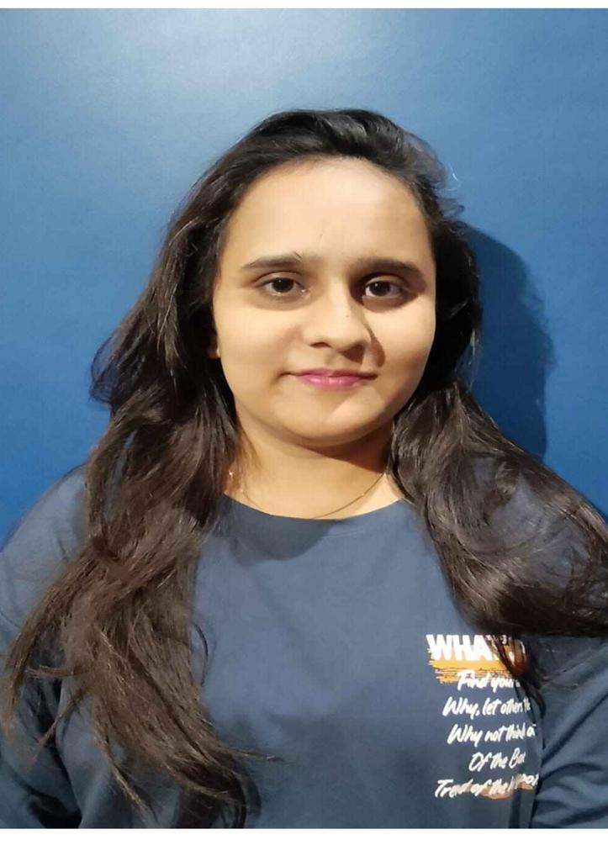
Department | English
Address (Official) | Kalindi College  University of Delhi  New Delhi-110008
Phone No. | 9461840897
Email | pragya@kalindi.du.ac.in
Education
Subject |  | Institution |  |  |  | Year |  | Details
BA |  | University Of Rajasthan, Jaipur |  |  |  | 2017 |  | 73%
MA |  | University Of Rajasthan, Jaipur |  |  |  | 2019 |  | 68%
MPHIL |  | University Of Rajasthan, Jaipur |  |  |  | 2021 |  | 68%
NET/JRF |  | UGC NET |  |  |  | 2020 |  | JRF
PHD |  | Banasthali Vidyapith, Newai, Tonk |  |  |  | 2025 |  | Submitted
Career Profile
Organisation/Institution |  | Designation |  |  |  | Duration |  | Role
Kalindi College |  | Assistant Professor (Permanent) |  |  |  | 22 June 2024 onwards |  | Teaching
Research Interests/Specialization
- English Language Teaching (ELT)
- Indian English Literature
- Feminism

Administrative Assignments / Contribution to corporate life
- Member of MITRAKSHAR The English Literary Society of Kalindi College 2024-25
- Member of Creative Writing Club 2024-25
- Member of Time Table Committee 2024-25
- Member of Attendance Committee 2024-25
- Member of EWS Admission Committee 2024-25
- Member of MITRAKSHAR 2025-26
- Co-Convenor of Creative Writing Club 2025-26
- Member of attendance committee 2025-26
- Member of Time Table Committee 2025-26
Teaching Experiences (Subject/Courses taught)

- Public Speaking and leadership
- Language and Culture
- Indian English Literature
- Social and Emotional Learning
- Reading in Indian Fiction
- Indian Classical Literature
- Contemporary South Asian Literature
- English Fluency 1

Research Guidance

NA
Publication (Peer Reviewed/Indexed Journals)
Year of  Publication | Title | Journal (Name of the journal. Vol Issue ISSN) | Co-Author
2023 | AHALYA, A FALLEN WOMAN: A THESIS, IT’S ANTITHESIS AND SYNTHESIS AS DEPICTED INVOLGA’S THE LIBERATION OF SITA | Anveshak ISSL 03784568 Vol 53 No 02 (IV): Jul- Dec 2023 UGC Care | Dr Sunil K Jha (Supervisor)
2023 | EXPLORING THE MODERN FEMINIST  VOICES IN CHITRA BANERJEE DIVAKARUNI’S THE FOREST OF ENCHANTMENTS | Shodha Prabha ISSN 09748946 Vol 48, Issue 4, Book no 1 2023 UGC Care | Dr Sunil K Jha (Supervisor)
2024 | A Historical Mythopoeia in Women of Ramayan: The Untold Stories by Kunal Kaushal | Educational Administration:  Theory and Practice, Vol 30, No 5, 2024, Scopus Q4 | NA
Seminar/Workshop/Conferences Presentation/Organisation

• National Seminar on Literature, Nature and Culture presented paper titled “Centralization
of the Marginalized Women Characters in the selected Retellings of The Ramayana”.

- National Conference on Intellectual Tradition of East and West: Thesis, Antithesis and Synthesis presented paper titled “Ahalya, A Fallen Woman: A Thesis, It’s Antithesis and Synthesis as Depicted in Volga’s The Liberation of Sita”.

- International Conference on Mapping the Marvellous presented paper titled “A Historical Mythopoeia in Women of Ramayan: The Untold Stories by Kunal Kaushal”.

- International Conference on World War 1; Modernism(s); And Time Binding presented paper titled “Exploring the Modern Feminist Voices in Chitra Banerajee Divakaruni’s The Forest of Enchantments”.

- National Symposium on Transgender and contemporary society: barriers and possibilities presented paper titled “Transgenders in India: From Mythology to Modernity”.

Public Service/ University Service/ Consulting Activity
NA

Professional Societies Membership
NA

Projects (Major Grants/ Collaborations)
NA
Other Details
- Attended a Faculty Induction Programme under MM-TTP of UGC organised by Iswar Saran P.G. College, Prayagraj from Nov 6 to Dec 5, 2024 and obtained A+
- Completed Online Refresher Course on “Shrimad Bhagavad Gita” under Malaviya Mission Teacher Training Programme of University Grants Commission organized by MMTTC: Ramanujan College, Delhi in Collaboration with Centre for Human Sciences, Rishihood University from 07 February,2025 to 20 February, 2025 and obtained grade A

