Curriculum Plan: B. Sc. (Hons) Mathematics (Semester VI)- RING THEORY AND LINEAR ALGEBRA II.
DR. ABHISHEK KR SINGH  Assistant Professor  Department of Mathematics  Kalindi College  University of Delhi  Delhi- 110008  Mobile: +91-8375834510  E- mail: abhishek@kalindi.du.ac.in |  | 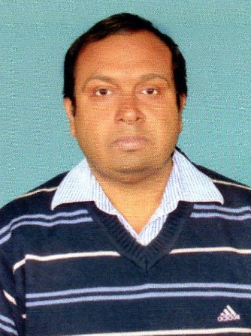 | Marks Distribution | Theory -75
 |  |  |  | Internal Assessment-25
 |  |  | Classes Assigned | Lectures: 5 per week
 | References | 1. JOSEPH A. GALLIAN (CONTEMPORARY ABSTRACT ALGEBRA) 4TH ED,  2. STEPHEN H. FRIEDBERG (LINEAR ALGEBRA) 4TH ED.
 | Week | Topics
 | 1st week  JAN 2-7 | POLYNOMIAL RINGS OVER COMMUTATIVE RINGS.
 | 2nd week  JAN 9-14 | DIVISION ALGORITHM AND CONSEQUENCES.
 | 3rd week  JAN 16-21 | PRINCIPAL IDEAL DOMAINS, FACTORIZATION OF POLYNOMIALS, REDUCIBILITY TESTS.
 | 4th week  JAN 23-28 | IRREDUCIBILITY TESTS, EISENSTEIN CRITERION, UNIQUE FACTORIZATION IN Z[X]
 | 5th week  JAN 30- FEB 4 | UNIQUE FACTORIZATION IN Z[X]
 | 6th week  FEB 6-11 | DIVISIBILITY IN INTEGRAL DOMAINS, IRREDUCIBLES
 | 7th week  FEB 13-18 | PRIMES, UNIQUE FACTORIZATION DOMAINS, EUCLIDEAN DOMAINS.
 | 8th week  FEB 20-25 | DUAL SPACES, DUAL BASIS, DOUBLE DUAL.
 | 9th week  FEB 27- MARCH 4 | TRANSPOSE OF A LINEAR TRASFORMATION AND ITS MATRIX IN THE DUAL BASIS.ANNIHILATORS.
 | 10th week  MARCH 13-18 | EIGENSPACES OF A LINEAR OPERATOR, DIAGONALIZABILITY, INVARIANT SUBSPACES.
 | 11th week  MARCH 20-25 | CAYLEY HAMILTON THEORAM, MINIMAL POLYNOMOAL FOR A LINEAR OPERATOR.
 | 12th week  MARCH 27- APRIL 1 | INNER PRODUCT SPACES AND NORMS. GRAM SCHMIDT ORTHOGONALISATION PROCESS.
 | 13th week  APRIL 3-8 | ORTHOGONAL COMPLEMENTS. BESSELS INEQUALITY, ADJOINT OF A LINEAR OPERATOR.
 | 14th week  APRIL 10-15 | LEAST SQUARES APPROXIMATION, MINIMAL SOLUTIONS TO SYSTEMS OF LINEAR EQUATIONS.
 | 15th week  APRIL 15-22 | NORMAL AND SELF ADJOINT OPERATORS.ORTHOGONAL PROJECTIONS AND SPECTRAL THEOREM.
APRIL 24-29- REVISION

