Curriculum Plan: B. Sc. (Hons) Mathematics (Semester VI)- DSE-4(i): NUMBER THEORY.

DR. ABHISHEK KR SINGH  Assistant Professor  Department of Mathematics  Kalindi College  University of Delhi  Delhi- 110008  Mobile: +91-8375834510  E- mail: abhishek@kalindi.du.ac.in |  | 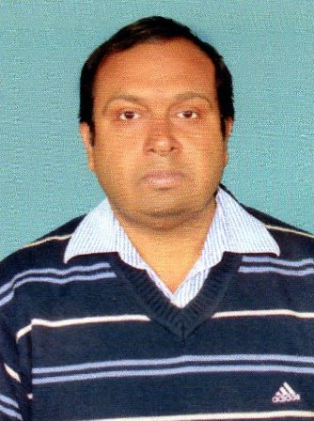 | Marks Distribution | Theory -75
 |  |  |  | Internal Assessment-25
 |  |  | Classes Assigned | Lectures: 3 per week.
 | References. | David M. Burton, Elementary Number Theory (7th Edition), Tata McGraw-Hill Edition, Indian Reprint, 2007.  Neville Robinns, Beginning Number Theory (2nd Edition), Narosa Publishing House Pvt. Limited, Delhi, 2007
 | Week | Topics
 | 1st week  JAN 2-7 | Linear Diophantine equation.
 | 2nd week  JAN 9-14 | Prime counting function. Statement of prime number theorem.
 | 3rd week  JAN 16-21 | Goldbach conjecture.
 | 4th week  JAN 23-28 | Complete set of residues.
 | 5th week  JAN 30- FEB 4 | Linear congruence.
 | 6th week  FEB 6-11 | Chinese remainder theorem.
 | 7th week  FEB 13-18 | Fermat’s little theorem.
 | 8th week  FEB 20-25 | Wilson’s theorem.
 | 9th week  FEB 27- MARCH 4 | The legendre symbol and its properties.
 | 10th week  MARCH 13-18 | Quadratic reciprocity.
 | 11th week  MARCH 20-25 | Quadratic congruences with composite moduli.
 | 12th week  MARCH 27- APRIL 1 | Public key encryption.
 | 13th week  APRIL 3-8 | RSA encryption and decryption.
 | 14th week  APRIL 10-15 | The equation x²+y²=z².
 | 15th week  APRIL 15-22 | Fermat’s last theorem.
APRIL 24-29- REVISION

