FACULTY PROFILE PROFORMA

Title  (Ms/Mr/Dr/Prof) | Ms |  | First  Name | Sneha | Last  Name |  | Sawai | Photograph
Designation | Assistant Professor |  |  |  |  |  |  | 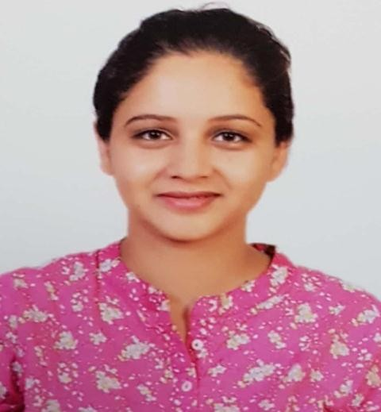
Department | English
Address (Official) | Kalindi College, East Patel Nagar, New Delhi 110008.
Phone No. | 9873792301
Email | sneh.sawai@gmail.com
Education
Subject |  | Institution |  |  |  | Year |  | Details
English |  | IGNOU |  |  |  | 2017 |  | PhD (Submitted)
English |  | Sri Venkateshwara  College,University of Delhi |  |  |  | 2010 |  | M.A.
English |  | Lady Shri Ram  College,University of Delhi |  |  |  | 2008 |  | B.A.
Career Profile
Organisation/Institution |  | Designation |  |  |  | Duration |  | Role
Kalindi College, University of Delhi |  | Assistant Professor |  |  |  | 27th July 2011 to  Present |  | Teaching
Research Interests/Specialization
- American Literature
- Popular Literature
Administrative Assignments / Contribution to Corporate life
- Co-convener of Timetable Committee (2021-22)
- Editor of College Magazine, Pravah (2013 to Present)
- Member of Prospectus Committee (2021-22)
- Member of Creative Writing Club (2021-22)
- Co-convener of Debating society English (2015-19)
- Member of Mitrakshar, The English Literary Society (2012 to 2014)
Teaching Experiences (Subject/Courses taught)

- B.A. (Hons.) English

  - Postcolonial Literature
  - American Literature
  - African Literature
  - Women’s Writing
  - Literary Theory
  - Popular Literature
  - Anglo-American Writing from 1930’s
  - Modern European Drama
  - Contemporary Literature
  - Indian Writing in English
  - Individual and Society
- B.A. (P):
Language through Literature,
Advanced English (A)
- Business Communication
- AECC: Advanced English (A)
Research Guidance
Supervised B.A. (Hons.) students, along with three other colleagues, for a research and Innovation Project titled “Exploring Gerontology: Literary, Cultural and Diasporic Perspectives”, a project sanctioned from the Antardhwani 2015 prize money, under promoting good academic practices in Kalindi College.
Publication (Peer Reviewed/Indexed Journals)
Year of Publication | Title | Journal (Name of the journal. Vol Issue  ISSN) | Co-Author
2020 | ‘Rosencrantz and Guildenstern are Dead: Reflections on Theatre, Death and Freewill’ | Rock Pebbles, a UGC-Care listed peer-reviewed journal of Multidisciplinary studies Vol. XXIV No. IV December 2020 issue. | NA
2021 | ‘Reclaiming Oneself: Subaltern Perspectives in Toni Morrison’s Beloved’ | Book Marginalised Voices in American Literature: Margins and Fringes  (ISBN 9788126931712) | NA
Seminar/Workshop/Conferences Presentation/Organisation
- Presented ‘Quest for Social Justice and Dalit Literature’ in National Conference on ‘Quest for Identity in English Literature’ organized by Department of Humanities and Management, Manav Rachna International University on 30th November 2013.

- Attended a workshop on ‘Cultural Diversity, Linguistic Plurality and Literary Traditions of India’ organized by Department of English, University of Delhi on 28th April 2015.

- Attended a one day workshop on ‘Language through Literature’ organized by Department of English, University of Delhi on 17th August 2016.

- Participated in a three-day Faculty Development Program on English Language Teaching Skill Enhancement Course organized by the Department of English, Kamala Nehru College (in collaboration with Embassy of the United States of America), University of Delhi from 30th September to 3rd October, 2016.

- Delivered a lecture on ‘Metatheatre and Tom Stoppard’ as a resource person at Delhi College of Arts and Commerce, University of Delhi on 15th February 2017.

- Participated in a Faculty Development Program on ‘Literature and Cinema’ organized by the Department of English, Kalindi College, University of Delhi on 16th February 2017.

- Participated in a one-day workshop on Poetry Writing organized by the Department of English, Kalindi College, University of Delhi on 1st October 2018.

- Participated in a one-day workshop on Translation organized by the Department of English, Kalindi College, University of Delhi on 30th March 2019.

- Attended a webinar on ‘Indian Classical Literature: Research and Pedagogic Dimensions’ organized by the Department of English, Mata Sundri College for Women, University of Delhi on 17th July 2020.

- Participated in a Faculty Development Program on “Travel Writing” organized by the Department of English, Kalindi College, University of Delhi on 6th April 2019.

- Presented ‘Reading beyond the Text: New Historicism and Cultural Materialism in Toni Morrison’s Beloved’ in the 6th JGU International Literature Online Conference on ‘Theory-Literature Interface’ organized by O.P. Jindal Global University on 24-26 July 2020

- Attended a webinar on ‘Writing History: A Study of Poetry in Nagaland’ by Dr. Emisenla Jamir and ‘Poetry of Conflict: An Overview of Contemporary Manipuri Poetry’ by Dr. Chingangbam Anupama organized by the Department of English, Kalindi College, University of Delhi on 16th October 2020.

- Presented a paper ‘Voices from the Margins: An Ecocritical Reading of Mamang Dai’ in a two-day national (online) seminar on ‘TRIBES: Learning and Unlearning Tribal Culture’ organized during 9-10 December 2021 by Janki Devi Memorial College, University of Delhi.

Awards & Distinctions

Public Service/ University Service/ Consulting Activity
Professional Societies Memberships
Projects (Major Grants/ Collaborations)
Other Details

